A Hebrew Lesson

 | English Title: |  | A Hebrew Lesson
 | Hebrew Title: |  | Ha’Ulpan
 |  | Documentary, Israel 2006. DigiBeta/BetaSP , color 3:4, 123 minutes

Created by: | David Ofek, Ron Rotem, Elinor Kowarsky
Directed by: | David Ofek and Ron Rotem
Produced by: | Edna & Elinor Kowarsky – Eden Productions
Languages: | Hebrew/English/Chinese/Russian/German/Spanish  English subtitles

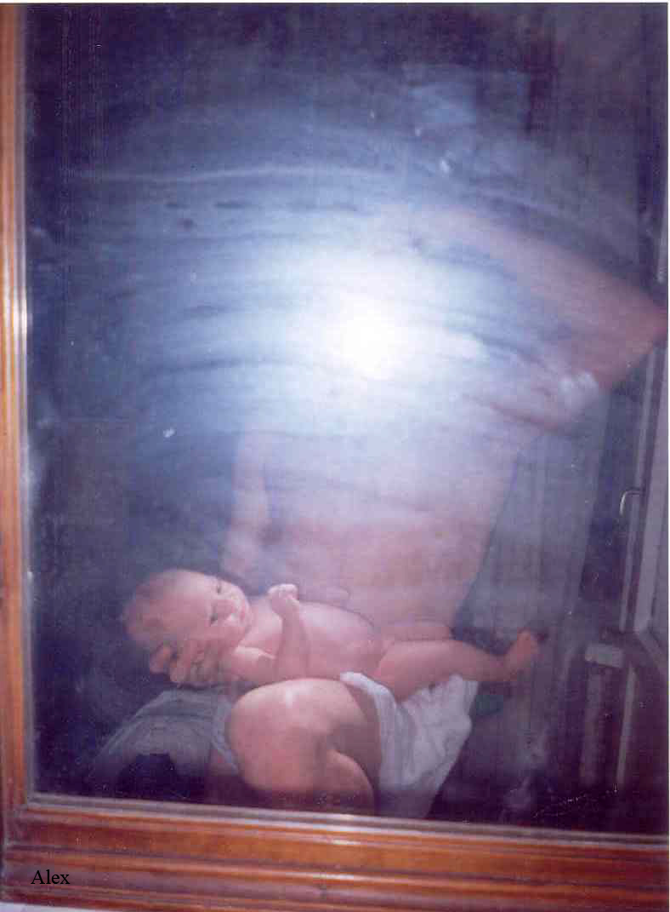

”Learning Hebrew has been central to establishing one‘s personal identity and sense of collective belonging. Language transcends political, religious and ideological divisions; it is what unites and coalesces the different parts of society.“ (The Jewish Agency pamphlet for Hebrew Ulpan teachers)

Chin left her daughter in China and came to Israel to make a living. She cleaned Ehud‘s house, and they fell in love. Sasha never considered immigrating to Israel. But four years after his woman left Russia with their daughter, he understood that life without his child is worthless. He left a thriving business behind only to find himself in Tel Aviv‘s worst neighborhood. Marisol grew up as a Jewish Princess in Lime Peru, and came to Israel to learn something about life. An unexpected pregnancy alters her plans.

These and other characters meet in a Hebrew language Ulpan where their personal stories meld with the complexities of Israeli reality. The immense effort of learning a new language is revealed through their encounter with a strange culture and an unfamiliar environment. Israeli society is revealed through the foreigner‘s eyes. This gaze, at times funny, at times sad, paints our daily reality with irony. But beyond the obvious differences, the human common denominator of longing and love, triumphs time and again.

From The Press:

Engrossing documentary "A Hebrew Lesson" brings a fresh take on how non-natives cope with life in a new culture.
(Jay Weissberg, “Variety”, February 22, 2007)

This movie oozes love and compassion. Every second of its 123 minutes is a celebration of pure humanity… the characters in the movie - the teacher, students, workers, and policemen – share a type of all-embracing human brotherhood. They are all entitled to compassion, and they all emanate compassion... It is not an artistic, sophisticated, prettified representation - but an analysis of humanity itself. Is there anything better to say about a documentary film?
(Jon Feder, “y-net”, December 24, 2006)

David Ofek's "A Hebrew Lesson," a delightful if thought-provoking look at the problems of several immigrant students in an oulpan, or intensive Hebrew class, traditionally a means of adapting newcomers to the values of the Jewish state. (Howard Feinstein, IndieWIRE, July 20, 2006)

“Le sujet est riche et le résultat à la hauteur des attentes. Sous l'oeil de David Ofek, l'oulpan apparaît bel et bien comme ce qu'il est : un espace de rencontres improbables entre des individus venus des cinq continents, de confessions différentes et dont la motivation varie parfois du tout au tout, mais aussi un lieu de passage faisant office de miroir de la société israélienne, de ses contradictions, de ses forces et faiblesses. Voire de son absurdité. Non seulement le rire et l'émotion sont au rendez-vous, mais les messages essentiels passent, l'air de rien.” (Nathalie Avisar, “The Jerusalem Post”, 18 juillet, 2006)

TELEVISION BROADCASTS:

- Channel 2, Israel
- YES-doco, Israel
- The Documentary Channel, Canada
- YLE, Finland

INTERNATIONAL FILM FESTIVAL SCREENINGS:

- Best Documentary Director Award – The Wolgin Award, The Jerusalem International Film Festival (Israel, July 2006)
- Best Documentary Editor Award – The Wolgin Award, The Jerusalem International Film Festival (Israel, July 2006)
- International Premiere - The International Film Festival Rotterdam (The Netherlands, January 2007)
- Official Selection - 30th Göteborg International Film Festival (Sweden, January 2007)
- Official Selection – 22nd Israel film festival (USA, March 2007)
- Official Selection - 7th Israeli film festival in Paris (France, March 2007)
- In Competition – The Bermuda International Film Festival (Bermuda, March 2007)
- In Competition - Thessaloniki Documentary Festival (Greece, March 2007)
- In Competition – The Chicago International Documentary Film Festival (USA, March 2007)
- Official Selection – The Toronto Jewish Film Festival (Canada, May 2007)
- Official Selection – The Stockholm Jewish Film Festival (Sweden, May 2007)
- Official Selection – 4th International Film Festival ‘Jewish Motifs’ in Warsaw (Poland, May 2007)
- Official Selection – 56th Melbourne International Film Festival (Australia, July 2007)
- Official Selection – 15th Filmfest Hamburg (Germany, October 2007)
- Best Documentary Series Award - The Israeli Documentary Filmmakers´ Forum Competition (Israel, June 2007)
- In Competition- The Pärnu International Film Festival (Estonia, July 2007)

- Official Selection – the UK Jewish Film Festival 2007 (UK, November 2007)

- Jury Award – Slow Film Festival (Hungary, July 2007)

- Official Selection- Philadelphia Jewish Film Festival (USA, March 2008)

- Official Selection- Stamford Jewish Film Festival (USA October 2007)

- Official Selection- Amsterdam Jewish film festival (The Netherlands, November 2007)

- Official Selection – The Boston Jewish Film Festival

(USA, November 2007)

- Official Selection – Hartford Jewish Film Festival (USA, March 2008)

- Opening Film– NY Premier at the New York Jewish Film Festival, presented by The Jewish Museum and The Film Society of Lincoln Center (USA, January 2008)

- In Competition- The Palm Beach International Film Festival (USA, April 2008)

- Official Selection – Madison University-Wisconsin (USA, February 2008)

- Official Selection - The Vancouver Jewish Film Festival (Canada, March 2008)

- Official Selection - Washington Jewish Film Festival (USA, April 2008)

Official Selection - Jewish Culture Festival in Cracow

(Poland, June 2008)

- Official Selection – JCC Manhattan (USA, March, 2008)

- Official Selection – Long Island JCC (USA, May, 2008)

- Official Selection – Sarasota Film Festival (USA, April 2008)

- Official Selection – the 16th Portland Jewish Film Festival. (USA, April 2008

MAIN CREDITS:
Created by: | David Ofek, Ron Rotem, Elinor Kowarsky
Directed by: | David Ofek and Ron Rotem
Producers: | Edna & Elinor Kowarsky, Eden Productions
Cinematography: | Ron Rotem
Script | David Ofek and Sari Ezouz
Editing: | Sari Ezouz
Music: | Oren Menashe & Idan Einav
Sound Design & Mix: | Ronen Nagel

PRODUCTION / TECHNICAL DETAILS:

Year of Production: | 2006
Running Time: | 123 minutes
Original Format: | DigiBeta
Preview Tape: | DVD PAL with English subtitles
Screening Format: | BetaSP/DigiBeta with English subtitles, 3:4

PRODUCTION:

Eden Productions
84 Arlozorov St. Tel Aviv – 62647, Israel
Tel: +972-3-5273403 / Fax: +972-3-5236076
E-mail: info@edenproductions.co.il / URL: www.edenproductions.co.il

SALES & DISTRIBUTION:
WORLD SALES:
Philippa Kowarsky - Cinephil
18 Levontine st. Tel Aviv 65112, Israel
Tel: +972-3-5664129 / Fax: +972-3-5601436
E-mail: info@cinephil.co.il / Website: www.cinephil.co.il

INTERNATIONAL FILM FESTIVALS & SCREENINGS:

Eden Productions
84 Arlozorov St., Tel Aviv – 62647, Israel
Tel: ++972-3-5273403 / Fax: ++972-3-5236076
E-mail: info@edenproductions.co.il / Website: www.edenproductions.co.il

About the Director
David Ofek, a graduate of the ”Sam Spiegel" Film School in Jerusalem, was awarded the Wolgin Prize in the past for his short films ”Home“ and ”Hi-Tech Dreams". Co-creator of the popular TV series ”Bat-Yam—New-York“ and “Melanoma my Love,“ Ofek directed the film ”No. 17“ which won the Israeli Academy Award for ”Best Documentary“ as well as other international Awards.

2006 Director of "Melanoma my love" (113 min, 35 mm)
Montreal world film festival - Official selection
Seoul Drama Awards – nominee
Director of the documentary "A Hebrew Lesson" (123 min, Beta)
Best director and Best editing – Jerusalem film festival 2006

2003 Director of the documentary “No. 17” (76 min, Beta)
Best Film – DocAviv (Tel Aviv International Documentary Film Festival)
Best Documentary – Israeli Academy Awards
Special Jury Award – Hot Docs International Film Festival 2004
International Press Award – Chicago Documentary Film Festival
Best Documentary – Syracuse International Film Festival
Amsterdam Documentary festival (IDFA)
New directors/new films – New York
“Input” conference - Denmark

2002 Director and scriptwriter of debut feature film “The Barbecue People” (103 min, 35 mm)
Silver Ombú for Best Screenplay – Mar del Plata Film Festival, Argentina
Best Dramatic Film – Dahlonega Film Festival, Atlanta
Best Film – Washington Independent Film Festival
Participated in over 25 international festivals, including Sao-Paulo, Istanbul, Hamburg

2000 Creator of series “Take-Away” for Israeli cable TV and director of four episodes
Nominated for Best Series – Israeli Academy Awards

1999 Director of documentary “5 Love Stories” (58 min, Beta)
Best Film – Doc-Aviv 2000
Best Documentary – Israeli Film Festival, US
Participated in documentary festivals in Taiwan and Greece
Co-producer of documentary “Martin” by Ra’anan Alexandrovitz
Volgin Prize for Best Documentary – Jerusalem Festival
Director of documentary “Spanish Orchard in America” for Israel’s Channel 2
Jerusalem film festival – The Jewish spirit

1995-7 Director of the three seasons of “Bat-Yam New York”
Best Television Drama – Israeli Academy Awards
Participated in “Input” conference

1994 Student director of graduation film “Home” (17 min, 16 mm)
Volgin Prize for Best Short Film – Jerusalem Film Festival
First Prize in Short Film Competition – Edinburgh International Festival
First Prize – Oberhausen Festival, Germany
Best Israeli Film – International Students’ Festival, Tel Aviv
First Prize – Israeli Film Festival, US
Special jury Award – San Francisco Festival
Participated in 50 festivals including New York and London

1992 Student director of “Hi-tech Dreams” (28 min, Beta)
Volgin Prize for Best Short Film – Jerusalem Festival 1993
Israeli Cinema Institute Prize for best Documentary, 1993
Best documentary at the school graduation ceremony
Participated in the London Festival

About the Director (2)

As an Israeli documentary director, cinematographer, and film teacher, Ron Rotem has been actively involved in filmmaking for over 30 years. Almost all of his award-winning documentary work has involved the telling of personal stories, some history related,
many dealing with the Palestinian-Israeli conflict and the Holocaust. He is currently based in Copenhagen working on a documentary series about the future of European identity.

