English Title: Luxuries
Original Title: Motarot

Documentary / 54min / Israel 2011 / DigiBeta / Color

Created by: David Ofek, Elinor Kowarsky
Directed by: David Ofek
Produced by: Edna Kowarsky, Elinor Kowarsky - Eden Productions
Language: Hebrew ‏‏‏
Subtitles: English

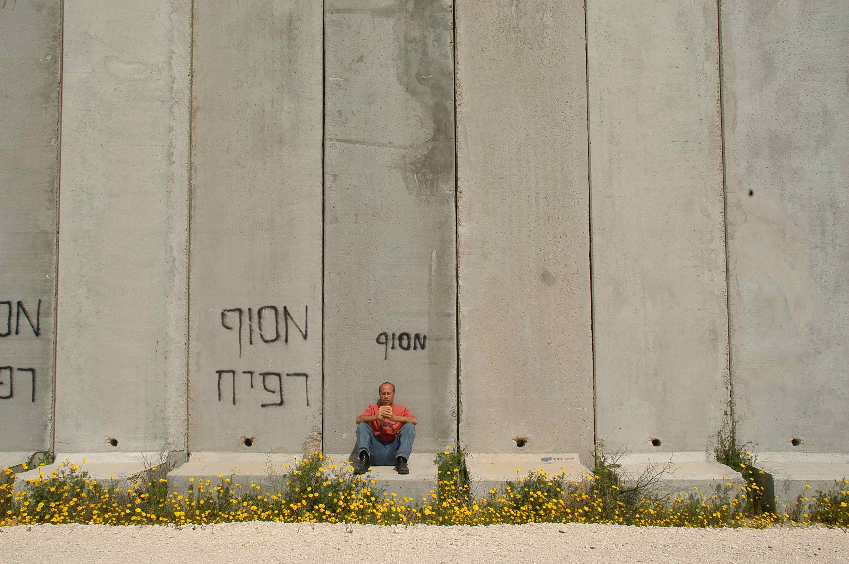

An elusive “coordinator,” vague formulas that calculate “survival capacity”, warehouses cramped with rotting goods, and donkeys dressed up as zebras – all take part in the mosaic that sketches a surreal reality in which evil and stupidity merge.
Director David Ofek takes the viewer on a journey to the absurd front of the Israeli “blockade on Gaza”, revealing the consequences of a policy that limits the flow of goods into Gaza.

This is the story of the merchandise itself – kiwis, fresh meat, toys, shoes, notebooks, canned food – goods that have been purchased, stored, expired, spoiled, and ultimately, destroyed. It is an ironic observation – sometimes comic, always tragic – that exposes the thin line Israel draws between bare necessities and luxuries.

From The Press:
"David Ofek's 'Luxuries' turns the Gaza blockade into a Fellini film." -Yair Raveh, Pnai Plus.

"With a humorist touch, a film that elegantly portrays the insanity here -- a sort of homage to Felini." -Moran Sharir, Ha'aretz

"David Ofek is an incredible filmmaker. He has the ability to take what seems a two-dimensional reality and find the small angles that really make the big picture that twists the viewer." -Nir Kipnis, Globes

Television Broadcasters:
- YES-doco, Israel

Funds:
- MAKOR Foundation for Israeli Films

International Festivals & Screenings:

- Cinema South Festival (Israel, June 2011)
- In Competition – In the Spirit of Freedom The Jerusalem International Film Festival (Israel, July 2011)
- DOK Leipzig International film Festival (Germany, October 2012)
- Shanghai TV Festival (China, June 2012)
- Official Selection - Toronto Jewish Film Festival, (USA, March 2012)

Main Credits:
Created by: David Ofek, Elinor Kowarsky
Director & Scriptwriter: David Ofek
Producers: Edna Kowarsky, Elinor Kowarsky
Cinematographer: Dror Lebendiger, Hen Lasker
Editor: Noit Geva
Original Music: Israel Bright
Sound: Ronen Nagel

Technical Information:
Original Format: DVCAM
Preview Tape: DVD PAL with English subtitles
Screening Format: BetaSP/ DigiBeta with English subtitles,
16:9 Anamorphic

Production Company:
Eden Productions Ltd.
84 Arlozorov st.
Tel Aviv, 62647
Israel
Tel: +972-3-5273403
Fax: +972-3-5236076
E-mail: info@edenproductions.co.il
Website: www.edenproductions.co.il

World Sales:
Cinephil – Philippa Kowarsky
18 Levontin st.
Tel Aviv, 65112
Israel
Tel: +972-3-5664129
Fax: +972-3-5601436
E-mail: info@cinephil.co.il
Website: www.cinephil.co.il

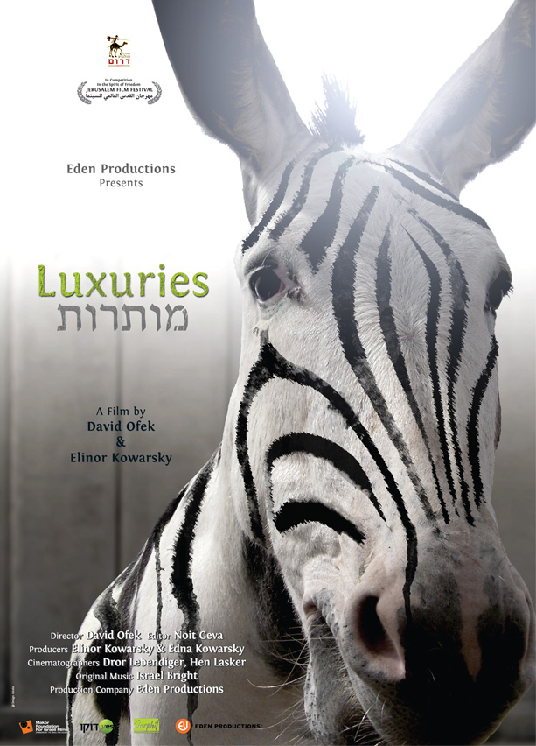

About the Director – David Ofek:
David Ofek's works always straddle on the fine line between documentary and feature film.
Among them: Home (1994, short drama) received the Volgin Award - Jerusalem IFF, First Prize in Edinburgh IFF and more. The TV series Bat-Yam New York (1995-97) received the Best Television Drama award - Israeli Academy Awards and Participated in "Input" conference. No. 17 (documentary, 76 min. 2003) won 5 international prizes and participated in over 90 international festivals, including "Input". His latest documentary The Tale of Nicolai & the Law of Return (2008, 54 min.) won 4 international prizes and participated in Input.

Filmography & Awards
2008 | Director of documentary The Tale of Nicolai & the Law of Return  Best Documentary, The Wolgin Competition, The Jerusalem International Film Festival  Israeli representative to the INPUT conference  Official Selection, Vision du Reel - Internatinal copetition
2007 | Director of documentary Bright Days (Yamim Zoharim)  Director of documentary Paradigma together with director Asaf Sudry
2006 | Director of documentary A Hebrew Lesson (Ha´Ulpan)  Best Director, The Wolgin Competition, The Jerusalem International Film Festival  Best Editing, The Wolgin Competition, The Jerusalem International Film Festival  Offical Selection, The International Film Festival, Rotterdam, The Netherlands
2005 | Director and scriptwriter of TV mini-series Melanoma My Love  Best Drama, Israel Academy Award  Official Selection, Rotterdam and Montreal World Film Festival
2003 | Director of documentary No. 17 (76 min, Beta)  Best Film - DocAviv (Tel Aviv International Documentary Film Festival)  Best Documentary - Israeli Academy Awards  Special Jury Award - Hot Docs International Film Festival 2004  International Press Award - Chicago Documentary Film Festival  Best Documentary - Syracuse International Film Festival  Participated in over 90 international festivals, including the Amsterdam Documentary Festival (IDFA), new directors/new films - New York, and "Input"
2002 | Director and scriptwriter of debut feature film The Barbecue People  Silver Ombú for Best Screenplay - Mar del Plata Film Festival, Argentina  Best Dramatic Film - Dahlonega Film Festival, Atlanta  Best Film - Washington Independent Film Festival  Participated in over 25 international festivals, including Sao-Paulo, Istanbul and Hamburg
2000 | Creator of series Take-Away for Israeli cable TV and director of four episodes  Nominated for Best Series - Israeli Academy Awards.
1999 | Director of documentary 5 Love Stories  Best Film - Doc-Aviv 2000  Best Documentary - Israeli Film Festival, US  Participated in documentary festivals in Taiwan and Greece
1995-7 | Director of 1st and 2nd seasons of Bat-Yam New York  Best Television Drama - Israeli Academy Awards  Participated in "Input" Festival, Mexico
1994 | Student director of graduation project film Home  Volgin Prize for Best Short Film - Jerusalem Film Festival  First Prize in Short Film Competition - Edinburgh International Festival  First Prize - Oberhausen Festival, Germany  Best Israeli Film - International Students´ Festival, Tel Aviv  First Prize - Israeli Film Festival, US  Judges´ Award - San Francisco Festival  Participated in 50 festivals including New York and London
1992 | Student director of third-year project film Hi-teq Dreams  Volgin Prize for Best Short Film - Jerusalem Festival 1993  Israeli Cinema Institute Prize for a Documentary, 1993  Prize for Best Documentary at the school graduation  Participated in the London Festival

