From the Producer/Director of the Sundance award-winning film ‘the art star and the sudanese twins’

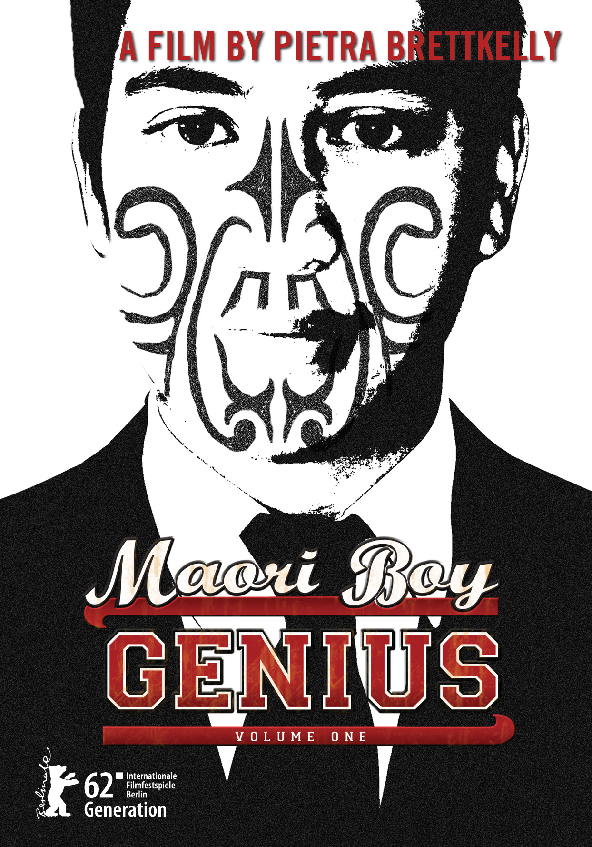
FACT SHEET

Title: MAORI BOY GENIUS

Writer/Director/Producer: Pietra Brettkelly
(pronounced Peetra)

Executive Producers: Joanna Paul
Jennifer Fox
Michael Haslund-Christensen
Vicki Jackways

Made with the assistance of: VPRO, NZ on Air, New Zealand Film Commission, Park Road Post, Doc Lab of the Binger Filmlab

Running Time: 85 minutes approx

Featuring: Ngaa Rauuira Pumanawawhiti
(pronounced Nya Ro-era)
Maakarita Paku
Adrian Davis
Mike Paku
Janet Paku
Dean William Whobrey
Riwai Rangihuna
Daniel Pikari

Director of Photography: Jacob Bryant

Editor: Molly Malene Stensgaard

Original Soundtrack: Anika Moa

Post Production Sound: Dick Reade, Reade Audio
SHORT SYNOPSIS

"He's precious, and gifted, a Matakite - a wiseman... but really he's just a child. Hee, hee." Grandma, aged 80.

Obama broke the mould. Bolivia’s Evo Morales broke the mould. And a teenager in New Zealand is breaking the mould to eventually stand in history with these leaders.

MAORI BOY GENIUS is a coming-of-age film profiling future leader Ngaa Rauuira, railing against his people’s statistics of uneducated youth, 40% of prisoners, and alarming suicide rates.

At 4 he learnt English.

At 12 he began his first university degree.

At 14 he googled international politics and came up with Yale University.

Ngaa’s story reveals a family of eight on a modest income, committing to a US$35,000 Yale bill; a weighty tribal expectation that he will be the voice of his people AND bring success in war dance competitions; laughing and crying with best friends, approaching adulthood and diverging pathways.

What if you could turn back the clock and watch the minds forming of those who would create political zeitgeist shifts in the future?

MAORI BOY GENIUS does just that.
LONG SYNOPSIS

As she was preparing to have her sixth child the mother in our film, Maakarita, tells us a story. Sixteen years previously she was giving birth to her first child, a boy. And there wasn’t just one omen with his birth, but two. Firstly he was born “in the caul” with the amnio covering his face, and when the old ladies went outside to announce his birth there was a double rainbow on the horizon.

He was named Ngaa Rauuira Pumanawawhiti, the energy around where lightning strikes.

He learned to memorise through the Maori tradition of singing and story telling. His first language is Maori and he learnt English at four years old. At 12 he began his first university degree; at 14 he googled "international politics'' and "education" and came up with Yale University. He applied to the Yale summer semester programme at age 15 and was accepted at the age of 16.

Ngaa says: "Maori didn’t have a written language. So we learn songs, we learn dances about everything like fishing. How can you go fishing if you don't know where the fish are? A song will tell us how to look for the fish and we would sing it as we went fishing."

Ngaa posseses spirituality and charisma. Among his people he is being hailed as a new leader for this confused and troubled age, a visionary who can directly tap into the wisdom of his ancestors.

He's also a goofy, gangling 16 year-old Maori boy who loves to hang out with his mates; watching his best friend Riwai - already a dad at 17 - practise his old school popping-and-locking dance moves, eating meat pies in his friend Daniel's car.

"But his real interest is human rights,'' his mother Maakarita says: "He's been talking that way since he was 10.''

One of Ngaa's favourite quotes: "We must always take sides. Neutrality helps the oppressor, never the victim. Silence encourages the tormentor, never the tormented."

Ngaa's name is based on an old tribal (Tuhoe) saying: “He uira ki te rangi he tauira ki te whenua....Like lightning in the sky, here is an example on earth.”

But it is Ngaa's grandmother who gently notes: “He’s a Matakite, a wiseman. But really he’s just a boy."

MAORI BOY GENIUS profiles this future leader as he takes his first steps toward breaking the mould, railing against his people’s horrifying statistics. This is the classic story of poor small town boy makes good, the greatest story ever told, that of rags to riches.

Ngaa was born in the small coastal New Zealand town of Otaki. He has lived with his retired grandparents (his grandfather worked on the railways and his grandmother a prison nurse) since the age of eight (customarily the eldest child in a family is given to their grandparents) while Ngaa's five siblings were bought up by his parents.

Ngaa Rauuira’s closest and most spiritually rich relationship is with his grandfather. His grandfather is sad when he admits he has lost the language that was beaten out of those of his generation when they spoke it in the school playgrounds. The culture was being crushed. But in the 1970s people marched on Parliament, insisting the culture and language be protected.

Some say Ngaa Rauuira is one of the greatest results of this renaissance, a product of a unique full immersion indigenous education system that aims to assist New Zealand into a bicultural society.

But expectations are high of Ngaa Rauuira; he is a young man with the world resting on his shoulders. His family of eight faces his US$35,000 Yale bill; his tribe expects success in kapa haka performance competitions AND in ‘saving’ them; he cannot fail.

Because of Ngaa Rauuira’s age he must be chaperoned at Yale University. Although he lives with his grandparents, it is his father Adrian, thunderstruck by the wonderment of his son’s talents, that is his companion. Both leave their family behind, Adrian’s wife Maakarita having just given birth to their sixth child three days before departure, the whole family having sacrificed so much for this boy’s education.

As we watch all these influences on Ngaa Rauuira, we see him begin to make his own decisions and take his first political steps. On his return from Yale Ngaa Rauuira takes up a megaphone and leads national protest. He is then asked to stand as a Member of Parliament. The political party have no idea how young he is. Just how inspiring.

Within the year, MAORI BOY GENIUS reveals the empowerment Ngaa Rauuira got not just from those around him but an international educational institution. This truly is Volume 1, the 7Up of the making of a political leader.

ABOUT THE PRODUCTION

The Director’s Motivation

As a documentary filmmaker I hear or read of things that interest me and it might be months or years later that I’m given the opportunity to explore that idea in film. I wait – subconsciously - for the right subject to come along.

I once heard that when we are 16 we begin to realise our own political views, that this is the year we become cognisant of the society around us, of differences in the lives of others. And we begin to become aware of how we can impact that – through our own voice be it writing, discussion or public protest, and in a democratic society like New Zealand by realising that in two years time at the age of 18 we can vote.

Truthfully when I was 16 my focus was the beach where I lived and volleyball tournaments. And in a recent international survey teens voted spray-tans and iPhones as the top inventions of all time. Are they really becoming politically aware? And if I was to explore this political coming-of-age did I really want to be hanging out with teenagers, sometimes monosyllabic moody individuals?

And then I met Ngaa Rauuira who at 16 becomes passionately political. One look now at his Facebook page tells how he champions the rights of the oppressed including his own people who were ousted from their lands, introduced to cigarettes and alcohol and banned from speaking their own language.

And so we filmed Ngaa Rauuira’s 16th year which evolved into an intense pressure cooker of political awareness – being halted from study as a New Zealand university because of his age, seeking educational opportunities overseas and departing his homeland for study at Yale summer semester - and getting As. All his previous 16 years of up-bringing and now this international study was percolating in this young mind and on his return to New Zealand he took his first major political steps leading protest marches. All in his 16th year.

Ngaa Rauuira is an exciting young man who talks in myths and finds his inspiration and direction from his ancestors. But is Ngaa Rauuira’s biculturalism relevant in the 21st century and will it help or hinder his political development? Or is he the future leader who can successfully straddle both worlds?

MAORI BOY GENIUS is my third narrative feature after 2003’s BEAUTY WILL SAVE THE WORLD shot is Libya and featuring a beauty competition hosted by Colonel Gadaffi, and THE ART STAR AND THE SUDANESE TWINS shot largely in South Sudan exploring the question Is international adoption the new colonialism?

As a first generation New Zealander, I wonder at the future of Aotearoa/New Zealand, a relatively new country, as we grapple with bi-culturalism and address the racial divides.

In MAORI BOY GENIUS I’m exploring these issues – and staying closer to home.
The Executive Producer’s Motivation

As a Maori growing up in New Zealand, and then with an international filmmaking career, I longed to be able to tell a story like Ngaa Rauuira’s, to point people I met in the direction of a film such as MAORI BOY GENIUS and counter the knowledge of our indigenous by such films as ONCE WERE WARRIORS made16 years ago.

Not just Maori but any indigenous culture wishes for a story such as Ngaa Rauuira’s.

It is difficult to understand just how different and special this young man is until bombarded with the kind of statistics that over half our young Maori men are leaving High School without a single qualification.

For a young man to have not only triumphed amongst his peers and friends and to have been brought up in his own culture as part of the renaissance of our Pacific peoples’ cultures; and now to be one of only a handful of Maori/Pacific people to have crossed that Ivy League threshold seems like a miracle. It Is.

We are filming the formatives years of a man for whom great leadership and responsibility will be expected and given.

And the pride I feel in showcasing this one positive story I know is justified.

Joanna Paul
Tribe: Ngai Te Rangi

KEY PERSONNEL

PIETRA BRETTKELLY: PRODUCER/ DIRECTOR
“I felt I was in the hands of a master storyteller.” Still in Motion magazine

Pietra is truly passionate about everything she does – the risks she’s taken in making some of her documentaries exhibit either passion or craziness. Pietra is motivated by stories that matter, the personal journeys that reflect a bigger issue.

With parents that took her everywhere from Papua New Guinea to Portugal, they encouraged a wonder and appreciation for the diversity of peoples and their stories.

“Pietra Brettkelly’s engimatic rendering … is not a straightforward artist’s profile, political commentary or domestic drama, but a poetic fusion of the three.” Variety Magazine

Pietra says her films have a considered quietness to them, a non-judgemental approach that allows subjects to tell their stories. She treasures the honesty and the privilege people grant me in capturing and documenting an often pivotal time in their lives.

Pietra’s work has featured on networks throughout the world, and screened to critical acclaim at international film festivals including the Sundance Film Festival. Her self-funded 2008 Sundance Film Festival award-winning documentary THE ART STAR AND THE SUDANESE TWINS enjoyed international success in competition at the Edinburgh International Film Festival, Hotdocs, Toronto, Zurich International Film Festival, the Melbourne International Film Festival and Rio de Janeiro International Film Festival.

The film has won the following awards:

Qantas Film and Television Best Documentary Director
Qantas Film and Television Best Festival Documentary
Best Director, EIDF Seoul Korea
Best Documentary Whistler Film Festival, Canada,
Best Editing Sundance Film Festival
Special Jury Prize Zurich Film Festival, Switzerland

Pietra is also the 2010 recipient of the New Zealand Film Commission Producer’s Award.

In 2003 her film ‘Beauty Will Save the World’ took her to Libya for that country’s first ever beauty pageant and an interview with the “mad dog of the Middle East” Colonel Muammar Ghadaffi. The film premiered at the American Film Institute Film Festival in Los Angeles and later at Hot Docs International Documentary Festival, Toronto and IDFA in Amsterdam.

Her film OCTOBER 15 has also been selected in competition for FIFO Film Festival Tahiti 2012 and was a finalist in Best Documentary, Aotearoa Film Awards.
www.pietrabrettkelly.com
www.theartstarandthesudanesetwins.com

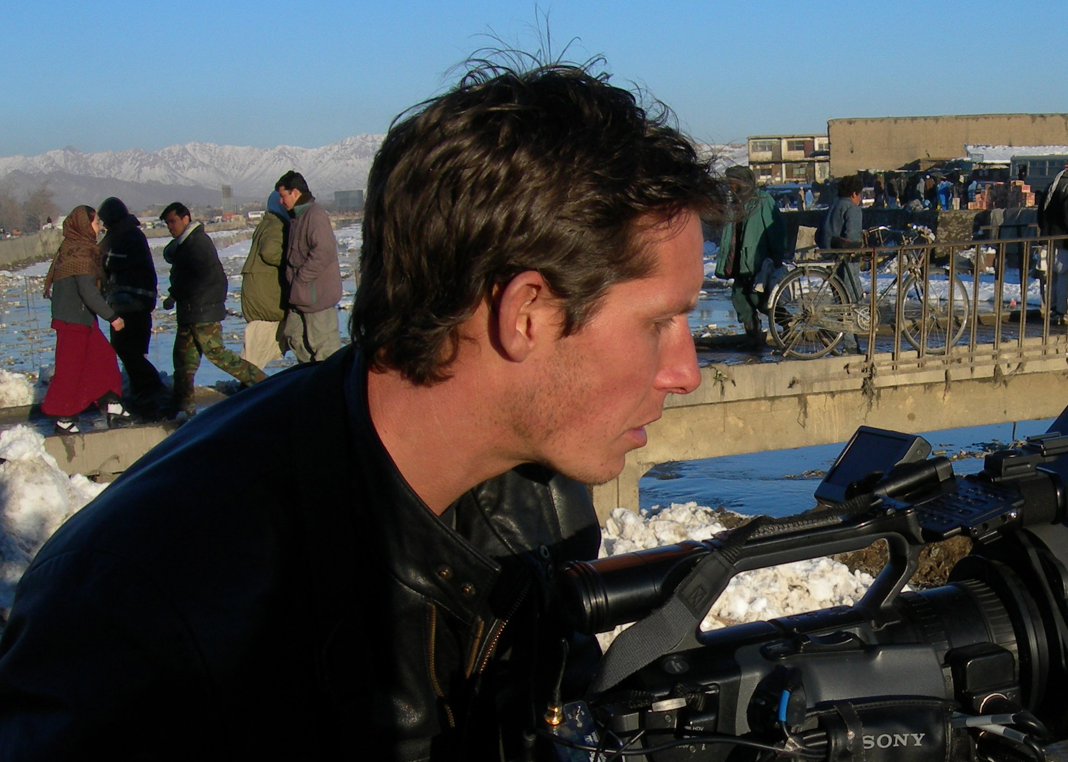JAKE BRYANT: CINEMATOGRAPHER

“…seductive photography lensed by the doc's cinematographer, Jacob Bryant” Moving Pictures Magazine

THE ART STAR AND THE SUDANESE TWINS
Follows the life of world-renowned artist Vanessa Beecroft and her intentions to adopt Sudanese twins. Shot in South and North Sudan, Milan, Venice, LA, London and New York. Shot on S16mm and HDV

DEATH ON THE BEACH
Focusses on whale strandings and the relationship New Zealand history has with whales.

ENDS OF THE EARTH
An extreme observational series looking at New Zealanders making a living in some of the toughest spots in the world. Shot in South Sudan, Afghanistan, Uganda, the Amazon and Kazakhstan.

ICE: THE ANTARCTIC
Five-part series investigating the history of New Zealand in the Antarctic. Shot in Antarctica and New Zealand.

OFF THE RAILS: A LOVE STORY
WINNER OF 3 QANTAS MEDIA AWARDS
Ten part series of a high-rating presenter-led history series tracing the stories behind the New Zealand Railways.

INTREPID JOURNEYS
WINNER OF 4 QANTAS MEDIA AWARDS
Ten one hours of a presenter-led adventure/travel programmes filmed in Myanmar, Mongolia, Syria, China and Russia.

THE REAL OFFICE
One hour documentary about the life of the office worker.

IANI PART 2
Lighting cameraman

PAPA JO
The story of Maori healing and its place today following a renowned healer both in New Zealand and the United States.

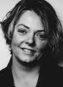MOLLY STENSGAARD: EDITOR
Molly Malene Stensgaard was born in Copenhagen, where she graduated in film editing from the prestigious Danish Film School. Her career is marked with the cooperation with the famous director and her fellow-countryman Lars von Trier. Having worked on almost all of his projects, she has left a permanent mark in Danish cinematography. From 2006–2010 she was commissioning editor for feature film at The Danish Film Institute and she was a jury-member at Berlinale in 2007 and for Short Film at Sarajevo Film Festival in 2010.

2010 Melancholia, director Lars von Trier
2006 The boss of it all, director Lars von Trier
2005 1:1, director Annette Olesen
2004 Manderlay, director Lars von Trier
Smiling in a war-zone, director Simone Kern (docu)
2003 In your hands, director Annette Olesen
2002 Dogville, director Lars von Trier
2001 I am Dina, director O.Bornedal
2000 Portrait of god, director Jon Bang Carlsen (docu)
1999 Dancer in the dark, director Lars von Trier
1997 The idiots, director: Lars von Trier
1996 It’s now or never, director Jon Bang Carlsen (docu)
1995 The Kingdom 5-8, director Lars von Trier
1994 The Kingdom 1-4, director Lars von Trier

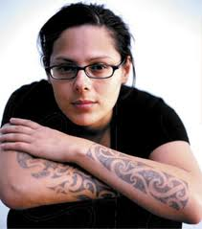ANIKA MOA: COMPOSER AND MUSICIAN
Tribe: Ngāpuhi and Te Aupōuri

Anika Moa and Pietra Brettkelly have collaborated on Pietra’s last seven documentaries. Anika is recognised as one of the industries foremost composers and musicians combining her knowledge of traditional Maori instruments with contemporary influences, in working not just in film scores but album releases.

After 12 years in the music business, numerous Apra Silver Scroll nominations, a debut double platinum album with Thinking Room, platinum status with her third album In Swings The Tide, Anika could be termed a minor veteran.

Evolving from the 18 year old handpicked to discover fame and fortune in New York City – to an industry savvy and undeniable talent. The common thread that ties her humble beginnings to the artist with three poignant and successful albums is her natural knack – an instinctive pop sensibility.

With MAORI BOY GENIUS Anika is drawing on her own upbringing in combining Pacific Island hiphop music and kapa haka (Maori performance) beats to enhance Pietra’s storylines of combining the present day with the mythical past.

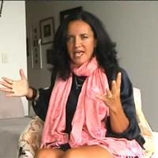JOANNA PAUL: EXECUTIVE PRODUCER
Tribe: Ngai Te Rangi

Executive Summary
- 2002 Maori Television General Manager of Programming Production and Acquisitions
  - Award winning journalism and media personality with more the 25 years experience leading and driving media services and solutions within the print, radio and television sectors.
  - Co-owner of Freckle Films, producer of documentaries, drama nad films.
  - Media strategist and spokesperson for a number of successful companies and Tertiary lecturer.
  - Strong corporate financial competencies, with experience personally developing and monitoring budgets of up to $44M over a 3 year period.

Achievements:
- Successfully consulted (both on and offshore) assessing, buying, producing and scheduling programmes and negotiating contracts for the New Zealand television and film industry.
- Awarded the role of Lecturer in Media Studies with the University of Canterbury and the University of Auckland.
- Consultant Executive Producer – Independent Production Houses
- Experienced in coordinating, facilitating and leading a wide range of media training events with budgets of up to $80K.
- Successfully managed more than 12 charitable events, generating up to $20,000 on each occasion in fund raising.
- Executive Development Producer for a Maori drama series for the New Zealand Film Commission.
- Radio New Zealand News Programme Producer and Newsreader
- Co-Producer of 'This is New Zealand', a weekly television series for US cable television.

Languages
- Fluent (written and oral) in English and Maori.

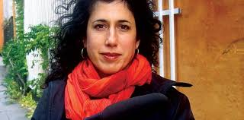JENNIFER FOX: EXECUTIVE PRODUCER

Jennifer Fox is an internationally acclaimed, award-winning director, producer, camerawoman, and educator who has been involved in countless documentaries over the last 25 years. Her first film, BEIRUT: THE LAST HOME MOVIE was released theatrically in nine countries and broadcast in 20 countries. It won seven international awards, including Best Documentary Film and Best Cinematography at the 1988 Cinema Du Reel Festival.

She directed the groundbreaking ten hour PBS/BBC/ARTE television series AN AMERICAN LOVE STORY, which received a Gracie Award for Best Television Series and was named "One of the Top Ten Television Series of 1999" by The New York Times and five other major American papers.

The acclaimed, cutting edge, six-part film FLYING: CONFESSIONS OF A FREE WOMAN was made through a unique Danish-American co-production and was funded by the Danish Film Institute, TV-2 Denmark, BBC, ARTE, YLE-1, SBS, SVT, ICON & Humanist Channels Netherlands, and HBO - and was awarded a prestigious Creative Capital Grant. FLYING premiered at the International Documentary Festival in Amsterdam (IDFA) in 2006 and the Sundance Film Festival in 2007 as Special Events as well as numerous other festivals, and recently completed a 20 city theatrical tour in North America before airing on the Sundance Channel, BBC, TV-2, SVT, and YLE in Summer 2008.

Recently Fox released her new feature documentary, filmed over twenty years, called REINCARNATION, co-produced with the Dutch Buddhist Television Network (BOS) and awarded a prestigious Hartley Film Foundation grant.

Fox has executive produced many films including the award-winners: LOVE & DIANE; ON THE ROPES; DOUBLE EXPOSURE; PROJECT TEN: REAL STORIES FROM A FREE SOUTH AFRICA; COWBOYS, INDIANS, AND LAWYERS; and ABSOLUTELY SAFE? She has consulted on numerous documentaries, including SOUTHERN COMFORT and STONE READER. Fox is one of the subjects of two documentaries on filmmaking, THE HECK WITH HOLLYWOOD! and CINEMA VERITE, DEFINING THE MOMENT. She has lectured and taught master classes on filmmaking at universities, television stations, and for government training programs around the world.

Jennifer has been mentoring and workshopping with Producer/Director Pietra Brettkelly at the Binger Doc Lab, Amsterdam.

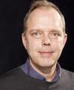MICHAEL HASLUND-CHRISTENSEN: EXECUTIVE PRODUCER

Michael’s company Haslund Film got off to a flying start with “Under New York” (Jacob Thuesen, 1996), a multi award-winning documentary about life in the New York subway. Michael co-produced the feature-length ”My name was Sabina Spielrein” (Elisabeth Márton, 2002), praised by the critics and winner of FIPRESCI Jury Prize in Sochi, Russia.

Michael’s films have explored Asian themes with “The Wild East – Portrait of an Urban Nomad” (Michael Haslund-Christensen, 2002), set in Mongolia’s capital Ulaan Baatar. Also “Larger than Life” (Helle Ryslinge, 2003), which guides us through Bombay’s Bollywood.

Michael has been mentoring and workshopping with Producer/Director Pietra Brettkelly at the Binger Doc Lab, Amsterdam.

Afghan Muscles (executive producer)
2006 The Prize of the Pole (producer)
2003 Larger Than Life (producer)
2002 My Name Was Sabina Spielrein (co-producer: Haslund Film Aps)
2002 The Wild East: Portrait of an Urban Nomade (producer)
2001 The Tools of an Actor (TV mini-series documentary) (producer)
2001 Faith, Love and Charity (producer)
1999 Ludvig and His Passions (producer)
1998 Last Chance (producer)
1997 Eye of the Eagle (producer)
1997 Budbringeren (co-executive producer)
1997 Under New York (producer)
1995 The Girl with Green Eyes (producer)
1991 Jabonah: Journey Into Mongolia (producer)

VICKI JACKWAYS: EXECUTIVE PRODUCER
Vicki has worked in the New Zealand film industry for over 25 years. Before joining Peter Jackson’s post facility Park Road Post Production in Marketing and Production in 2004 Vicki produced local and international television commercials for Flying Fish NZ Ltd.

Vicki is now Head of Marketing at Park Road / LA Representative for Film New Zealand. This new role combines Vicki’s knowledge of production and filming in New Zealand with an understanding of the needs of Hollywood after five years working with studios and producers in this most important market.

This film was made with the support of the Doc Lab and the Binger Filmlab

