POSTER

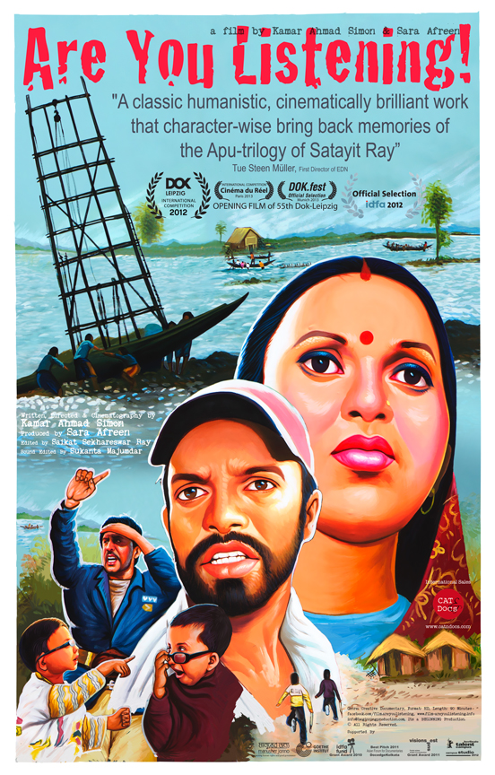
REVIEWS

“A classic humanistic, cinematically brilliant work that character-wise brings back memories of the Apu-trilogy of Satayit Ray”.
Steen Müller, First Director of EDN, Documentary Teacher & Critique

“A gorgeously shot observational documentary… Filming from an unusually low camera angle, he (the director) almost physically drags the viewer into a community”.
International Documentary Film Festival of Amsterdam (IDFA)

“A powerful visual narrative about that most fundamental human instinct – the will to survive, against all resistance and reason”.
Matthias Heeder, Selection Committee, Dok-Leipzig

LOG/ SYNOPSIS/ NARRATIVE

Log line
A mother’s dream, a jobless husband’s frustration and community’s struggle to get back the land lost, since the last tidal surge washed away the coastal belts of Bangladesh.

Short Synopsis
By the coastal belts of Bangladesh, in a small village named ‘Sutarkhali’, RAKHI lives with her man SOUMEN (32) and their son RAHUL (6); fighting against all the odds of the woods, along with around a 100 families, they cultivate the land for generations. On May 27, 2009 when RAHUL is only 4 years old, a tidal surge hits the coastal belts of Bangladesh; for RAKHI, SOUMEN and RAHUL life is not the same anymore. 'Are You Listening!' is about RAKHI’s hope to ensure a dignified future for her son RAHUL; it’s about her jobless husband SOUMEN's frustration for failing to provide for his family and about a community’s struggle to get back the land they have lost.

Seasons change topography, even relations…
yet after the rain...
they go out with spades and shovels
to reclaim the life again,
Are You Listening!

Narrative
“Can’t you build me a playroom mom?”…asks RAHUL (6) as his mother, Rakhi (27), tries to put him to sleep. “Let’s rebuild the dyke first… then we shall build it all again!” consoles Rakhi. For RAHUL, the dyke has been his only playground, since the tidal surge hit their village. Stranded on a narrow strip of land with nothing but water all around… RAKHI, RAHUL, his father SOUMEN (32) and the entire village wait for the rebuilding to start. For RAKHI, this isn’t a question of rebuilding only; it’s her way to regain a dignified life. Between her makeshift school and the roadside den, she builds a small world dreaming of a beautiful tomorrow for her son. When all the village women rush to collect fresh rainwater, RAKHI takes refuge in rain-bath. But SOUMEN doesn’t respond to her call to join! Since the catastrophe hit, he has become nothing but an outnumbered ‘destitute’ listed in the relief card! After all, in this volatile time, who isn’t a destitute? Getting frustrated with his condition, he challenges the local politicians, but even they can’t tell when all these suffering will end.

Season changes topography, even relations… life hangs between the real and the surreal, where children memorise the duties of being a ‘Good Citizen’ and women pass time playing ‘Snake & Ladder’. ‘Waiting’ seems to be the only thing ‘happening’ in this small strip… far from the visible world. Yet they dream, yet after the rain…they go out with their shovels, spades to reclaim the life again!

An uneven battle starts between man and nature to re-write…what seemed to be ‘destiny’.
DIRECTOR’S NOTE
“In preparation of my first feature in 2009, when I have just given up Architecture and a settled career in advertising, a tidal surge hit the coastal belts of Bangladesh. Leaving almost a million homeless, and stranded under the open skies on an age-old dyke. I heard the world buzzing about Climate Change, looking who to take the blame! Living in the comfort of a city, I was privileged to have access to both the global buzz and local visuals. Gothic clay-figures from the daily newspapers started rallying in my dreams; I could hear the footsteps of a million marching forward… bathed in mud and naked. Friends started cracking jokes “Bangladesh may not survive the 21st century”; some even started to opt for migration. Sitting right in the middle of the catastrophe of the millennium, I was a disturbed witness of my time. I stalled my feature project, set out on a local boat and ended up travelling the entire coastal belt in the coming months. I started out in anger… but I returned with hope. I started writing a script for the world to share a tale of believing in breathing, of dreaming and, of celebrating against all reason… Are You Listening!” – Kamar Ahmad Simon
ABOUT THE FILMMAKERS
Writer-Director-Cinematographer

Kamar Ahmad Simon
Kamar Ahmad Simon, born in a traditional Islamic family in Old Dhaka, was trained as Architect and did career in Advertising before turning into filmmaking. His first feature, ‘Shunte Ki Pao!’ (Are You Listening!) - a creative documentary, is the first ever film from Bangladesh invited in the main international competition and also as the ‘Opening Film’ of 55th Dok-Leipzig, the oldest documentary festival of the world. It was one of the ‘Best Pitch’ projects of DocedgeKolkata 2010 awarded by IDFA Fund and Visions Sud Est. Kamar’s first feature script ‘Silence of the Seashell’, awarded by Script Grant from Goteborg International Film Festival, was the only non-European script invited in European Producers Workshop (EAVE) 2012. In pursuit of his passion for Independent Filmmaking, Kamar has initiated a number of national and international film festivals, workshops, etc. He is the founder of ‘Filmy-Bahas’ – an active group of filmy dialogue, discussion and debate in Bangladesh. Kamar is one of the very few local filmmakers who regularly contribute to local publications and enjoys teaching as a part-time faculty in a local university.

About Producer

Sara Afreen
Amongst a handful of young upcoming Producers from Bangladesh, Sara is the first Bangladeshi to be in European Producers Workshop (EAVE) 2012 on full scholarships from CNC and MEDIA Mundus. An Architect-turned-Creative Producer, Sara has produced more than 30 top-rated television commercials, working with almost all the top-chart Commercial Directors from Bangladesh. She has worked as ‘Head of Campaign’ in leading multi-national and groomed a number of new talents in the industry. Today Sara runs her own production studio BEGINNING, that has already produced independent shorts, feature, commissioned projects for broadcasters like NHK and international brands like H&M.

FESTIVALS
OPENING FILM & MAIN INTERNATIONAL COMPETITION: 55th Dok Leipzig, 2012, Germany
REFLECTING IMAGES – PANORAMA: 25th IDFA, 2012, Netherlands
INTERNATIONAL COMPETITION: 35th Cinéma du Réel, 2013, France
OFFICIAL SELECTION: International Documentary Film Festival Munich, 2013, Germany

Credit List
Written, Directed & Cinematography by Kamar Ahmad Simon
Produced by Sara Afreen
Edited by Saikat Sekhareswar Ray
Sound Editing Sukanta Majumdar

FACTSHEET
Original Title: Shunte Ki Pao!
English Title: Are You Listening!
Duration: 90’/ 75’/ 52’
Country of Production: Bangladesh
Language: Bengali
Sub-title: English
Genre: Environment/ Social

