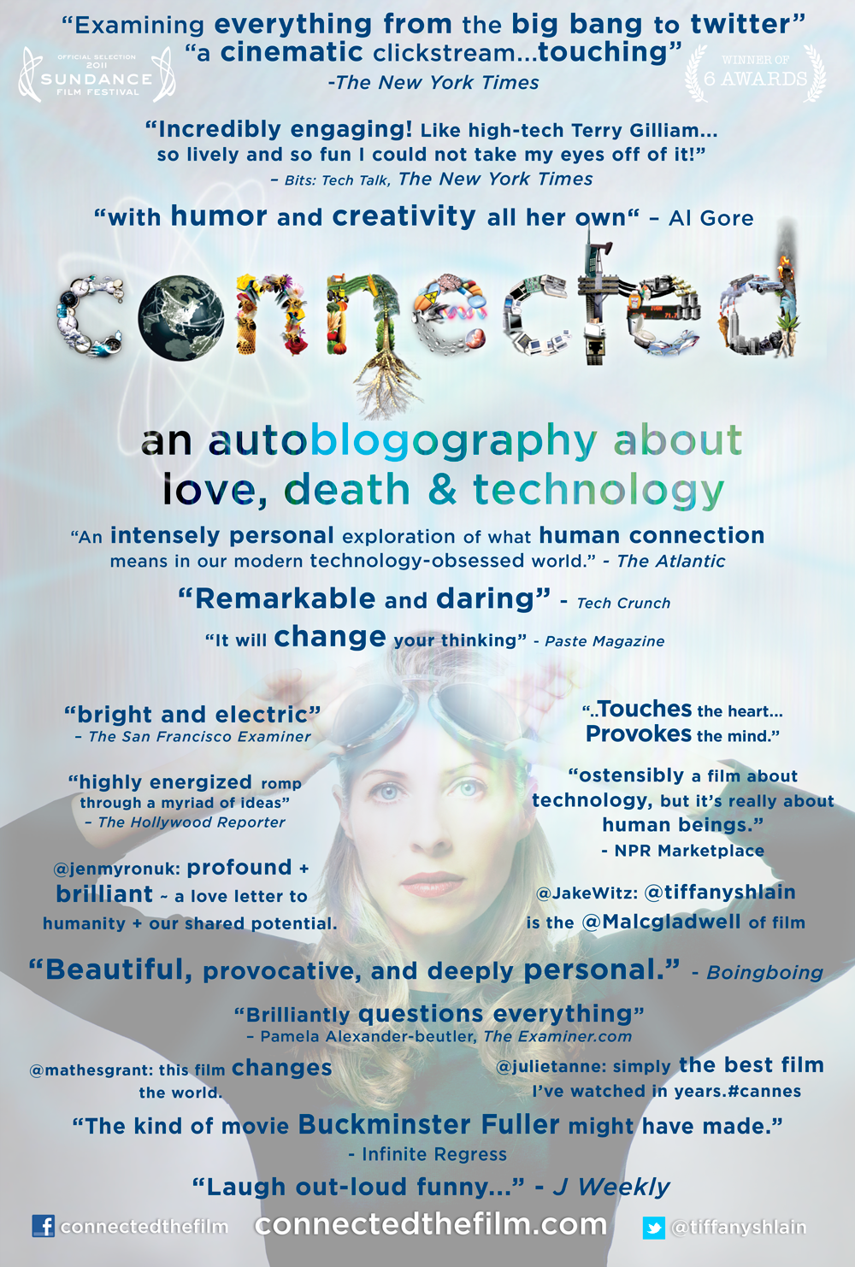
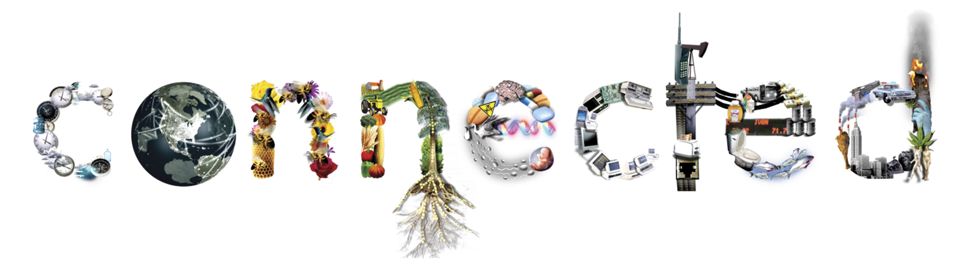
Festivals, Awards & Distinctions:
- World Premiere at the 2011 Sundance Film Festival
- Selected by the State Department to be part of the 2012 American Film Showcase and as the first film to launch the Showcase (June 2012—Capetown, South Africa)
- Inspired a whole lecture series at The Boston Museum of Science
- Over 500 screenings since launch including 38 film festivals including Rio de Janeiro Film Festival, Jerusalem Int'l Film Festival, special screening at Cannes Int'l Film Market, Cleveland Int'l, and many more (complete list at connectedthefilm.com)
- Used in over 150 educational institutions around the world, on 6 continents.
- Many screenings lined up for early 2012, around the United States, Canada, Hong Kong, Singapore, Colombia, Canada, Australia, Israel, England, Poland, Estonia, and many more...
- Connected script included in official Motion Picture Academy Library
- On Paste Magazine's 2011 list of best documentaries
- Winner of 13 awards & distinctions including:
  - Selected for the Disruptive Innovation Award from The 2012 Tribeca Film Festival
  - The Interdependence Film Prize from The Berlin International Film Festival and the Interdependence Movement
  - Best Doc Audience Award from the Maui Film Festival
  - Best of Festival Documentary from the Portland, ME Film Festival
  - Women in Film Award from the National Geographic All Roads Grant at Sundance
  - Honorable Mention from the Jerusalem International Film Festival

SYNOPSIS:
Have you ever faked a restroom trip to check your email? Slept with your laptop? Or become so overwhelmed that you just unplugged from it all? In this funny, eye-opening, and inspiring film, Director Tiffany Shlain takes audiences on an exhilarating rollercoaster ride to discover what it means to be connected in the 21st century. From founding The Webby Awards to being a passionate advocate for The National Day of Unplugging, Shlain’s love/hate relationship with technology serves as the springboard for a thrilling exploration of modern life…and our interconnected future. Equal parts documentary and memoir, the film unfolds during a year in which technology and science literally become a matter of life and death for the director. As Shlain’s father battles brain cancer and she confronts a high-risk pregnancy, her very understanding of connection is challenged. Using a brilliant mix of animation, archival footage, and home movies, Shlain reveals the surprising ties that link us not only to the people we love but also to the world at large. A personal film with universal relevance, Connected explores how, after centuries of declaring our independence, it may be time for us to declare our interdependence instead.

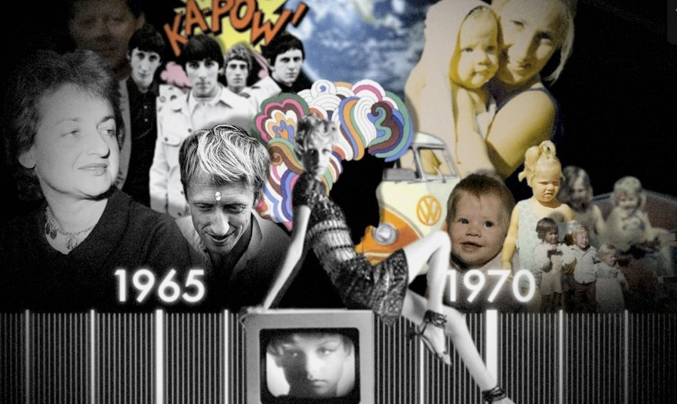

ABOUT THE FILMMAKERS:


TIFFANY SHLAIN, Director
Honored by Newsweek as one of the “Women Shaping the 21st Century,” Tiffany Shlain is a filmmaker, founder of the Webby Awards, and co-founder of The International Academy of Digital Arts & Sciences. A celebrated thinker and catalyst, she’s known for her ability to illuminate complex ideas in culture, science, technology, and life through her unique films, dynamic talks, and innovative projects. She’s delivered the keynote commencement address at UCBerkeley and her films and work have received 50 awards and distinctions. Her last four films premiered at Sundance, including her 2011 acclaimed feature documentary, Connected: An Autoblogography about Love, Death & Technology, which The New York Times hailed as “Examining Everything From the Big Bang to Twitter..incredibly engaging.” Connected had an 11 city theatrical US release this past fall and was just selected by the US State Department & USC as one of the films to represent America at the US embassies around the world for The 2012 American Film Showcase that kicks off in South Africa in June. She is currently working on a new film series that employs a new way of making films that she calls, CLOUD FILMMAKING. The film series, Let it Ripple: Mobile Films for Global Change, will include twenty 4-minute films about important aspects of life that will then be offered for free with custom endings to organizations around the world to help further their mission. The first film, A Declaration of Interdependence, with music by Moby, has been translated into 65 languages and has been customized for free for over 100 organizations. The next two films in the series that Tiffany and her film studio are in production on are Brain Power, which explores the best way to nurture young children’s brains as well as the global brain we are creating via the Internet, and Engage, about the importance of engaging in society. They will both be released fall 2012. She just published a “Cloud Filmmaking Manifesto” at The Tribeca Film Festival where she received a 2012 Disruptive Innovation Award. She has been called the “Malcolm Gladwell of film,” and her work has been described as “the kind of films Buckminster Fuller would have made.” Tiffany is a Henry Crown Fellow of The Aspen Institute, a member of the advisory board of M.I.T.’s Geospatial Lab and The Institute for the Future.
CREDITS:
Written by Tiffany Shlain, Ken Goldberg, Carlton Evans, and Sawyer Steele
Narrated by Peter Coyote
Edited by Tiffany Shlain and Dalan McNabola
Animation by Stefan Nadelman
Composed by Gunnard Doboze

Connected’s original animations are by Stefan Nadelman, who won Grand Jury prize at Sundance for his short film Terminal Bar. The writing team includes Tiffany Shlain, acclaimed filmmaker and University of California, Berkeley Professor of Robotics, Ken Goldberg Ph.D, Carlton Evans Ph.D, and Sawyer Steele. Composer Gunnard Doboze scored the 2009 Oscar-nominated Last Campaign of Governor Booth Gardner. Narrator Peter Coyote is an Emmy Award- winning film, stage, and television actor and voiceover artist who has appeared in over 100 films, and narrated over 165 documentaries.
The supporters of this project include Impact Partners headed by Dan Cogan and Geralyn Dreyfous, the executive producer of the 2004 Oscar-winning documentary, Born Into Brothels. Impact Partners is a film fund for investors and philanthropists who seek to promote social change through film. Since its inception less than three years ago, Impact Partners has been involved in the financing of over 25 films, including two that have received Academy Awards—The Cove and Freeheld—and The Garden, which was nominated for an Academy Award for Best Documentary Feature in 2009. Other supporters of this project include Executive Producers Sarah Johnson Redlich, and Pam Boll.

ABOUT OUR DISTRIBUTION:

THE MOXIE INSTITUTE film studio is known for distributing socially minded films in exciting new ways by coupling traditional media like films, books, and live events with new technologies to engage people with the important questions of our day. Their previous project, The Tribe, was singled out by The Sundance Institute, The New York Times, and Variety as an example of innovative distribution using the Internet, and was the first documentary to reach #1 on iTunes.

One year after the Connected world premiere at Sundance, The Moxie Institute team is having great success employing a combination of traditional distribution channels and new forms of self-distribution. Connected had a US theatrical release with Paladin in 11 cities, held over in 5 cities including New York City. After the theatrical release, Connected began a worldwide community screening tour where people can host their own screenings or hold fundraisers to raise money for non-profit organizations. They also launched the Connected Educator’s Edition, a discussion kit that includes a university curriculum to help educators bring these conversations about interdependence into the academic sphere, the Connected Companion Book: A Complete Guide to the Universe and Everything in It (Condensed Version), and a deck of conversation cards with images from the film, facts, and thought experiments to help take the conversation further. Ro*co Films, the international distributor, has made deals with Canada and Israel, with many more in the works. Still to come in 2012: New Video will be releasing VOD and DVD in late 2012 along with a home use version of the discussion kit, the mobile phone app including online discussion tools and ways to declare your interdependence. You can find out more about all of the distribution plans at connectedthefilm.com.

CONTACTS:
INTERNATIONAL DISTRIBUTOR DIRECTOR OF MARKETING & DISTRIBUTION
Christine Dewey, International Sales Simone Nelson
Ro*co Films International, LLC The Moxie Institute
cristine@rocofilms.com simone@connectedthefilm.com
(415) 332-6471 x201 310-422-1604

DIRECTOR
Tiffany Shlain
The Moxie Institute
t@tiffanyshlain.com
415-380-0881

View Trailer and find out more information at:
www.connectedthefilm.com

connectedthefilm  @tiffanyshlain

