C-LINE FILMS
Presents

FAMILY AFFAIR
A Film by Chico Colvard

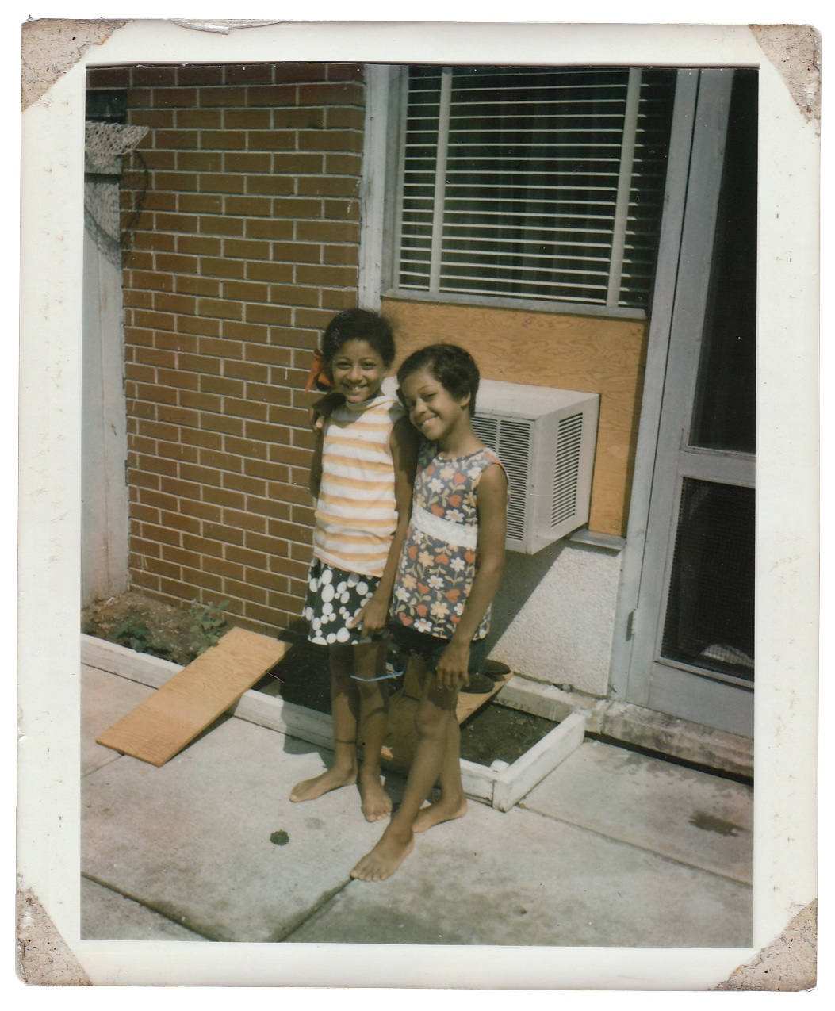

Sundance Film Festival 2010
Documentary Competition - World Premiere

Media Contacts:

David Magdael and Associates
Los Angeles
213-624-7827

David Magdael – 213-399-1434
dmagdael@tcdm-associates.com

Winston Emano – 310-739-0946
wemano@tcdm-associates.com
FAMILY AFFAIR
A FILM BY CHICO COLVARD
SHORT SYNOPSIS

Like a scene torn from The Color Purple or Capturing the Friedmans, filmmaker Chico Colvard’s deeply personal and uncompromising documentary, FAMILY AFFAIR, examines the complex levels of pedophilia and how it can manipulate and control an entire family for life. This is also a story about resilience, survival and one's capacity to accommodate a parent's past crimes in order to satisfy an eternal longing for family.

At 10 years old, Chico Colvard shot his older sister in the leg. This seemingly random act detonated a chain reaction that exposed unspeakable realities and shattered his family. Thirty years later, Colvard ruptures veils of secrecy and silence again. As he bravely visits his relatives, what unfolds is a personal film that’s as uncompromising, raw, and cathartic as any in the history of the medium.

Driving the story forward is Colvard’s sensitive probing of a complex dynamic: the way his three sisters survived severe childhood abuse by their father and, as adults, manage to muster loyalty to him. These unforgettable, invincible women paint a picture of their harrowing girlhoods as they resiliently struggle with present-day fallout. The distance time gives them from their trauma yields piercing insights about the legacy of abuse, the nature of forgiveness, and eternal longing for family and love. These truths may be too searing to bear, but they reverberate powerfully within each of us.

FAMILY AFFAIR does not attempt to mitigate the long-term dysfunctional impact of incest. Instead, this documentary reshapes the commonly held view that molesters are pushed to the margins of society, never to reconnect with their victim/survivors. In the end, the film focuses on the motives, accommodations and levels of forgiveness survivors make in order to maintain some semblance of family.

FAMILY AFFAIR
A FILM BY CHICO COLVARD
SYNOPSIS

My mother is a German-Jew, born during WWII. By contrast, my father is an African-American, who was raised in the segregated south of Georgia. My three older sisters and I are a remarkable mix of our parents and were affectionately referred to as "Army Brats" growing up. Although we were raised on a number of military bases around the world, it was in Radcliff, Kentucky, a small town outside of Fort Knox, where our lives were changed forever.

Growing up I fantasized about being Chuck Connors in THE RIFLEMAN. At the age of ten I discovered my father’s military rifles and accidentally shot one of my sisters in the leg. Believing she would die from her injuries, my sister revealed to my mother and later the police, that our father had sexually abused her and my other two sisters for years. I witnessed my father’s arrest and the unraveling of our family. My parents divorced. My sisters and I were sent to foster homes and unwelcoming relatives, who blamed my mother for having their brother (my father) arrested. My father was found guilty of sexual assault in the 1st degree and sent to a Kentucky minimum-security prison on Valentine's Day, 1979. He was released less than one year later.

As I grew older and came to understand the full magnitude of what my father did to my sisters, I began to detest the man I once admired as a kind of "G.I. Joe" action hero. As a result, I cut off contact with my father for more than fifteen years. Surprisingly, all three of my sisters continued seeing my father immediately after he was released from prison, spending weekends and holidays at his home and even leaving their children (his grandchildren) alone with him from time-to-time. In 2002, while visiting one of my sisters in Kentucky, my father arrived at a Thanksgiving dinner and was warmly welcomed by a number of adoring family members, my sisters and friends. Although I did not know it at the time, this would be the start of my documentary FAMILY AFFAIR.

At first, this documentary ran the risk of turning into a crude indictment of my father, a figure the audience is sure to view as a "monster". While that assessment might be unavoidable, I do not want the audience to only view him or other pedophiles as a one-dimensional "monster-like" figure. In point of fact, in the USUAL SUSPECTS Kevin Spacey's character, Verbal Kint, a seemingly crippled con man, explains to one of the investigating officers that "Keyser Soze," an omnipotent, “monster-like” figure was, in fact -- real. Spacey tells the doubting detective that the greatest trick the devil ever played was convincing the world that he did not exist. Similarly, my father's health is ailing. Overweight and with the right side of his body atrophied from multiple strokes, he no longer resembles the menacing figure embedded in my childhood memories. And while he remains in denial about the unspeakable atrocities he committed against my sisters, I can't help but feel that the companionship my sisters share with him makes them complicit in his attempts to convince the world that he too is not a monster.

FAMILY AFFAIR does not attempt to mitigate the long-term dysfunctional impact of incest. Instead, this documentary reshapes the commonly held view that molesters are pushed to the margins of society, never to reconnect with their victim/survivors. In the end, the film focuses on the motives, accommodations and levels of forgiveness survivors make in order to maintain some semblance of family.

FAMILY AFFAIR
A FILM BY CHICO COLVARD
DIRECTOR’S STATEMENT

When I first started this project, I didn't know I was making a "documentary," it felt more like I was lawyering with a camcorder: gathering eyewitness testimony, preparing evidence and arguments to present later at trial. I wanted to playback for my sisters how every time we got together, the cordial conversations and light banter inevitably digressed into sorrowful accounts of a troubled past. I wanted to redirect their rage toward our father.

In 2002, my sisters invited me to spend Thanksgiving with them in Kentucky. It was only after I arrived that I learned my father would be there. I hadn’t seen him since severing ties 15 years prior. As he walked through the door, I watched my sisters, their children and neighbors warmly greet him. They laughed at his pithy remarks and catered to his every need. It was absurd. Disturbing. And rather than indict him, as I had practiced in my mind a thousand times, I was reduced to a terrified child, hiding behind my camcorder. All I could muster up the courage to say is, “Hey, how are you?” as he walked toward me and filled the frame. I felt like a coward
.
After returning to Boston, I was ashamed at my lack of bravery, at my failure to challenge my father and rally my sisters and neighbors behind me. In time, I came to discover that this was the story ‐‐ the part no one talks about when it comes to incest and families in crisis. Why were my sisters and others accommodating this man, who did these terrible things? The way I’d always seen child molestation presented in the media was much cleaner: The abuse is brought to light, then the abuser and victim‐survivor go their separate ways ‐‐ the abuser banished to the margins of society, the victim‐survivor left to recover. Never did the two voluntarily reunite and forge a seemingly “normal” father‐daughter relationship.

Filming took a toll on me both physically and emotionally. To sit with my father and listen to his opinions was difficult, but necessary. I feared that he retained control over me and this project. As a key subject in the film, he possessed the power to derail it simply by saying, “I don’t wish to participate.” He could opt to not sign a release form, demand I turn off the camera, or simply ask me to leave. The discomfort of having to sit in my father’s presence, absorb the gravity of my sisters' experience and document my mother's long absence – the emotional impact of it all wouldn't quite sink in until I returned home and began to sit with the footage. It was only then that the truth of this story – my story – dug its way into my soul, often shutting me down for days.

As I increasingly spent less time teaching and more of my time dedicated to this project, people would ask, “So what’s your film about?” A seemingly innocuous question that I had difficulty answering. As I danced around the subject, searching for the right words to talk about this taboo ‐‐ this terrible thing that’s not suppose to happen, but in fact does, I’d watch people recoil, change the subject or simply walk away. In time, the gradual support of key funders and well respected members of the film community not only lent credibility to the project, but gave people, myself included, permission to talk more openly about the troubled complexities of family.

Inevitably, some will reduce FAMILY AFFAIR to an “incest” film. Clearly that crime lies at the heart of this project, but I chose to make a film that does not solely define my sisters by the worst act that happened to them as girls. Their story should resonate with anyone who’s found him‐ or herself making accommodations for a parent, who was abusive, neglectful or harmful in some way. I meet a number of people after screenings who say that, although they weren’t molested as a child, they have painful memories of a parent who was an alcoholic, verbally abusive, self‐absorbed, cheated on their mother, or committed some act of betrayal, and that today they find themselves still struggling with their past. Mostly, they say, that’s because they find themselves complicit in creating the illusion of a happy, healthy, cohesive family. Exploring that complicity, as much as exposing the original crimes my father committed, became my intent in making this deeply personal film.

– Chico David Colvard
FAMILY AFFAIR
A FILM BY CHICO COLVARD
CREW BIOS

Chico David Colvard | Director/Producer
Chico was born in Augsburg, Germany, the son of a WWII German‐Jewish mother and African-American father raised in the segregated south of Georgia. After pursuing a career in theatre arts, Chico received his J.D. from Boston College Law School and now teaches “race, law & media” related courses at the University of Massachusetts, Boston. He is a former Filmmaker-in‐Residence at WGBH in Boston, a member of the Producer’s Lab at Firelight Media and arecent Sundance Institute Creative Producing Fellow. FAMILY AFFAIR has received a number of grants including the LEF Moving Image Fund and Paul Robeson Fund for Independent Media. FAMILY AFFAIR is Chico’s feature‐length documentary debut and premieres in competition at Sundance.

Rachel J. Clark | Editor
Rachel is an Emmy award winning video editor currently residing in Boston. Born in Scotland, and raised mostly in Yorkshire and Bristol, she moved to the States as a teenager. She received her BFA in painting and printmaking from Carnegie Mellon University in Pittsburgh, where she graduated with honors. For the past 10 years, she has been employed as a professional video editor both in London, UK and Boston, MA. She has worked for such notable clients as the History Channel, the Discovery Channel, the BBC, Errol Morris, PBS, Avid Technologies, and Cinemax. A 3‐time Emmy nominee, she recently edited the award winning HBO documentary 'Have You Seen Andy?'

Producer | Liz Garbus
Liz Garbus co‐founded Moxie Firecracker, Inc. - an independent documentary production company, with filmmaker Rory Kennedy in 1998. Her directorial credits include “The Farm: Angola, USA,” which was nominated for an Academy Award®, and won two Emmys® and the Sundance Grand Jury Prize; “The Execution Of Wanda Jean” (HBO); “The Nazi Officer’s Wife” (A&E); “Girlhood” (Wellspring/TLC); and “Xiara’s Song” (HBO). Most recently she produced “Yo Soy Boricua!, Pa Que Tu Lo Sepas” for IFC, a film about Puerto Rican culture, directed by Rosie Perez. Last year, Garbus and Rory Kennedy executive produced the Academy Award®‐ nominated “Street Fight.” She recently completed a documentary for HBO, “Shouting Fire: Stories from the Edge of Free Speech."

Composer | Miriam Cutler
Los Angeles‐based film composer Miriam Cutler has been writing, producing, and performing music for over 20 years. Her evocative scores have graced numerous narrative features and award‐winning documentaries, as well as television, corporate videos, cartoons, and even two circuses. She's known for her versatility, her soulful integration of world music styles, and her enthusiasm for working collaboratively.

Cutler began her musical career as a singer/horn player in several bands, including the popular MYSTIC KNIGHTS OF THE OINGO BOINGO. She also led THE NEW MISS ALICE STONE LADIES SOCIETY ORCHESTRA and the jazzy SWINGSTREET, writing most of their music and arrangements, producing several recordings, and touring with them. Her love of jazz also led to a stint co‐producing albums for Polygram‐Verve including Joe Williams (nominated for a Grammy), Nina Simone, Marlena Shaw, and Shirley Horn. Miriam has served on documentary juries including the first‐ever World Cinema Documentary competition at Sundance, The Independent Spirit Awards, International Documentary Association Awards, and American Film Institute's Film Festival Awards. She also serves on the Board of The Society of Composers and Lyricists and has been an advisor for the Sundance Institute’s Composers Lab.

Executive Producer | Dan Cogan
Dan is the co‐founder of Impact Partners. He is also the founder of DMC Films, a film production company based in New York. DMC Films is devoted to discovering emerging voices in documentary and fiction film and to exploring new models of independent film finance. DMC Films currently has projects in development with Universal Studios, New Line Cinema and Casey Silver Productions.

In 2006, Mr. Cogan launched the Chrysler Film Project. This screenwriting and directing competition, underwritten by Chrysler, sought to identify an important new voice in American independent film and finance their feature film. In launching the program, Mr. Cogan oversaw the screenplay and directing competition and secured co‐financing for Chrysler for the winning film. The winning project, Derek Cianfrance's BLUE VALENTINE, goes into Production in August 2008, starring Ryan Gosling and Michelle Williams. Mr. Cogan's credits include The Lifestyle, a feature‐length documentary about middle‐American swingers directed by David Schisgall and executive produced by Ted Hope and James Schamus; and Torte Bluma, a short film based on the true story of Nazi death camp commandant Franz Stengl. Torte Bluma was directed by Benjamin Ross (RKO 281, The Young Poisonner's Handbook) and stars Stellan Skarsgard and Simon McBurney. Before entering the film business, Mr. Cogan worked as a speechwriter for Senator Edward M. Kennedy of Massachusetts and as a journalist, writing for The New Republic, The New York Observer and The Washington Monthly. Mr. Cogan received his B.A. from Harvard University, Magna Cum Laude, and attended the Film Division at Columbia University's Graduate School of the Arts.

Executive Producer | Abigail Disney
Abigail Disney is a filmmaker and philanthropist. Her first film, a feature‐length documentary called Pray the Devil Back to Hell tells the inspirational story of the women of Liberia and their efforts to bring peace to their broken nation after decades of destructive civil war. It won the 2008 Tribeca Best Documentary award and is currently playing in theaters. She is also involved in producing a number of other documentaries with social themes, and is developing a four hour project for WNET/Wide Angle called Women, War & Peace.

Along with her husband, Pierre Hauser, Abigail is also co‐Founder and co‐President of the Daphne Foundation, a progressive, social change foundation that makes grants to grassroots, community‐based organizations working with low‐income communities in New York City. Since 1991, the Daphne Foundation has made millions of dollars in grants in areas ranging from women’s rights to AIDS advocacy, children’s health, labor conditions, incarceration, and community organizing. Over the years Abigail has played a critical role in a number of different social and political organizations. She currently serves on the boards of the Roy Disney Family Foundation, the White House Project, the Global Fund for Women, and the Fund for the City of New York, as well as the advisory boards of a broad range of organizations working in the areas of poverty, women’s issues, education and environment.

Abigail received her Bachelors degree from Yale University, her Masters degree from Stanford University, and her Doctorate from Columbia University. She lives in New York City with her husband and their four children.
FAMILY AFFAIR
A FILM BY CHICO COLVARD
TOPIC SUMMARY

“THE ORDINARY RESPONSE TO ATROCITIES is to banish them from consciousness. Certain violations of the social compact are too terrible to utter aloud: this is the meaning of the word unspeakable.”
Judith Herman, M.D.

Once sexual abuse survivors break their silence, they are often cast to the margins of society. This is not always the case for offenders. Incest is a taboo because it is not supposed to happen, but in fact it does. Studies from the National Crime Victimization Survey, Bureau of Justice, National Institute of Justice and the FBI show that nearly 25% of all women are sexually abused by someone they know during childhood – so family members are often implicated. FAMILY AFFAIR speaks to any number of people affected by sexual assault and those who can identify with what it means to be a survivor. Dr. Judith Herman, a Clinical Professor of Psychiatry at Harvard Medical School and Director of Training at the Victims of Violence Program in the Department of Psychiatry at the Cambridge Hospital, states in her book FATHER DAUGHTER INCEST that the incestuous father and their families are made-up of a wide cross-section of society; including, but not limited to the unemployed, house wives, artists, lawyers, rabbis, priests and teachers – all from various ethnic backgrounds, religious affiliations and social classes. Incest, like rape, is a weapon of war. It is used as a display of power and dominance in the confines of prison, dark alleyways, and rural farmlands. Child sex abuse also occurs in seemingly safe cookie-cutter suburban homes, as well as the bedrooms of children living in the depressed neighborhoods of the inner city. Somewhere along this stretch of humanity lies my family. Dr. Judith Herman also states in her second book TRAUMA AND RECOVERY that “[i]n the second stage of recovery, the survivor tells the story of the trauma. She tells it completely, in depth and in detail. This work of reconstruction actually transforms the traumatic memory, so that it can be integrated into the survivor’s life story.” This act of uncovering the past has an empowering effect on the survivor. To that end, FAMILY AFFAIR works as an ally for the survivors, empowering them to confront the horrors of their past and to do so in a safe environment. One of my sisters said that she was looking forward to seeing the completed film – to hearing my father’s responses to questions she never felt safe asking him face-to-face and to do so in an environment where she knew he could not “get her.” This documentary intends to serve as a safe passage to recovery for women, girls and others who have survived sexual abuse.

FAMILY AFFAIR approaches this topic from a deeply personal and uncompromising vantage point – presenting to its audience a more complicated way to view child molesters and the, often times, ongoing relationship with their victim/survivors. Still, it is important to stress that this is not just a film about “incest.” It is also a portrait of a family that struggles with common issues we all face – from mental illness, race and membership, to isolation and abandonment. FAMILY AFFAIR reveals that no one is ever just a victim nor solely defined by what happens to them as a child. This documentary adds the shades of gray to what surviving means in a larger universal context. In so doing, I examine the ways my father capitalized on isolating my mother and sisters in a society that criminalized interracial marriages until the 1967 Loving v. Virginia U.S. Supreme Court case, which made it unconstitutional for states to enforce anti-miscegenation laws. I also explore the failed legal response to domestic violence in the 1960s and 1970s, when there were virtually no support services or police protection for battered women – even fewer for a German-Jew (“nigger lover”) with bi-racial children living in states like Kansas and Kentucky. Mandatory arrest laws and restraining orders would not come into effect until the 1980s – a time when it was already too late for my mother and sisters to escape the isolation and terror they suffered at the hands of my father. Their story is a relevant and timeless one about resilience, surviving and having the capacity to accommodate a parent’s unspeakable atrocities in order to restore one’s fundamental longing for family.

FAMILY AFFAIR
A FILM BY CHICO COLVARD
CREDIT LIST

directed and produced by | Chico Colvard

produced by | Liz Garbus

edited by | Rachel J. Clark

executive producers | Dan Cogan and Abigail Disney for Fork Films

original score by | Miriam Cutler

piano | Deborah Sealove
harp | Stephanie Bennett
clarinet | Micky Summers
strings | Pasa Doble
electric & accoustic guitars | Ira Ingber
arco bass | Carl Sealove -
guitarviol | iZler

orchestrator | Desha Dunnahoe

mixing engineer | Les Brockmann

writer | Chico Colvard

consulting editor | Sam Pollard

assistant editor | Sauli Pillay

additional camera work | Marcus Fletcher
Rachel J. Clark
Jennifer Pearce

web designer | Rinze van Burg and Modulus

legal assistance | Sandy Forman
Jodi K. Hanover

publicist | David Magdael & Associates

production assistants | Sonia Weinhaus
Jennifer Pearce

archival coordinator | Serin Marshall

archival | The Rifleman ®
Levy-Gardner-Laven Productions, Inc.
Artbeats ®
U.S. Army History Institute
istockphoto
AP Images
Library of Congress
Butler Center for Arkansas Studies
Center for American History, University of Texas, Austin

animation | Handcranked Productions

post house | Eric Masunaga, Evan Schwenterly,
Joe Boyd Vigil

fiscal sponsors | The Center for Independent Documentary
The Pan African Forum

funding | LEF Moving Image Fund
The Color of Film
Impact Partners
Harold Simmons Foundation

advisors | Steven Shainberg
Tina DiFeliciantonio
Macky Alston
Robb Moss
Stanley Nelson

thanks/supporters | Caroline Berz
Berz Family
Colvard Family
Robert Johnson
Amy Merrill
Casey Riley & Robert Bertrand
Betty & Larry Silk
Chi-Ho Lee
Isabel Garcia
Maddy Barr O’Leary
Laura Barr & Jean O’Leary
Pietre Valbuena
Cheryl Eagan-Donovan
Donald & Erica Stern
Sarah E. Herman
Margot & Terry Strom
Jong Kyu Choi
Eileen & Paul Shakespear
Chadwick J. Johnson
Susanna Hall
Jay & Susan Kaufman
Debra A. Bramble
Jessica Engel & Scott W. Helman
Robert & Dale Mnookin
Dr. Aziza Bey
Clarence & Jennifer Clark
Lewis E. Feibelman
Peggy Kemp
Kerri Pulo-Ryan
Justin Mahoney
Melanie Perkins
Shoshanna Ehrlich
Janet Picinich
Tamela Roche
Amy Shatsky
Geralyn Dreyfous
Betsy Healy
Lisa Simmons
Serena Simmons Connelly
Susi Walsh
Kathryn Ostermier
Lyda Kuth

special thanks to my sisters | Angelika, Paula & Chiquita

produced in association with | Impact Partners
Firelight Media
WGBH

Moxie Firecracker Films
C-LineFilms

