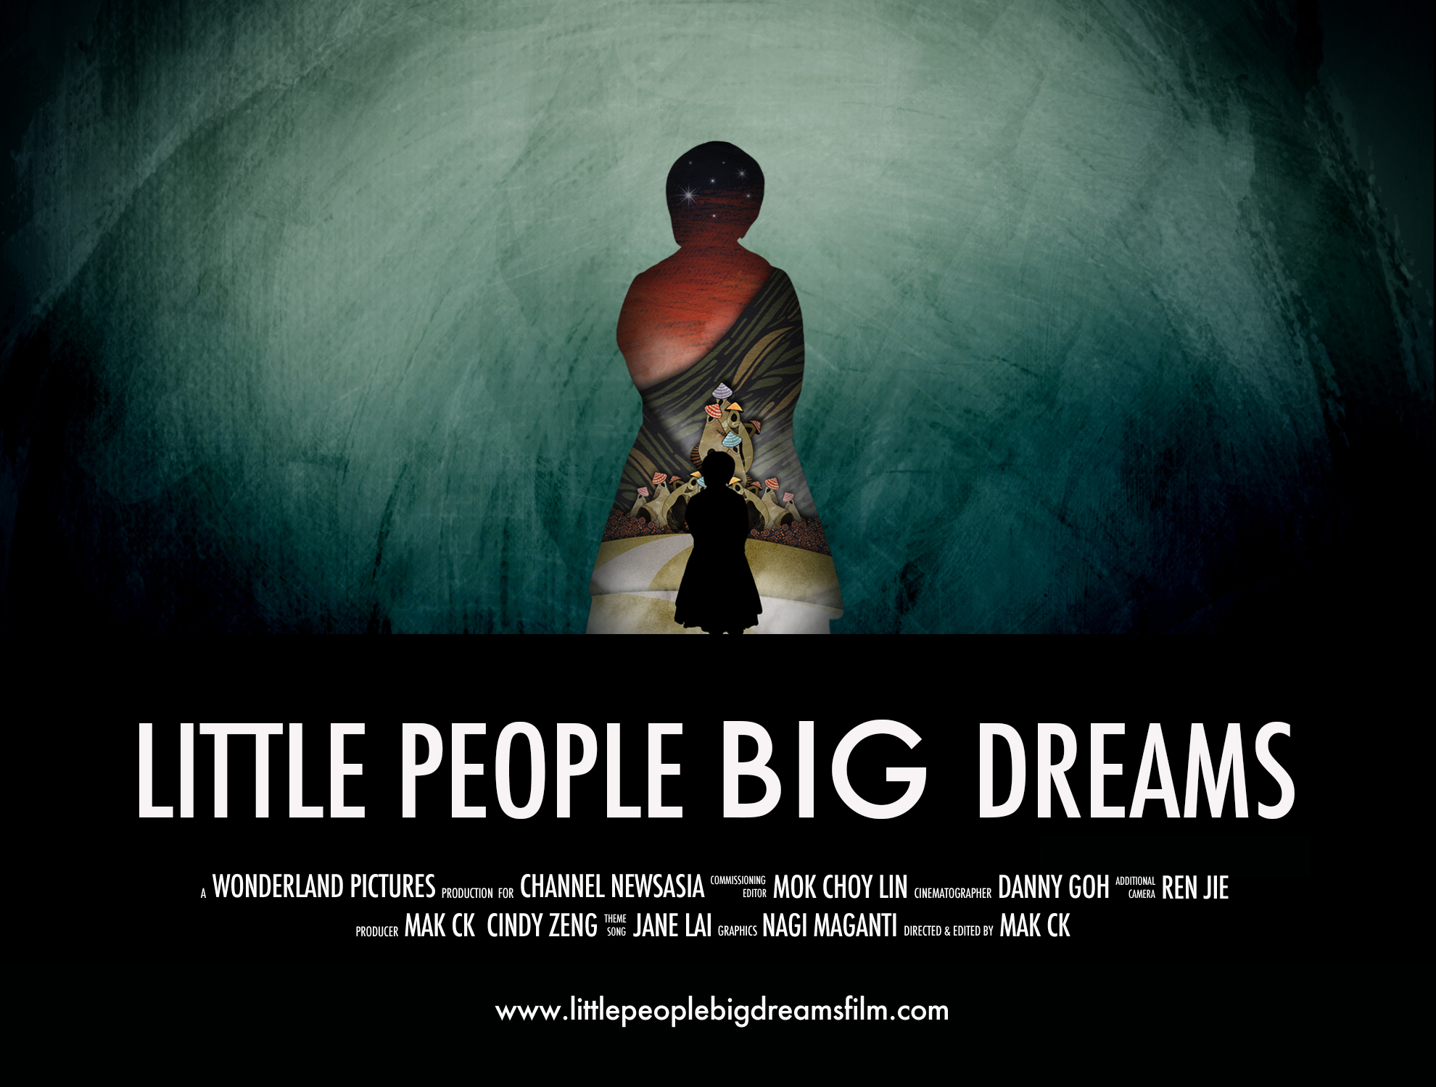

International sales :

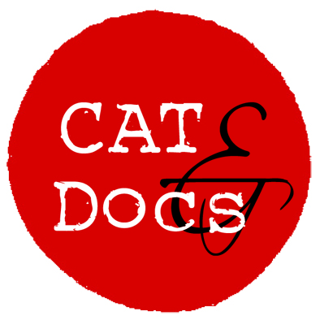
CAT&Docs
cat@catndocs.com
www.catndocs.com

SYNOPSIS

Go behind the curtains of the most unlikely kingdom on earth. This is China's Dwarves Empires, where little people stand tall. Or do they? Join them on a journey in the pursuit of dreams and a life of happiness, against all odds.
A millionaire wanted to create a utopia for little people in China. A land where they could live and work among themselves, away from the discrimination of mainstream society. And so the ‘Dwarves Empire’ was born. This is an unlikely theme park where dozens of little people reside and perform for anyone who pays a US$16 entrance fee. Tourists can enjoy a fantasy world where little people work in mushroom houses, dress in fairy tale costumes and put on a variety of performances.
This observational documentary chronicles the journeys of a few employees at a pivotal point in their lives. A change of heart, a secret escape, a struggle to find true love and a venture beyond the confines of the ‘Dwarves Empire’ lead to vastly different experiences. Connected by a will to pursue their dreams and a life of happiness, these little people take their chances in an uncertain world. For some, their destinies are forever changed. ‘Little People Big Dreams’ explores the cost of prejudice and the shades of modern-day morality.

DIRECTOR'S STATEMENT
When I first read about the theme park online, I was immediately intrigued by the existence of such a bizarre attraction in this day and age. I have always been interested in microcosms of society. And communities that are discriminated or gravely under-represented in the media.
‘Little People Big Dreams’ checks all boxes. Through this film, I've had the privilege of learning about the lives of little people in the world’s most populous nation. The personal life stories featured in the film are both heartbreaking and inspiring. Their pains, triumphs and dreams are a lot more similar to those of average-sized people than largely perceived. This is a universal tale about the pursuit of happiness.
Over the course of making this film, I struggled with how I feel about the park. And I've come to realise that many a time, morality comes in different shades of grey.


ABOUT THE DIRECTOR
Mak CK’s debut documentary feature film, 'The World's Most Fashionable Prison', about a fashion rehabilitation programme in the Philippines’ largest maximum security prison is an official selection at over 15 film festivals including the prestigious Hot Docs Canadian International Documentary Festival 2012. It received the ‘Audience Award’ for Documentary Film at the Lighthouse International Film Festival and the ‘Gold Kahuna Award’ for Documentary Film at the Honolulu Film Awards.
With over a decade of experience working in television, Mak is a multi-award-winning director-producer with a portfolio that includes projects for National Geographic Channel Asia, A+E Networks Asia, Discovery Networks Asia, Star TV, MTV Asia, Disney Channel Asia and Channel NewsAsia. Having filmed in 22 countries worldwide, he has produced and directed over 30 factual TV series and documentaries. His multiple wins at the New York Film and TV Festival include a Best Direction Silver World Medal for ‘China Close Up’ in 2014.

THE TEAM
DIRECTED & EDITED BY
Mak CK
PRODUCED BY
Mak CK & Cindy Zeng
CINEMATOGRAPHY
Danny Goh
ADDITIONAL CAMERA
Ren Jie
GRAPHICS
Nagi Maganti
THEME SONG
Jane Lai
FESTIVAL MANAGER
Stephanie Holzhuber
WEBSITE
Thomas Wagner
COMMISSIONING EDITOR (FOR CHANNEL NEWSASIA)
Mok Choy Lin

