The Orchard Presents
An A&E IndieFilms
Our Time Projects and Documentary Group Production
In Association with Whitewater Films

CARTEL LAND

A Film by Matthew Heineman

Executive Produced by Kathryn Bigelow

2015 SUNDANCE FILM FESTIVAL
Winner: Best Director US Documentary
Winner: Special Jury Award for Cinematography

100 MIN / U.S.A / COLOR / 2014 / ENGLISH & SPANISH

Press Contacts:
Strategy PR (NY)
Chanelle James
646.918.8736
Chanelle.James@StrategyPR.net

Elizabeth Kushel
646.918.8156
Elizabeth.Kushel@StrategyPR.net

Acme PR (LA)
Nancy Willen
nancywillen@acmepr.net

http://cartellandmovie.com/
SYNOPSIS

With unprecedented access, CARTEL LAND is a riveting, on-the-ground look at the journeys of two modern-day vigilante groups and their shared enemy – the murderous Mexican drug cartels.

In the Mexican state of Michoacán, Dr. Jose Mireles, a small-town physician known as "El Doctor," leads the Autodefensas, a citizen uprising against the violent Knights Templar drug cartel that has wreaked havoc on the region for years. Meanwhile, in Arizona's Altar Valley – a narrow, 52-mile-long desert corridor known as Cocaine Alley – Tim "Nailer" Foley, an American veteran, heads a small paramilitary group called Arizona Border Recon, whose goal is to stop Mexico’s drug wars from seeping across our border.

Filmmaker Matthew Heineman embeds himself in the heart of darkness as Nailer, El Doctor, and the cartel each vie to bring their own brand of justice to a society where institutions have failed. From executive producer Kathryn Bigelow (THE HURT LOCKER, ZERO DARK THIRTY), CARTEL LAND is a chilling, visceral meditation on the breakdown of order and the blurry line between good and evil. At the 2015 Sundance Film Festival, Heineman received both the Directing Award and Special Jury Award for Cinematography in the U.S. Documentary competition.
DIRECTOR’S STATEMENT

I was compelled to make CARTEL LAND after reading media accounts of Nailer and El Doctor, the film's main characters. I was immediately drawn to know more about their worlds, in which everyday citizens have been forced to take the law into their hands. I wanted to tell their stories from an intimate, yet action-driven verité perspective, without outside experts or text cards. It took many months to gain their trust and to gain the access that I needed to tell this story.

Over the year that I was embedded with both Nailer and El Doctor and their vigilante groups, the story unfolded in incredible and surprising ways that I could never have predicted when I first got started. Having no experience filming in risky situations, CARTEL LAND pushed me into some pretty precarious places – I’ve been in shootouts on the streets of Michoacán and in Breaking Bad-like meth labs in the middle of the dark, desert night. Utilizing small crews or shooting by myself, my goal was to be there to capture in real time each chapter of the ever-evolving and arcing stories, with the camera in the action, not observing it from the outside. It was a wild adventure and a grueling film to make.

The more time I spent down there, the more complex the story became: it was partly an ascent of people seeking to fight evil and partly a descent into hell as they took the law into their own hands, with many twists and turns in between. It is about elemental issues of order and chaos, of the desire for law but also of terrifying brutality and lawlessness.

I became even more motivated, almost obsessed, as the lines between good and evil became ever more blurred. The film doesn't offer pat answers and, instead, presents a story that I believe will be interpreted and understood in many different ways.

It is this moral ambiguity that intrigues me, and it emerges naturally in the story and in our characters. For me, it became a timeless story of the conflict between idealism and violence, which has eerie echoes throughout history and across the world today.

-- Matthew Heineman

FILMMAKER BIOGRAPHIES

MATTHEW HEINEMAN
Director, Producer, Cinematographer, Editor

Matthew Heineman is an Emmy-nominated filmmaker based in New York. He directed and produced ESCAPE FIRE: THE FIGHT TO RESCUE AMERICAN HEALTHCARE, which premiered at Sundance 2012. After winning numerous festival awards, the film was theatrically released to critical acclaim by Roadside Attractions / Lionsgate before airing on CNN and earning an Emmy nomination. Heineman previously collaborated for two years with a team at HBO on the groundbreaking, Emmy-nominated HBO series, The Alzheimer's Project, which aired in May 2009. He also directed and produced OUR TIME – a feature-length documentary about what it's like to be young in today's America. Heineman has directed several short films and commercials and is currently developing a few different projects.

TOM YELLIN
Producer

Tom Yellin is Co-Founder and President of The Documentary Group, an independent production company. The DocGroup’s projects include the ground-breaking GIRL RISING, a feature film and a global campaign to support girls’education in developing countries. Other recent projects include AMERICA IN PRIMETIME, a four part PBS series showcasing the creative minds behind the new golden age of television; the Peabody award-winning ABC News Special, TO IRAQ AND BACK; and the Academy Award nominated documentary OPERATION HOMECOMING.

KATHRYN BIGELOW
Executive Producer

Kathryn Bigelow is an artist of singular talent. As a film director/producer, she has crafted a singular body of work that challenges genre norms and offers viscerally stunning portraits of characters and conflicts resonant to contemporary culture.
Two time Oscar winner Bigelow most recently directed and produced the critically acclaimed, multi-Oscar-nominated “Zero Dark Thirty,” starring Jessica Chastain and written by Mark Boal, which chronicles the decade-long manhunt for Osama bin Laden. More than 200 top ten lists honored the film, which went on to receive five Oscar nominations, including for Picture, Actress and Screenplay.
For “Zero Dark Thirty,” Bigelow won Best Director honors from both the New York Film Critics Circle (the second time only in that group’s history a director has won for back to back films) and the National Board of Review. Additionally she was nominated for the second time by the Directors Guild of America. The film received four Golden
Globe nominations for Best Picture, Best Director, Best Screenplay and Best Actress (Drama), which Chastain won; a Best Picture nomination from the Producers Guild of America; and a Best Original Screenplay win from the Writers Guild of America for Boal.
In 2009, her direction and producing of “The Hurt Locker” earned her two Oscars, for Best Picture and Director. Chronicling an unseen side of the Iraq war while revealing the soul-numbing rigors of the modern battlefield, the film was hailed by Time’s Richard Corliss as “a near perfect movie,” and deemed “a classic of fear, tension and bravery which will still be studied twenty years from now,” by the New Yorker’s David Denby.
The Hurt Locker was written by Boal, produced by Bigelow and Boal, and was honored by critics on over 250 top ten lists. It garnered numerous additional accolades and awards, including Golden Globe nominations for Best Picture and Best Director, a Best Picture win from the Producer's Guild of America, and a Best Director win for Bigelow from the DGA. The film was nominated for 9 Academy Awards and won 6, including Best Director, Best Picture, and Best Screenplay.
Bigelow’s second feature, which she directed and co-wrote, was the stirring, instant cult classic “Near Dark.” The film was critically lauded as a “poetic horror film.” Bigelow subsequently directed the hit action thriller “Point Break,” which starred Keanu Reeves and Patrick Swayze. Executive produced by James Cameron, Point Break explored the perilous extremes of a psychological struggle between two young men, and the film endures as an oft-imitated classic action/thriller classic.
With the release of “Strange Days,” starring Ralph Fiennes, Angela Bassett, and co-written by James Cameron, critics began to assess Bigelow’s filmmaking in a new light, with Roger Ebert calling it a “technical tour de force,” and the NY Times’ Janet Maslin describing it as “a troubling but undeniably breathless joyride.” In the film, Bigelow explored the unsettling prospects of computer-generated virtual reality and the impending new millennium.
Bigelow then directed “The Weight of Water,” based on the bestselling Anita Shreve novel, and starring Sean Penn, Sarah Polley, Catherine McCormack and Elizabeth Hurley. Variety described the film as being “Bigelow’s richest, most ambitious and personal work to date; imbued with suspense, benefiting from Bigelow’s penchant for creating a visual sense of menace and an atmosphere of fear.”
Bigelow quickly followed with the big screen action epic “K-19: The Widowmaker,” starring Harrison Ford, Liam Neeson and Peter Saarsgard. Telling the true story of a heroic Soviet naval crew who risked their lives to prevent a near nuclear disaster aboard their submarine, the film proved to be one of the more critically well-received films of the summer of 2002.
Originally trained as a painter, Bigelow graduated from the San Francisco Art Institute
and was invited to study at the Whitney Museum Independent Study Program. She then entered the graduate film program at Columbia University, where she studied theory and criticism and earned her master’s degree. Her professors included Sylvère Lotringer and Susan Sontag, and she worked with the Art & Language Collective and noted conceptualist Lawrence Weiner. She has also taught at the California Institute of the Arts.
For almost five months in 2011, MoMA honored Bigelow’s work in both film and the visual arts with a showcase and exhibition entitled "Crafting Genre: Kathryn Bigelow."
Bigelow supports many environmental and animal welfare charities, in addition to the EOD Memorial Foundation, Wounded Warrior Foundation & Naval Special Warfare Family Foundation. Kathryn also recently created the Public Service Announcement Last Days in conjunction with WildAid and Annapurna Pictures, and was awarded The Humane Society of the United States Genesis Award in 2014 for Outstanding Short Film. The award cited the "impactful story-telling to call critical attention to the link between terrorism and the ivory trade and its dire consequences for elephants.”

MOLLY THOMPSON
Executive Producer

Molly Thompson launched and runs A&E IndieFilms, the network’s feature documentary division. A&E IndieFilms’ productions include the Oscar-nominated, Sundance Award-winner MURDERBALL, the Oscar-nominated JESUS CAMP and the Emmy Award-winners THE TILLMA STORY and UNDER AFRICAN SKIES. Thompson executive produces the division’s original productions including: AMERICAN TEEN, THE SEPTEMBER ISSUE and THE IMPOSTER. A&E IndieFilms’ most recent productions include SUPERMENSCH THE LEGEND OF SHEP GORDON directed by Mike Myers, and HAPPY VALLEY directed by Amir Bar-Lev. Thompson also EP'd two scripted Lifetime Films' features: LAST OF ROBIN HOOD, which premiered at TIFF in 2013 and released by Goldwyn, and the forthcoming LILA AND EVE, starring Viola Davis and Jennifer Lopez.

MATTHEW HAMACHEK
Editor

Matthew Hamachek began his career working on the Oscar-nominated documentary STREET FIGHT with Marshall Curry and went on to collaborate with Curry again on RACING DREAMS (Best Documentary, Tribeca Film Festival) and IF A TREE FALLS, which won the Documentary Editing award at the 2011 Sundance Film Festival and was nominated for an Academy Award for Best Documentary.
Hamachek went on to win the editing award at the 2013 Sundance film festival for
GIDEON’S ARMY. Since then he has edited MISTAKEN FOR STRANGERS about the band The National and CONSOLE WARS (executive producers Scott Rudin and Seth Rogen) about the battle between Sega and Nintendo in 90s.

BRADLEY J. ROSS
Editor

Bradley is an Emmy nominated producer and award winning editor residing in New York City. Over the last decade, he has edited and produced a variety of content for Showtime Networks, Ogilvy & Mather, MTV and Amazon Studios. Recently, Bradley co-founded Manhattan Productions, a full service production / post-production company which creates commercials, trailers, network promos, television series and feature films. In 2012, he co-produced and edited ESCAPE FIRE: THE FIGHT TO RESCUE AMERICAN HEALTHCARE, which was a Sundance Official Selection, won numerous awards across the country, and was nominated for a 2013 Emmy Award.

PAX WASSERMANN
Editor

Pax Wassermann is a film editor and producer with twenty years in features, television and documentaries. In addition to CARTEL LAND, his documentary work includes DEVIL’S PLAYGROUND, the Sally Mann documentary WHAT REMAINS, the recent films ELAINE STRITCH: SHOOT ME and THE NOTORIOUS MR. BOUT, and WHICH WAY HOME, which was nominated for an Academy Award in 2009. His fiction work includes Peter Bogdanovich’s upcoming comedy SHE’S FUNNY THAT WAY, starring Owen Wilson and Jennifer Aniston, and Noah Buschel’s directorial debut BRINGING RAIN.

MYLES ESTEY
Co-Producer

Myles Estey is a journalist, producer and editor based in Mexico City since 2010, covering the drug war, politics and underground economies across Mexico and Central America.

He has produced radio and video documentaries that have aired on Discovery, BBC, CBC, CNN and others. His writing has appeared in publications such as the Times of London, Toronto Star, Global Post, Monocle and the Guardian. And he has produced video and radio news features for CBC, BBC, PRI’s The World and Univision, and spot news and commentary for CBS, NPR and France 24.

The co-founder and Editor-in-Chief of the New York-based, award-winning Makeshift Magazine, Myles leads an international, multimedia team covering creativity and ingenuity

across the world’s informal economies and black markets. Prior to Mexico, Myles lived in Liberia from 2008 - 2010.

MATT PORWOLL
Cinematographer

Matt Porwoll is a documentary cinematographer based in New York. CARTEL LAND is Porwoll's second collaboration with director Matthew Heineman: Emmy-nominated ESCAPE FIRE: THE FIGHT TO RESCUE AMERICAN HEALTHCARE, shot by Wolfgang Held, made its premiere at the 2012 Sundance Film Festival.

Matt has also served as additional cinematographer on BE HERE NOW: THE ANDY WHITFIELD STORY with Academy Award-nominated director Lilibet Foster, HBO’s Emmy-nominated BY THE PEOPLE: THE ELECTION OF BARACK OBAMA, directed by Amy Rice and Alicia Sams, and GUNNIN’ FOR THAT #1 SPOT directed by Adam Yauch of the Beastie Boys. Recently Matt worked with cinematographer Tony Hardmon and director Ellen Goosenberg on HBO’s CRISIS HOTLINE: VETERANS PRESS 1, which was nominated for an Emmy and recently nominated for the 2015 Academy Awards Documentary Short Subject Category.

H. SCOTT SALINAS
Composer

Award-winning composer, H. Scott Salinas has contributed towards an impressive variety of notable projects including the Academy Award nominated documentary film THE SQUARE, HBO and Aaron Sorkin’s smash hit The Newsroom, World of Coca-Cola’s 4-D ride In Search of the Secret Formula, and the wildly popular Spider-Man 3: The Video Game.
Along with accolades such as the prestigious Cannes Lion, Clio and Turner Classic Movies Young Film Composer awards, Scott's accomplishments have earned him esteem and recognition as a highly versatile yet specialized talent.
Scott resides in Los Angeles where he is currently working on NBC's new spy thriller, Allegiance, premiering in 2015.

JACKSON GREENBERG
Composer

Jackson Greenberg is a composer, singer, songwriter and producer based in Los Angeles, California. Originally from Philadelphia, Greenberg’s collaboration with award winning composer H. Scott Salinas on CARTEL LAND marks his first appearance at The Sundance Film Festival. Since moving to Los Angeles, the 24-year-old Greenberg has
worked with legendary artist Randy Newman, written songs for numerous others and can be seen performing his own work at venues around town. He has scored multiple festival award winning short films and composed music for national television commercials. He received his undergraduate degree in music from Princeton University and his graduate degree in composition from The Thornton School of Music at the University of Southern California.

COMPLETE PRODUCTION CREDITS
A&E INDIEFILMS Presents

An OUR TIME PROJECTS and DOCUMENTARY GROUP Production

In Association With WHITEWATER FILMS

A Film By MATTHEW HEINEMAN

Executive Producers
KATHRYN BIGELOW
MOLLY THOMPSON
DAVID MCKILLOP
ROBERT DEBITETTO

Music by
H. SCOTT SALINAS
JACKSON GREENBERG

Cinematography by
MATTHEW HEINEMAN
MATT PORWOLL

Edited by
MATTHEW HAMACHEK
MATTHEW HEINEMAN
BRADLEY J. ROSS
PAX WASSERMANN

Co-produced by
MYLES ESTEY

Produced By
TOM YELLIN

Directed and Produced By
MATTHEW HEINEMAN

----end credits----

Directed, Produced, and Filmed By
MATTHEW HEINEMAN

Produced By
TOM YELLIN

Co-produced by
MYLES ESTEY
MATTHEW HAMACHEK
MATT PORWOLL
BRADLEY J. ROSS

Editors
MATTHEW HAMACHEK
MATTHEW HEINEMAN
BRADLEY J. ROSS
PAX WASSERMANN

Music by
H. SCOTT SALINAS
JACKSON GREENBERG

Co-Executive Producers
WHITEWATER FILMS
ROBERT A. COMPTON
DONNA AND KEVIN GRUNEICH
GABRIEL ROSENZVIT

Executive Producers
KATHRYN BIGELOW
MOLLY THOMPSON
DAVID MCKILLOP
ROBERT DEBITETTO

----end scroll----

Line Producers
ERIN OWENS
JO BUDZILOWICZ

Story Consultants
SUSAN FROEMKE
DAMON TABOR
ADAM H. WHITE
Field Producer
ANDRÉS ARIAS

Production Coordinators
ALBA JARAMILLO
REBECCA STERN

Assistant Editors
ANDRÉS ARIAS
NICHOLAS BIAGETTI
JACOB GERVICH

Production Assistants
RACHAEL BENJAMIN
BRIAN FELIX
ROBERT ROOK

------------------------------------------------------------------
U.S.A. Unit

Cinematography By
MATTHEW HEINEMAN
MATT PORWOLL

Sound by
ANDRÉS ARIAS
GLENN MICALLEF
PETER MILLER

Production Assistants
ZACH HEINEMAN
REBECCA STERN

Aerial Cinematography by
JOSHUA LAMBETH
NOEL LAMBETH

Arizona storyline inspired by Damon Tabor’s Rolling Stone article “Border of Madness”

------------------------------------------------------------------
México Unit

Cinematography By
MATTHEW HEINEMAN

Local Co-Producer
MYLES ESTEY
DANIEL FERNÁNDEZ

Field Producers
ANDRES ARIAS
HANS MAXIMO-MUSIELIK

Additional Cinematography
MATT PORWOLL
ROSS MCDONNELL
DANIEL CARTER

Sound By
ANDRES ARIAS
MYLES ESTEY
MATT PORWOLL

Additional Sound
DANIEL FERNANDEZ
JORGE TORRES LÓPEZ

Additional Footage Provided By
MATTHIEU COMIN
HANS MAXIMO-MUSIELIK
JEROME SESSINI

Driver
DAVID FRANCO

------------------------------------------------------------------

Post Production Line Producer
INNBO SHIM

Post Production Supervisor
JOEDAN OKUN

Offline Post Production Facilities
DUART FILM AND VIDEO

Producer for DuArt
JOE MONGE

Sound Post Production by
GIGANTIC STUDIOS

Supervising Sound Editor and Re-recording Mixer
TOM PAUL

Sound Editors
LESLIE BLOOME
RYAN COLLISON
JONATHAN FANG
MARK FILLIP
SEAN GARNHART
BILLY ORRICO

Title Treatment/Graphics
NICHOLAS BIAGETTI

Digital Intermediate provided by
RICART & CO.

Colorist
SETH RICART

DI Colorist Producer
MARCUS LANSDELL

------------------------------------------------------------------

Score Mixers
JACKSON GREENBERG
H. SCOTT SALINAS

Music Editor
JOE DEVEAU

Orchestrated by
JACKSON GREENBERG
H. SCOTT SALINAS

Additional Orchestrations
MATTHEW ATTICUS BERGER

Vibraphone, Percussion, Bass, Mandolin, Nylon, Piano
JACKSON GREENBERG

Charango, Mandolin, Nylon, Percussion, Bass
H. SCOTT SALINAS

Violins
CLAUDIO OLACHEA

Cellos
ARTYOM MANUKYAN

Accordion
MARITO

Title Song
"En Las Calles"
Written by H. Scott Salinas and Jose Cancela
Courtesy Salinas Music

------------------------------------------------------------------

Translations, Subtitles, and Transcripts by
DZANA ASHWORTH
ANTONELLA CARRASCO
CONNIE CHAVEZ
STEPHANIE CLAVEL
HENESSYS DISLA
BRIAN FELIX
MERILAY FERNÁNDEZ
MIGUEL GARZON MARTÍNEZ
EMMANUEL HERNÁNDEZ
ALBERTO DE LEÓN
NATHALIE NIEVES
PAOLA QUINTERO
REBECCA RESSLER
DANIEL RIVERA
KRISTI STOUT
ASHLEY THOMPSON

Archival Footage
ARIZONA BORDER DEFENDERS
ARTBEATS
SHUTTERSTOCK

Accounting
MARA CONNELLY
MICHELLE JACOBY
ANDREA YELLEN

Production Insurance
Aon /Albert G. Ruben Insurance Services, Inc.

Publicity Services
NANCY WILLEN (ACME PR LLC)

Legal Services
JERRY DASTI, ESQ (SLOSS ECKHOUSE LAW CO LLP)
CHRIS PEREZ (DONALDSON AND CALLIF LLP)

Financing and Distribution Advisory Services
CINETIC MEDIA

------------------------------------------------------------------

Special Thanks

SARAH ARMSTRONG
ADOLFO ARZATE
CHRISTOPHER BEHLAU
LAUREN BERGER
SUE BODINE
DEBORAH BONELLO
BRUCE BROWN
DALE BUCKNER
ALEX BUSHE
ENRIQUE CASTRO
EU-HUA CHUA
MARSHALL CURRY
JERRY DASTI
DEBORAH DICKSON
MIGUEL DIMAYUGA
TED DINTERSMITH
DIMITRI DOGANIS
CHARLIE ETHRIDGE
ULISES ESACAMILLA
LAWRENCE EVERSON
JOSÉ FERNÁNDEZ
SHARI FINKELSTEIN
DAVID FRANCO
FERNANDO FRIAS
SUSAN FROEMKE
JESSICA VAN GARSSE
ALAN GONZÁLEZ
MICHAEL GOTTWALD
TINA GRAPENTHIN
GLOBAL GUARDIAN
SARA GREENBERG
IOAN GRILLO
DANIEL GURZI
LUIS GUZMÁN
LILLY HARTLEY
DINA HAWANA
ADAM HAWKINS
BEN HEINEMAN
ZACH HEINEMAN
CHERYL HORNER
TABITHA JACKSON
MILES JAY
KAYCE FREED JENNINGS
BENITO JIMÉNEZ
CHRISTINE KECHER
BART LAYTON
ELLIOT LICHTMAN
DOUG LIMAN
JOSHUA MARSTON
IVAN MELIKOFF
WILLIAM MENO
EDUARDO AMERENA MINVIELLE
THE MIRELES FAMILY
JOE MONGE
GABRIELA PÉREZ NEGRÓN
MARK OBENHAUS
ALAN ORTEGA
ROSS PARTRIDGE
ENRIQUE PEDRAZA
MARK POTEK
BRETT RATNER
RICK ROSENTHAL
CRISTINE RUSSELL
JOHN SLOSS
DAVID STERNBACH
MARK STEVENSON
THE SUNDANCE DOCUMENTARY FILM PROGRAM TEAM
THE SUNDANCE INSTITUTE CATALYST INITIATIVE TEAM
THE TORTA LADIES IN BUENAVISTA
KEITH SUMMA
TRACY DROZ TRAGOS
LAURA VIGILANTE
BRENDAN WALSH
LIA WALTON
ADAM H. WHITE
JEREMIAH ZAGAR

This film was supported by a grant from the Sundance Institute Documentary Film Program with additional support from the Sundance Institute Catalyst Initiative.

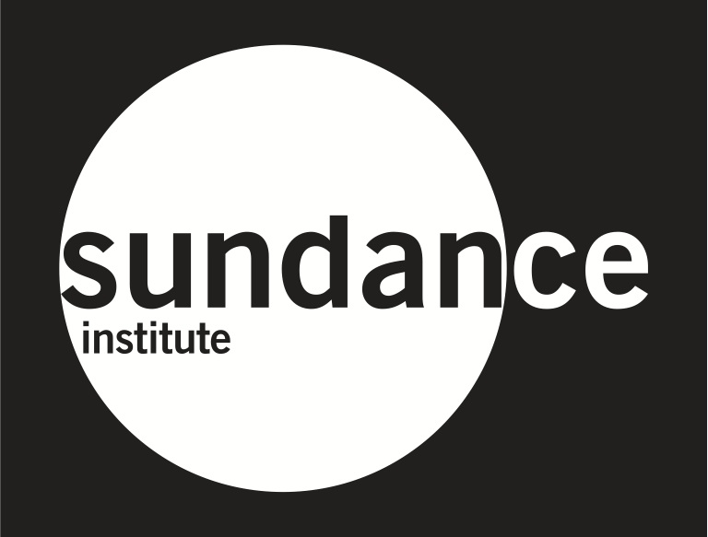

The filmmakers also want to give special thanks to the support of:

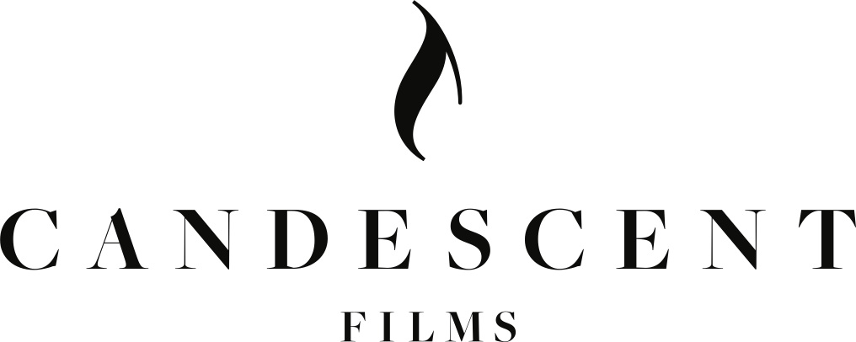

A Film By Matthew Heineman

© Copyright 2015 A&E Television Networks, LLC

