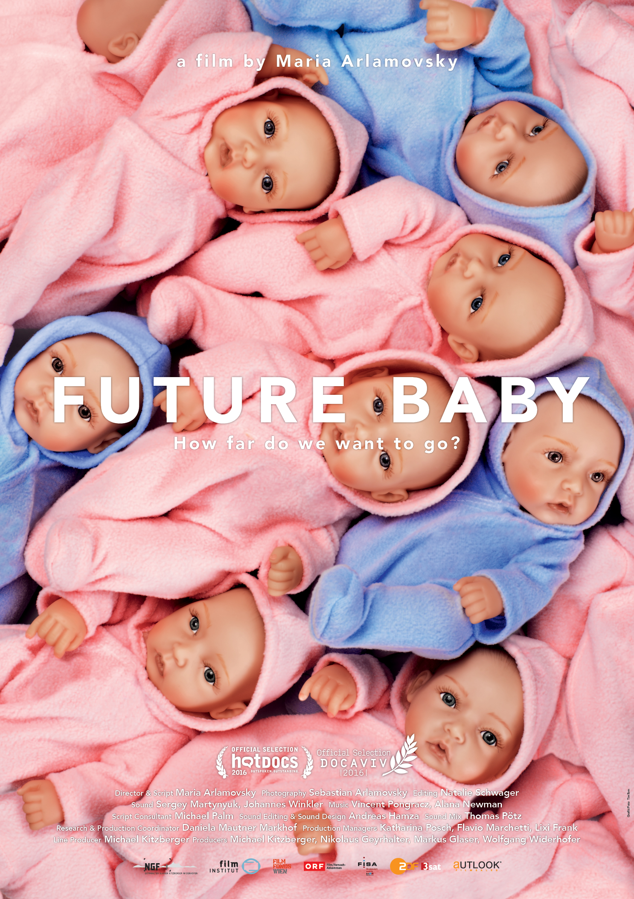

FUTURE BABY

A documentary by Maria Arlamovsky
Austria 2016, 91 min., 4k, DCP

www.futurebaby.at
facebook.com/futurebabyfilm

CONTACTS

World sales

Autlook Filmsales GmbH
Salma Abdalla
Spittelberggasse 3/14, A-1070 Vienna
T +43.720.3469.34. mobile +43 676 900 3771
welcome@autlookfilms.com
www.autlookfilms.com

Festival coordination

Austrian Film Commission
Anne Laurent
Stiftgasse 6, A-1070 Vienna
T +43.1.526.33.23.203
festivals@afc.at
www.afc.at

NGF Nikolaus Geyrhalter Filmproduktion GmbH

Silvia Burner
Hildebrandgasse 26, A-1180 Vienna
T +43.1.403.01.62
burner@geyrhalterfilm.com
www.geyrhalterfilm.com

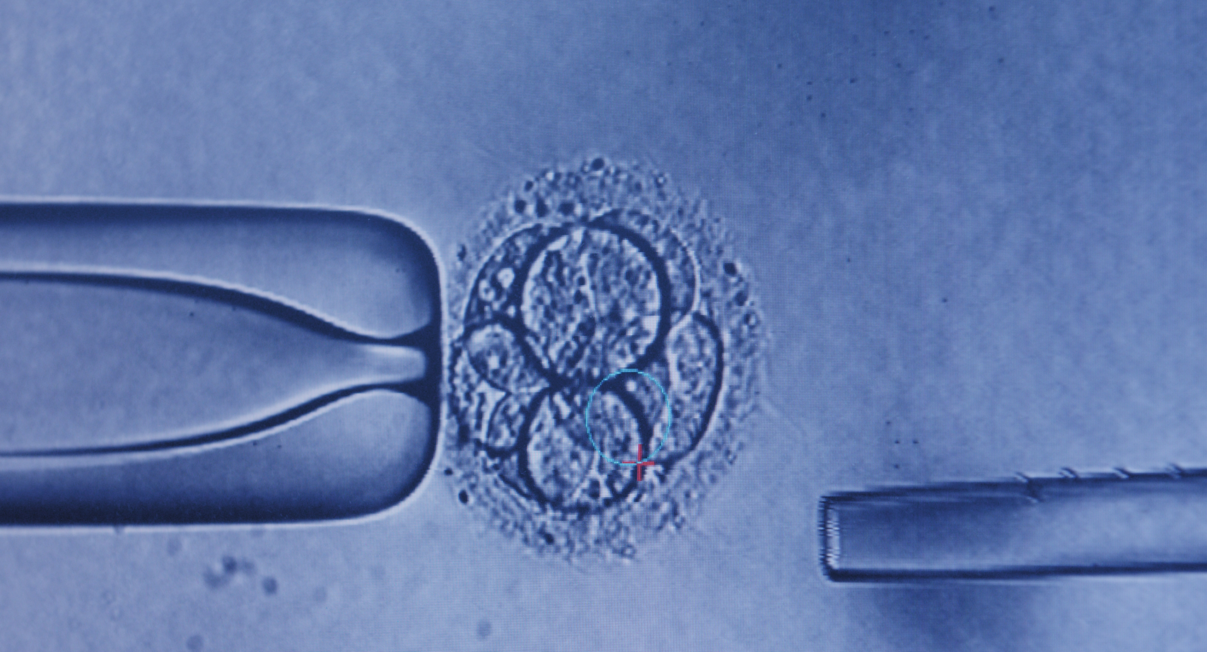

SHORT SYNOPSIS

FUTURE BABY is a film about the future of human reproduction as it is happening right before our eyes. Maria Arlamovsky’s exploration takes her all around the world—to patients and researchers, to egg donors and surrogate mothers, to laboratories and clinics. The hopes and wishes of future parents mesh with research on how to "upgrade" human embryos in the face of an ever-accelerating rate of progress. How far do we want to go?

SYNOPSIS

FUTURE BABY examines the complex field of reproductive medicine and technology from a variety of perspectives. Maria Arlamovsky travels the globe to visit doctors, scientists, and technicians in hospitals and sterile laboratories. She accompanies couples longing for a child as well as egg donors and surrogate mothers on their journeys through medical appointments and procedures. In this documentary, both supporters and skeptics have a chance to speak, along with the first generation of artificially conceived children. From this complex mosaic, a vision emerges that reflects the ambivalence surrounding these revolutionary technologies and procedures whose consequences we still don't know and whose ethical and legal boundaries are the subject of heated debate: How much can and should we humans interfere with nature?
Without explicitly answering this question, FUTURE BABY paints a worrisome scenario: examinations, tests, procedures, corrections. What originally began as an attempt to help infertile couples have a child, but also to select embryos based on certain genetic predispositions has today become a lucrative business. As such, it not only caters to our desires around “risk prevention” but also, in some ways, commodifies the child, the “product of our love.” Factory-made designer babies: Biological clocks are turned back, human “incubators” acquired, bodies selectively “improved,” and undesirable features culled. Fantasies of control, touching on various discourses, are redefining what it means to be a woman or a parent. But above all, we are faced with the fundamental question of how we conceptualize viability and health: What right to exist does an individual have who does not meet our societal standards for beauty and health? What does it mean for our future when biological boundaries disintegrate and the origins of life—the “miracle of nature”—begin to fall under the purview of technology? FUTURE BABY presents us with a visually stunning snapshot of the future, which has already arrived, a snapshot that is as disturbing as it is informative.
EXCERPTS FROM FUTURE BABY

„What I later learned is that the doctors operating in this industry wear two hats at the same time – they wear their medical hat and they wear their business hat.
Miriam Zoll, journalist & author, USA

„Everything in this room is intended to never let the eggs or sperm know they had ever left the body.”
Dr. Jeffrey Steinberg, The Fertility Institutes, USA

„We are constantly pushing the edge. And I always say, never put handcuffs on scientists. It’s detrimental. Allow the scientists to work. You can regulate and watch them but let them do their thing.“
Dr. Jeffrey Steinberg, The Fertility Institutes, USA

„Now the kitchen is paid off. So now we can take out a loan for the same amount as for our kitchen and get ourselves a baby.“
Carol Anne and Norbert Utz

„When I was younger I wanted to know my father or sperm donor - it depends how you look at it. When I realized I couldn’t, I think that was the hardest part. Not the fact that my family is different, but the fact that I don’t know who my father is, I don’t know half of my roots, I don’t know half of my heritage.”
Noa und Ruth Shidlo, Shorashim, Israeli Donor Families, Israel

„I’m a mother. If I couldn’t have kids, I would want someone to help me, too. Also, there is financial compensation, which I can really use.“
Susa*, egg donor, Spain

„There are soldiers of whom the sperm was extracted, even post mortem and was frozen because of the demand of the family. … Some of these men were not married. So the question is always what do to do with this sperm. What egg cells are you using, who is going to be pregnant with them, what’s the future of the baby who was conceived with the sperm of a dead father.
The same problem can also occur with a woman who froze her egg cell and unfortunately is not alive any more. Then you create a baby without the mother being alive at all.”
Prof. Jaron Rabinovici, fertility specialist, Sheba Medical Center, Israel

„Now I’m here to have one last child, maybe even twins, and then that’s it. I had IVF done five years ago. There were embryos left and I had them frozen. So I had to go through the whole painful process again.”
Dana*, patient Sheba Medical Center, Israel

“It’s about having a right to be a parent. … And in it’s extreme versions it’s more of a consumer right. In other words: It goes from being a wish or a desire, to immediately becoming a need and a right. …
But what does it mean when we say we have a right to parenthood? Does it mean by whatever means?”
Prof. Carmel Shalev, bioethicist, Israel

„If a baby is born with an anomaly today the gynecologist is asked by the parents or the law or a part of society whether this hadn’t been foreseeable during pregnancy.”
Marisa Lopez-Teijon, CEO Institut Marques, Spain

„I’m now doing a biopsy with the young embryo. A beautiful embryo, 8 cells, wonderful. They were thawed today, they were frozen embryos. Now I’m pulling out the cell. The embryo will stay in the lab to grow. And the cell will be sent to genetics, they will give us the information whether this embryo is healthy or not.”
Mascha*, embryologist, Israel

„I think that in advanced societies we won’t tolerate that children are being born with illnesses, the same way we won’t tolerate that someone dies of cancer, or that someone dies on the highway for driving too fast.”
Marisa Lopez-Teijon, CEO Institut Marques, Spain

„We are starting to externalize more and more of human reproduction. The production of gametes, potentially there are wombs one day and certainly the fertilization process. This is a slow, yet significant shift in human evolution. … We have been slowly shifting human evolution ever since we started making technology. But it’s one that really strikes to the essence of creation.”
Andrew Hessel, biotechnician, USA

„But the decision making process about which lives are unworthy of life is the one we are normalizing. And we do it clean and scientifically and there are no actual lives being destroyed. …And then there along comes a truck and you have got a kid with impediment anyway. So it’s not like you are actually choosing the kind of child you want to raise.”
Prof. Barbara Katz-Rothman, sociologist, USA

“We store any reproductive tissue: eggs, embryos, sperm. … We store them in liquid nitrogen, which keeps them at about minus 400 degrees Fahrenheit. It keeps them stored in a status of suspended animation. As long as the tissue stays frozen it can be viable forever. 30 years, 40 years, it won’t matter. You can come back, thaw an embryo, or sperm or egg and potentially create a child.
Scott Brown, California Cryobank, USA

CREW

Director & screenplay Maria Arlamovsky

Photography Sebastian Arlamovsky

Editing Natalie Schwager

Sound recording Sergey Martynyuk
Johannes Winkler

Sound editing & Andreas Hamza
Sound design

Sound mix Thomas Pötz, Cosmix Studios

Music Vincent Pongracz
Alana Newman

Script consultant Michael Palm

Research & Daniela Mautner Markhof
production coordinator

Production coordinators Rica Linders, USA
Jenny von der Recke, Barcelona, Spain
Marie Hofbauer, Alicante, Spain
Dana Karni, Israel
Rebecca Prosser, UK
Petra Fischer, Mexico

Production managers Katharina Posch
Flavio Marchetti
Lixi Frank

Line Producer Michael Kitzberger

Producers Michael Kitzberger
Wolfgang Widerhofer
Nikolaus Geyrhalter
Markus Glaser

Production: NGF - Nikolaus Geyrhalter Filmproduktion GmbH

With support from: Österreichisches Filminstitut
Filmfonds Wien
ORF Film/Fernsehabkommen
FISA - Filmstandort Austria
ZDF/3sat

CAST

Miriam Zoll
Journalist, author

Jeffrey Steinberg
CEO, The Fertility Institutes

Renata Huttelova
Embryologist, IVF Cube

Michal Jelen
Operations manager, IVF Cube

Carol Anne und Norbert Utz

Jon Aizpurua
CEO, IVF Spain

Noa and Ruth Shidlo
Shorashim, Israeli Donor Families

Jaron Rabinovici
Fertility specialist, Sheba Medical Center

Carmel Shalev
Bioethicist, University of Haifa

Lilly Frost
My Donor Cycle Agency, Surrogacy Beyond Borders

Marisa Lopez-Teijon
CEO Institut Marquès

Andrew Hessel
Biotechnician, Autodesk Research

Barbara Katz-Rothman
Sociologist, City University of New York

Scott Brown
California Cryobank

Carl Djerassi (2015 deceased)
Inventor of the contraception pill, Author

Cast continued

Anna Smajdor
Bioethicist, University of East Anglia

Evelyn Escorza
Cefam Agency

Haseeb, Christy und Grayson Amireh
Parents

Vanessa, Sean, Jackson, Jordy und Jaden Soman
Parents and triplets
DIRECTOR’S STATEMENT – MARIA ARLAMOVSKY

Children are an important part of my life, a part that despite the effort I would not want to miss. I understand why people want to have and raise children and want to live as a family, be it in a straight or gay relationship or as a single parent.

Adopting a child who comes with a lot of unknowns or taking in a foster child, having to deal with officials and justifying why you want to have a child, proving that you have sufficient resources, etc., appears difficult to many and is not yet an option for all. Injecting hormones to produce more eggs, ejaculating into a jar, and hoping that the considerable financial effort will pay off seems, in a way, more predictable.

It is estimated that since 1978, 5 million children have been born who were not conceived through parental sex but through science, pharmaceuticals, and medical technology—children who (most of the time) are happy to be alive and don't want to be viewed as test-tube babies or guinea pigs. They are planned children of parents who very much wanted “their” child.

But in 2013, for example, the actual live birth rate for IVF in Austria was only 26 percent. Today there are statistics that say one shouldn't give up before the sixth IVF attempt. That makes for lucrative business. Similar to cosmetic surgery, reproductive medicine capitalizes on the desire to get what we don't have—something we don't absolutely need but desperately hope to attain.

The hopes and wishes of prospective parents, the promises of clinics, hospitals, and physicians, and the visions of scientists working in the field, as well as how these different aspects interact, have fascinated me throughout my work on FUTURE BABY. Everyone seems to be trudging along on their own track while losing sight of the bigger picture, too close to see the trajectory of a development that does lead to children but has other social, psychological, and ethical consequences as well that are often overlooked.

FUTURE BABY does not provide any answers, but it does try to bring together images that are usually kept apart. Young egg donors who offer their eggs willingly and gladly because of monetary compensation, surrogate mothers who hope to provide a better future for their own children by carrying a genetically unrelated embryo for someone else, and people who were themselves conceived with the genetic material of someone they don't know meet those who would prefer not to think about all of this on their quest for a child of their own.

With FUTURE BABY, I wanted to explore where the rapidly developing fields of reproductive medicine, genetics, and birth control are taking us, and I believe we have come to a point where it is imperative that we ask ourselves, “how far do we want to go?”

MARIA ARLAMOVSKY

Short biography

Born 1965, lives and works in Vienna, Austria. Three children (one son adopted) and two foster children. She studied at the University for Music and Performing Arts Vienna, the Film Academy (M.A. 2000) and the Donau University in Krems (MA 2011).

Filmography

ANGST HAB’ ICH KEINE, ABER LEID TU’ ICH MIR JETZT SCHON /
RUBBER CHICKEN
A 1998, Video, 75 min.

LAUT UND DEUTLICH / LOUD AND CLEAR
A / D 2002, Video, 67 min.

EINES TAGES, NACHTS... / A WHITE SUBSTANCE
A 2008, Video, 21 min.

LOOKING FOR QI. A documentary about Zhineng Qigong, China.
A 2011, Video, 57 min.

Script & research

UNSER TÄGLICH BROT, 2005, Dir.: Nikolaus Geyrhalter

7915KM, 2008, Dir.: Nikolaus Geyrhalter

ABENDLAND, 2011, Dir.: Nikolaus Geyrhalter

HOMO SAPIENS, 2016, Dir.: Nikolaus Geyrhalter

NGF - Nikolaus Geyrhalter Filmproduktion

Founded by Nikolaus Geyrhalter in 1994, with Markus Glaser, Michael Kitzberger and Wolfgang Widerhofer joining as partners in 2003, the core competence of NGF lies in the production of documentary and feature films for theatrical release as well as high quality works for television.
NGF works with directors and authors who have a strong and innovative style and a passion and understanding for their respective medium—be it the big screen or television. Fascinating stories that are tangible and moving, implemented in formats that are radically new.
In its early years, the company was exclusively devoted to the production of documentary films. Works such as PRIPYAT, ACROSS THE BORDER, OUR DAILY BREAD, ABENDLAND, and FOOD DESIGN are representative of NGF’s approximately 45 documentary films for cinema and television that have garnered numerous prestigious awards and have been shown around the world.
In 2010, NGF produced its first feature film, THE ROBBER by Benjamin Heisenberg, which celebrated its world premiere at the 60th Berlinale Competition. In 2011, NGF’s second feature film, MICHAEL, the film debut by Markus Schleinzer, was selected to compete at the Cannes Film Festival.
NGF’s first television documentary series was launched in 2008 with GOISERN GOES EAST, and since 2010, several seasons of REISECKER’S TRAVELS, a television series, have been produced.
NGF’s most recent accolades include the European Film Award for MASTER OF THE UNIVERSE by Marc Bauder, the premiere of OVER THE YEARS, a 10-year project by Nikolaus Geyrhalter, at the Berlinale Forum 2015 and of THE VISIT by Michael Madsen at the competition of the Sundance Film Festival.
2016 begins with the invitation of Nikolaus Geyrhalter’s new Film HOMO SAPIENS to the Berlinale Forum, the cinema release of EVERYTHING UNDER CONTROL by Werner Boote and the selling of the remake rights of THE ROBBER to FilmNation Entertainment (with director J.C. Chandor).
Currently, NGF is working on the historical feature film LIGHT by Barbara Albert (with Maria Dragus and Devid Striesow), on new feature films by Katharina Mückstein, Daniel Hösl a.o. and on new documentaries by Nikolaus Geyrhalter, Maria Arlamovsky, Fritz Ofner, among others.

http://www.geyrhalterfilm.com

NGF FILMOGRAPHY (selection)

FUTURE BABY. A + 2016 + 91 min. + Director: Maria Arlamovsky
Homo Sapiens. A + 2016 + 94 min. + Director: Nikolaus Geyrhalter
Alles unter Kontrolle / Citizen B. A + 2015 + 93 min. + Director: Werner Boote
Über die Jahre / Over the Years. A + 2015 + 188 min. + Director: Nikolaus Geyrhalter
The Visit. DK/A/IRL/FIN/NOR + 2015 + 83 min. + Director: Michael Madsen
Die unglaubliche Reise der Familie Zid / The Amazing Journey of the Family Zid. 2015 + 80 min. + Director: Gunnar Walter
Meine Narbe / My Scar. A + 52 min. + 2014 + Director: Mirjam Unger
Reiseckers Reisen / Reisecker’s Travels. A + 2010-2014 + 25 x 25 min. + Director: Michael Reisecker
Das Kind in der Schachtel / The Child in the Box. A + 2014 + 85 min. + Director: Gloria Dürnberger
Master of the Universe. D/A + 2013 + 88 min. + Director: Marc Bauder
CERN. A + 2013 + 75 min. + Director: Nikolaus Geyrhalter
Population Boom. A + 2013 + 93 min. + Director: Werner Boote
Schulden G.m.b.H. / Debts Inc. A + 2013 + 75 min. + Director: Eva Eckert
Die Lust der Männer / Men’s Lust. A + 2012 + 65 min. + Director: Gabi Schweiger
Donauspital SMZ Ost / Danube Hospital. A + 2012 + 75 min. + Director: Nikolaus Geyrhalter
Anfang 80 / Coming of Age. Fiction + A + 2011 + 90 min. + Directors: Sabine Hiebler & Gerhard Ertl
Michael. Fiction + A + 2011 + 96 min. + Director: Markus Schleinzer
Abendland. A + 2011 + 90 min. + Director: Nikolaus Geyrhalter
Allentsteig. A + 2010 + 79 min. + Director: Nikolaus Geyrhalter
Die Lust der Frauen / Women’s Lust. A + 2010 + 61 min. + Director: Gabi Schweiger
Der Räuber / The Robber. Fiction + A/D + 2009 + 96 min. + Director: Benjamin Heisenberg
Food Design. A + 2009 + 52 min. + Directors: Martin Hablesreiter, Sonja Stummerer
7915 KM. A + 2008 +106 min. + Director: Nikolaus Geyrhalter
Eines Tages, nachts… / A White Substance. A + 2008 + 21 min. + Director: Maria Arlamovsky
Flieger über Amazonien / Flyers over Amazonia. A + 2008 + 80 min. + Director: Herbert Brödl
Mein Halbes Leben / (Half) the Time of My Life. A + 2008 + 93 min. + Director: Marko Doringer
Unser Täglich Brot / Our Daily Bread. A + 2005 + 92 min. + Director: Nikolaus Geyrhalter
Über die Grenze / Across the Border. A + 2004 + 131 min. + Dir.: P. Łoziński, J. Gogola, P. Kerekes, R. Lakatos, B. Čakič-Veselič
Carpatia. D/A + 2004 + 127 min. + Directors: Andrzej Klamt, Ulrich Rydzewski
Die Souvenirs des Herrn X / The Souvenirs of Mr. X. A/D + 2004 + 98 min. + Director: Arash T. Riahi
Laut und Deutlich / Loud and Clear. A/D + 2002 + 67 min. + Director: Maria Arlamovsky
Elsewhere. A + 2001 + 240 min. + Director: Nikolaus Geyrhalter
Pripyat. A + 1999 + 100 min. + s/w + Director: Nikolaus Geyrhalter
Das Jahr nach Dayton / The Year After Dayton. A + 1997 + 204 min. + Director: Nikolaus Geyrhalter
Angeschwemmt / Washed Ashore. A + 1994 + 86 min. + s/w + Director: Nikolaus Geyrhalter

