Presents
TIME TO CHOOSE

A film by Academy Award®-Winning Filmmaker Charles Ferguson

Narrated by Oscar Isaac

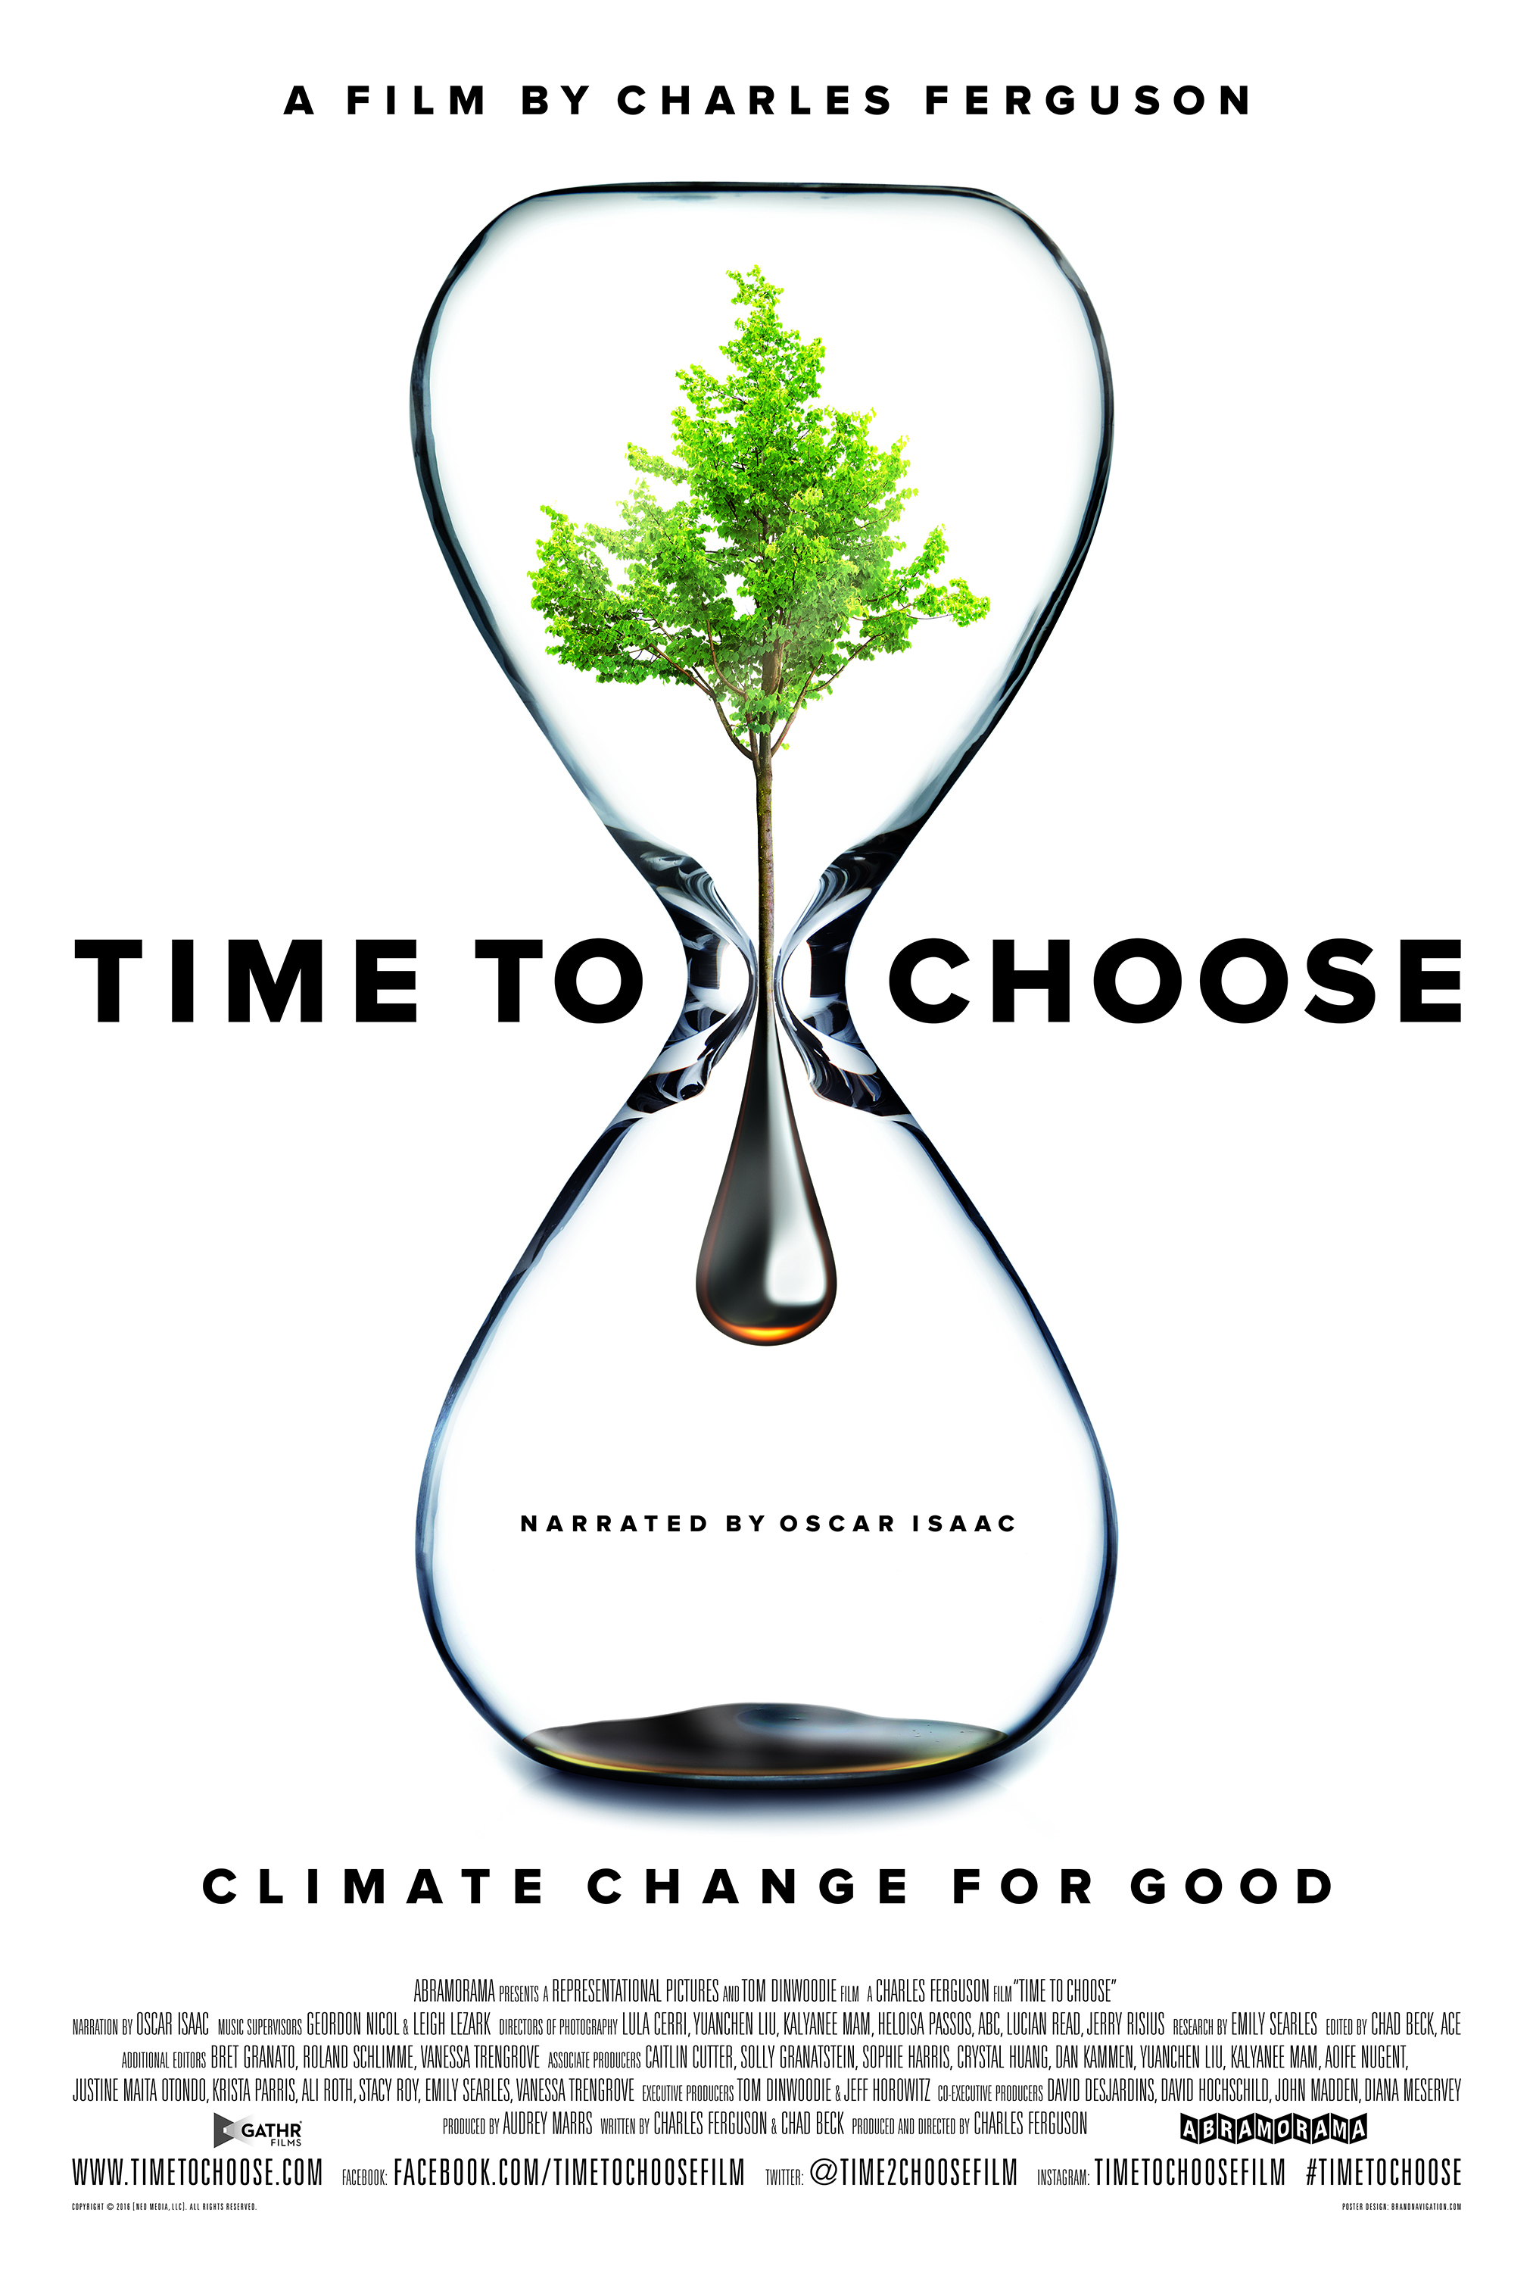

In Theaters June 3, 2016

RT: 97 Minutes
http://www.timetochoose.com

Facebook: Facebook.com/TimeToChooseFilm
Twitter: @Time2ChooseFilm
Instagram: TimeToChooseFilm
#TimeToChoose

Publicity Contacts:
Falco Ink.
Michelle DiMartino & Monica Delamater
MichelleDiMartino@Falcoink.com, MonicaDelamater@Falcoink.com
Copyright © 2016 [Neo Media, LLC]. All Rights Reserved
SHORT SYNOPSIS

Academy Award®-Winning documentary filmmaker Charles Ferguson (Inside Job, No End in Sight) turns his lens to address worldwide climate change challenges and solutions in his new film TIME TO CHOOSE.

Featuring narration by award-winning actor Oscar Isaac, TIME TO CHOOSE leaves audiences understanding not only what is wrong, but what can to be done to fix this global threat.

Ferguson explores the comprehensive scope of the climate change crisis and examines the power of solutions already available. Through interviews with world-renowned entrepreneurs, innovators, thought leaders and brave individuals living on the front lines of climate change, Ferguson takes an in-depth look at the remarkable people working to save our planet.

LONG SYNOPSIS

Climate change is the biggest challenge humanity has ever faced – and it is also our greatest opportunity. We have the solutions we need, but we are in a race against the clock to implement them in time.

Oscar-winning documentary director Charles Ferguson captures the urgency and innovation of this critical moment in his new film, TIME TO CHOOSE which takes audiences on a journey from the threats we face to the remarkable stories of people changing our world for the better.

Narrated by award-winning actor Oscar Isaac, TIME TO CHOOSE also delivers a clear message to audiences: we can take action to stop this global threat. It is the first major film to offer compelling stories of the innovators, leaders and average people fighting on the front lines for a cleaner, more sustainable world.

Its scope is truly global, with footage and interviews from five continents. The film’s investigation of the true costs of fossil fuels and industrialized agriculture takes audiences inside the drivers of these global phenomena. Audiences meet Appalachian residents suffering from coal-poisoned waters, descend into the dangerous coal pits of China, see the red night skies of Nigeria’s oil and gas lands, and hear from courageous officials fighting corruption and deforestation in Indonesia. Through these portraits and more, Ferguson shows the toll the status quo is taking on human lives and the world around us.

But TIME TO CHOOSE also features world-renowned entrepreneurs, innovators, and thought leaders who point the way to a better world. Lyndon Rive, CEO of SolarCity and Nobel Prize winner Mohammed Yunus show viewers how citizens around the globe are accessing affordable renewable energy, while Dr. Jane Goodall connects climate to the places and animals we love. Governor Jerry Brown urges leaders to join the path to sustainability and Chinese wind and solar manufacturers discuss how they’ve built some of the largest renewable energy installations in the world. Plus, regular people from around the world talk about winning fights to save their communities from the effects of fossil fuels and industrial agriculture.

TIME TO CHOOSE leaves audiences understanding not only what is wrong, but what needs to be done to fix it. It looks squarely at our unique common moment on earth, with an eye to helping change the course of human history.

DIRECTOR’S STATEMENT

I made TIME TO CHOOSE because climate change is the most important issue facing humanity and we urgently need broader understanding of how enormously we would all benefit from addressing it. Fortunately it is a challenge that we hold in common, and the film shows that across the globe, in myriad ways, people are coming together to find and implement solutions. We’re not too late, and our hope is that TIME TO CHOOSE will help audiences see both the tragedy that is unfolding and the remarkable and innovative ways in which humanity is finding a better way forward.

In making the film, my team and I traveled to parts of the world where climate solutions are not only politically unpopular – it is often personally dangerous to advocate them. I think it’s important for people to understand that the corruption, inequality and violence faced by many people the world over are tied to the pollution, waste and destruction that are fueling climate change. If we solve one, we help solve the other.

My most surprising discovery in making this film is also the most crucial fact about this issue: the solutions to climate change are already here, waiting for us. We saw them in places as diverse as Indonesia, Kenya, China, Western Europe and California. Everywhere we traveled, people were developing new ways of living and benefiting from them. Their stories and their work are what will lead us forward.

I was fortunate enough to cross paths with Tom Dinwoodie, a co-founder of SunPower, just as my own interest in climate change and the possibilities of new technology was peaking, and he agreed to come on board the film as an executive producer and financier. His unwavering support made it possible for me to bring my vision to the screen and has helped make TIME TO CHOOSE both a project that’s extremely meaningful to me and I hope truly groundbreaking.

There is simply no reason not to move into a new, sustainable world. I believe people are ready for that, and our hope is that TIME TO CHOOSE will help inspire audiences to be part of this new future.

TIME TO CHOOSE TEAM BIOS

CHARLES FERGUSON (Director, Co-writer, Producer)
Charles Ferguson is a filmmaker and writer. He is the founder and president of Representational Pictures, and the director and producer of INSIDE JOB, winner of the 2011 Academy Award for Best Documentary Feature, and of NO END IN SIGHT: THE AMERICAN OCCUPATION OF IRAQ, which was an Academy Award nominee as well. His latest film, TIME TO CHOOSE, is the first comprehensive examination of how to address climate change and the bigger challenge of global sustainability. Ferguson was originally trained as a political scientist and holds a B.A in mathematics from the University of California, Berkeley, and a Ph.D. in political science from MIT. He has also been a consultant to the White House, the Office of the U.S. Trade Representative, the Department of Defense, and several U.S. and European technology firms.

In 1994, Ferguson founded Vermeer Technologies which he sold in early 1996 to Microsoft, which integrated FrontPage into Microsoft Office. After selling Vermeer, Ferguson turned to research, writing and filmmaking. He is the author of five books, including High Stakes, No Prisoners: A Winner’s Tale of Greed and Glory in the Internet Wars. Ferguson’s most recent book is Predator Nation, focuses on the roots of the financial crisis and economic inequality, and was published by Random House/Crown in May 2012. He has written for The Huffington Post, The Guardian, The New York Times, and other publications. Ferguson spent several years as a Senior Fellow at the Brookings Institution, and is a life member of the Council on Foreign Relations and a director of the French-American Foundation.

OSCAR ISAAC (Narrator)
OSCAR ISAAC is one of the great young actors of today. He gained critical acclaim, a Golden Globe nomination, and an Independent Spirit Award for “Best Male Lead” for his portrayal of the title character in the Coen Brothers’ film Inside Llewyn Davis. After receiving rave reviews for his starring role opposite Catherine Keener in the HBO miniseries “Show Me A Hero,” Isaac went on to receive a Golden Globe Award for “Best Actor in a Miniseries or Television Film” and a Critics’ Choice Television Award nomination for “Best Actor in a Movie or Miniseries

In 2014, Isaac led J.C. Chandor’s action-packed drama, A Most Violent Year, for which he earned the National Board of Review Award for “Best Actor.” The film itself won the National Board of Review Award for “Best Film.” The following year, Isaac starred alongside Alicia Vikander and Domhnall Gleeson in Ex Machina written and directed by Alex Garland.

Most recently, Isaac starred as the Resistance pilot, Poe Dameron, in the highly awaited Star Wars: The Force Awakens, the seventh installment in the main Star Wars film series. Isaac is set to make his reprise as Poe Dameron in Star Wars: Episode VIII due for release in 2017. He will next be seen as the villain in the highly anticipated 20th Century Fox’s X-Men: Apocalypse due for release on May 27, 2016. He recently completed filming on The Promise with Christian Bale in Spain.

CHAD BECK (Co-writer/Editor)
Chad Beck is an award-winning documentary editor and writer based in New York City. Chad edited and co-wrote the Charles Ferguson's Oscar-winning Inside Job, and also edited Ferguson's Academy Award-nominated No End in Sight. He has worked on numerous other non-fiction projects including Comedy Central's Emmy-nominated South Park: Six Days to Air and Andrew Rossi's Page One: Inside the New York Times, for which he received an Emmy nomination for Best Documentary Editing.

AUDREY MARRS (Producer)
Audrey Marrs is a film producer who has produced three documentary films that were directed by Charles Ferguson: “No End In Sight” (2007), an Academy Award-nominated film about the American occupation of Iraq; “Inside Job” (2010) a film about the global economic crisis of 2008 for which she and Mr. Ferguson won an Academy Award; and “Time To Choose” (2016), a film about climate change and its solutions. She received her Bachelor of Arts degree from the Evergreen State College in Olympia, Washington, and her Master of Arts degree in Curatorial Practice from California College of the Arts in San Francisco, California. Ms. Marrs lives with her husband and two daughters in Los Angeles, CA.

TOM DINWOODIE (Executive Producer)
Tom Dinwoodie is Executive Producer of TIME TO CHOOSE, a film on Climate Change and its Solutions by Charles Ferguson. He is a serial entrepreneur with over 40 years experience with climate solutions technologies. He is a co-founder of SunPower Corporation, where he served as CEO, then CTO of SunPower Corporation Systems. He is former Chair of the Rocky Mountain Institute, and has served on the boards of Etrion Corporation, Keystone Tower Systems, Fenix Int’l, and Solar Mosaic, Inc., as well as the Sierra Club's Climate Cabinet and Scientific Advisory Panel. Dinwoodie holds numerous patents on PV and related products. He holds a B.S. in Environmental Engineering from Cornell University, an M.S. from the Department of Mechanical Engineering at MIT, and an M.A. in Architecture from the University of California at Berkeley.

JEFF HOROWITZ (Executive Producer)
Jeff Horowitz is an environmental activist and a television and movie producer specializing in stories about climate change. He serves as a Co-Executive Producer for the Emmy Award winning docu-series, “Years of Living Dangerously” focused primarily on deforestation stories, (with Season 2 to be aired on National Geographic TV late Fall, 2016).

Jeff independently produced “Stop the Burning”, narrated by Dr. Jane Goodall. This environmental film short debuted in Paris at the December 2015 global climate summit and was featured at key climate change events during the conference. The film focuses on the horrifying realities of the out of control practice of “slash and burn agriculture.”

Horowitz has collaborated on television projects for the U.S. based “PBS NewsHour,” the Weather Channel, and Germany’s ZDF Television. He has been a contributor and official blogger for the Huffington Post, The Guardian, Mongabay (a major internet environmental journal), and other print and on-line outlets.

Over the past eight years, Jeff has served as a speaker and moderator at major international climate change and conservation conferences.

Prior to his television and filmmaking projects, Jeff was the founder of Avoided Deforestation Partners (www.adpartners.org), a global nonprofit network of prominent individuals dedicated to advancing U.S. and international climate policies, with particular focus on ending deforestation. Most recently, AD Partners has become internationally recognized for facilitating partnerships between major corporations and governments to produce agricultural commodity supply chains that are deforestation-free.

Diana Meservey (Co-Executive Producer)
Diana Meservey is a planner and designer. She was an early promoter of visual media in the planning/ public review process. She served as co-Director of the APA-sponsored Bay Area Planning and Design, Symposium & VideoFest (1991) and wrote and produced a documentary on wind energy development in the Northeast. As a land use/ environmental planner, she drafted regional and environmental policy for general plans/EIR’s, and led coastal access and community design efforts for leading Bay Area firms. She was Coordinator of Massachusetts’ One Percent for Art Program, integrating public art into State building projects, and assisted Fort Point Planning, Boston to draft a mixed-use rehab plan of artist-occupied warehouses. She later focused on communications as Art Director/Designer for renewable energy enterprises and non-profits. Recent film credits include Associate Producer for Josh Fox’s latest film on climate change, “How To Let Go…” (2016). She holds an A.B. in Economics and Fine Arts with honors from Smith College, was a portfolio scholarship competition winner in the Fine Arts program, Art Institute of Boston, and received a Master of Regional Planning degree from Cornell University.

FILM SUBJECT BIOS
(in order of appearance)
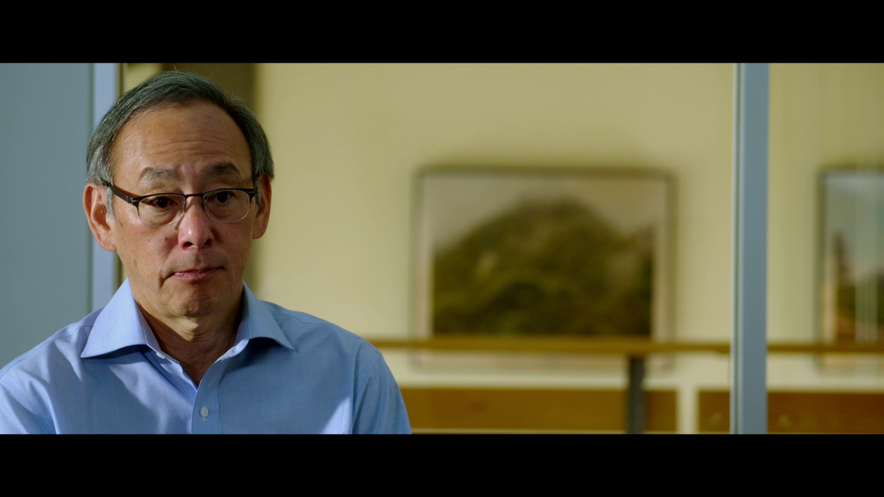
STEVEN CHU
U.S. Energy Secretary, 2009-2013; Professor of Physics and Molecular & Cellular Physiology at Stanford University; 1997 Nobel Prize Winner in Physics
Dr. Chu was the 12th U.S. Secretary of Energy serving from January 2009 until the end of April 2013. He was the first scientist to hold a Cabinet position and the longest serving Energy Secretary. Currently, Dr. Chu is the William R. Kenan, Jr., Professor of Physics and Professor of Molecular & Cellular Physiology in the Medical School at Stanford University. Dr. Chu holds numerous awards including the 1997 Nobel Prize in Physics in addition to 26 honorary degrees.
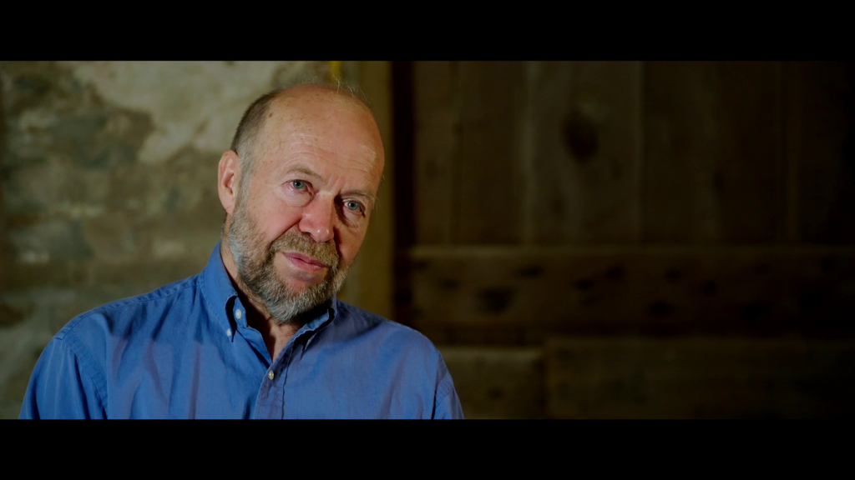
JAMES HANSEN
Climate Scientist, Columbia University
Dr. James Hansen is a world-renowned climate scientist and the first individual to testify to the existence of climate change before Congress in 1988. A former head of the NASA Goddard Institute for Space Studies in New York City, his latest study concludes that two degrees Celsius is too dangerous and humanity must aim far below. A tireless advocate for climate action, Dr. Hansen speaks around the world, writes, and studies climate change to develop new models to predict its direction and effects.

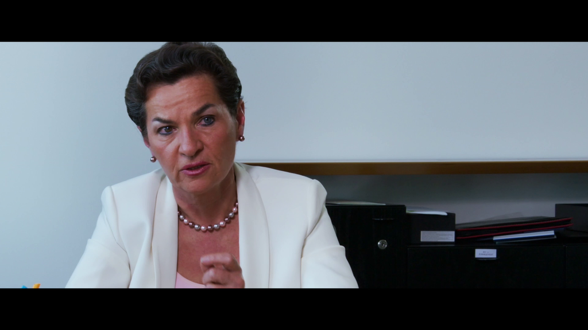
CHRISTINA FIGUERES
Executive Secretary, UN Global Climate Negotiations
Christiana Figueres has been the Executive Secretary of the United Nations Framework Convention on Climate Change since 2010 and will oversee the Paris Climate talks in December 2015. Ms. Figueres began her career in 1982 as the Minister Counselor at the Embassy of Costa Rica in Bonn, Germany. Additionally, Ms. Figures served as a member of the Costa Rican climate negotiating team from 1995-2000 and has worked on climate change and renewable energy programs in the US and Latin America.
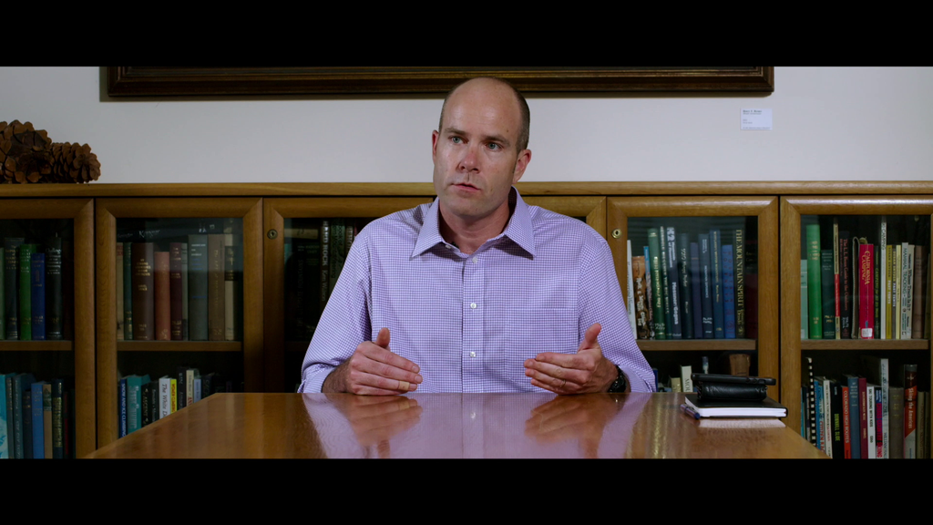
MICHAEL BRUNE
President, The Sierra Club
Michael Brune is the Executive Director of the Sierra Club and author of Coming Clean: Breaking America’s Addiction to Oil and Coal. Prior to his position with the Sierra Club, Mr. Brune served as the Executive Director of the Rainforest Action Network and as an organizer at Greenpeace. Mr. Brune’s first experience with environmental protection was organizing for clean water as a teenager on the New Jersey shore.
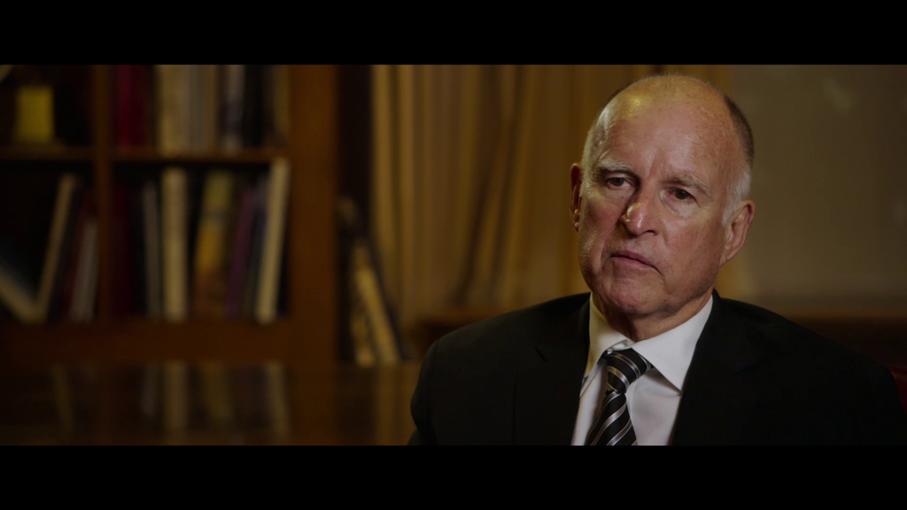
JERRY BROWN
Governor, California
Governor Jerry Brown is the Governor of California and was elected to his third gubernatorial term in 2010. Prior to his service as Governor of California, Governor Brown has served as the Mayor of Oakland, the California Attorney General, and the Chairman of the Democratic National Convention. Governor Brown has been a tireless advocate for the environment, with legislative efforts including enacting the nation’s first energy efficiency standards in the 1980’s to making California a global leader in renewable energy and climate policy.

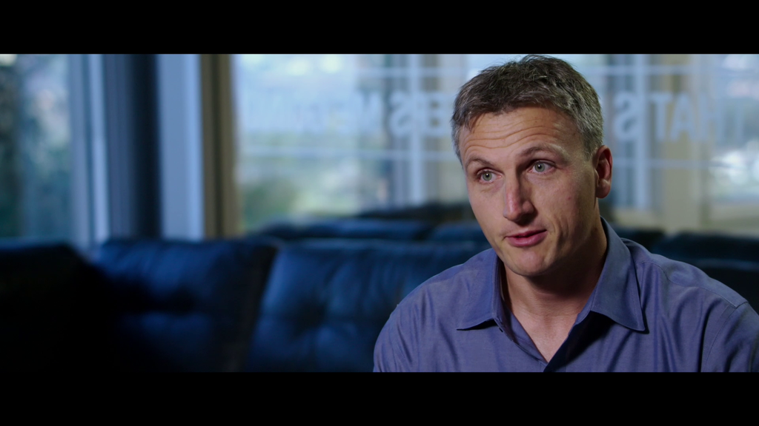
LYNDON RYVE
Co-Founder and CEO, SolarCity
Lyndon Rive is the co-founder and CEO of SolarCity, now the largest installer of residential solar systems in the US. Mr. Rive founded his first business at age 17 in South Africa, and, much like his cousin Elon Musk of Tesla, has been a serial entrepreneur ever since. He co-founded SolarCity in 2006 with his brother Peter with the goal to make solar energy accessible and affordable for every American.

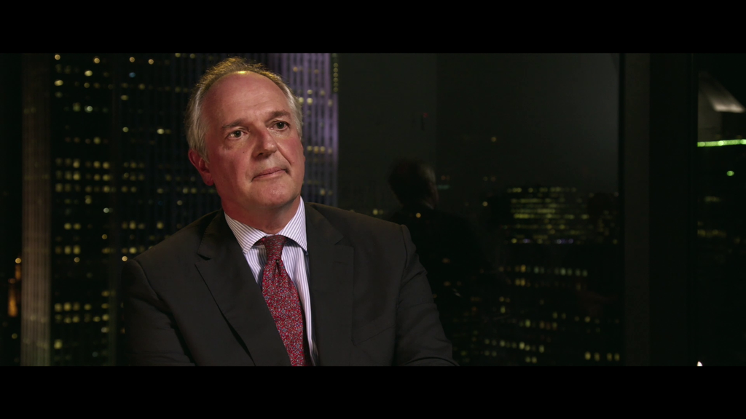
PAUL POLMAN
CEO, Unilever
Paul Polman is the CEO of Unilever, one of the largest and most recognizable brands in the world. As CEO, Mr. Polman has made Unilever a leader in sustainability and is an outspoken voice for strong action on climate and corporate social responsibility. Mr. Polman is a member of the UN Global Compact, the Chairman of the World Business Council for Sustainable Development, and has served on several high level UN panels.

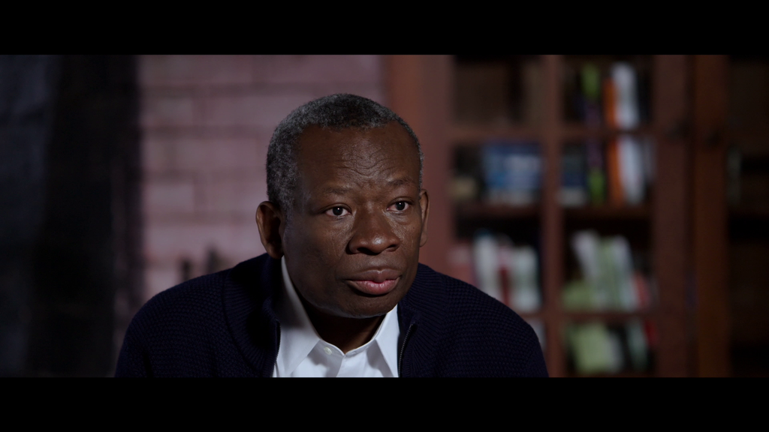
ORONTO DOUGLAS
Environmental Activist and Lawyer
Oronto Douglas was a leading human rights and environmental lawyer in Nigeria who worked to protect the Niger Delta and its communities from environmental degradation and later served as Special Advisor to President Goodluck Jonathan. Mr. Douglas co-founded Nigeria’s most influential environmental protection organization, Environmental Rights Action/Friends of the Earth Nigeria and was an outspoken advocate for human rights despite repeated imprisonment and torture by Nigeria’s military regime. Mr. Douglas died on April 9th, 2015, from stomach cancer.

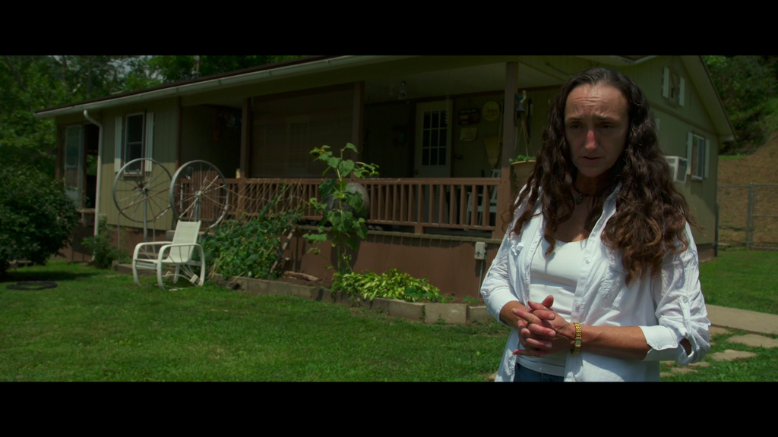
MARIA GUNNOE
Boone County, W. Virginia
Maria Gunnoe, a lifelong resident of Boon County and descendant of coal miners, is one of Appalachia’s most outspoken activists and in 2009 won the Goldman Environmental Prize for her work. She became an environmental activist after the Jupiter mine started removing a ridge above her home, triggering massive flooding on her land.

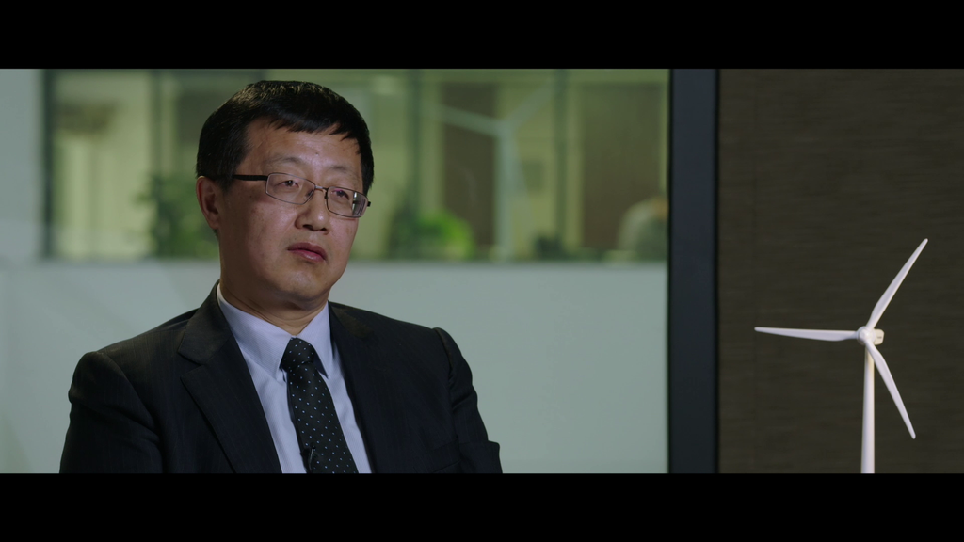
WU GANG
Chairman, Goldwind Corporation
Wu Gang is the Chairman of the Goldwind Corporation, one of China’s largest wind turbine manufacturers. Mr. Wu has worked in the wind industry since the 1980’s and in 2006 was awarded the World Wind Energy Award for his work advancing the global wind industry. Mr. Wu was named one of China’s most powerful people by Newsweek in 2009.

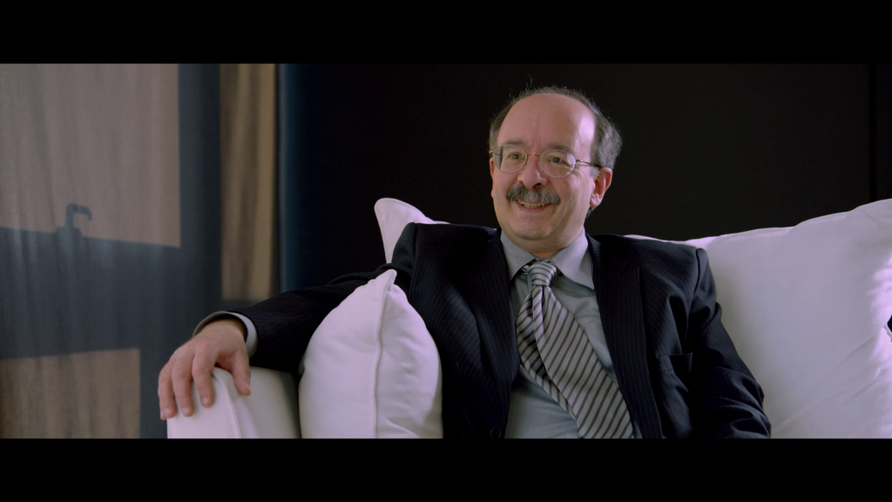
AMORY LOVINS
Chief Scientist, Rocky Mountain Institute
Amory Lovins is an international authority on sustainable energy and technology. Mr. Lovins’ forty-plus year career has included advising heads of state, global companies, energy efficient home design, and pioneering utility models, among others. He founded the Rocky Mountain Institute, a “think and do tank” on energy. with his wife L. Hunter Lovins.

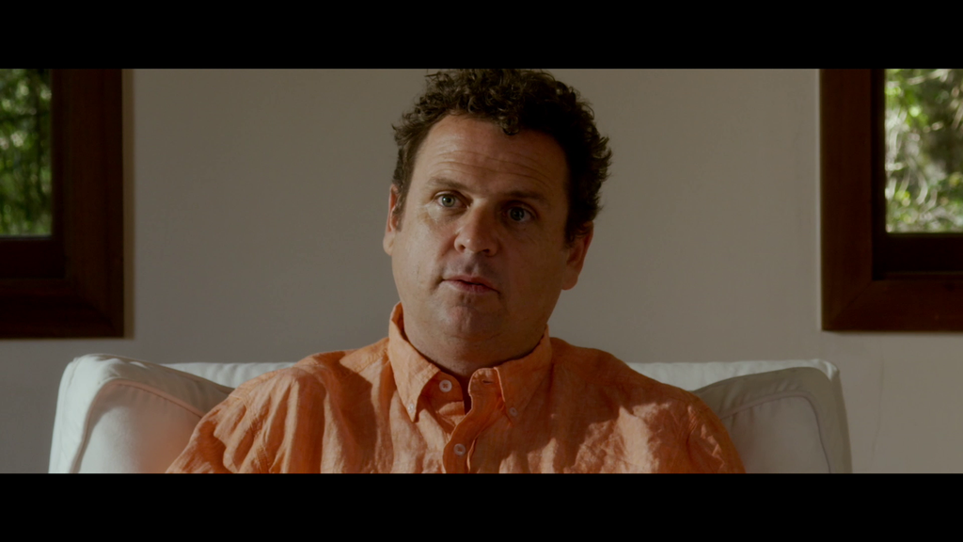
DANNY KENNEDY
Co-founder, Sungevity
Danny Kennedy is the co-founder of Sungevity and an internationally recognized leader on energy and environment. Mr. Kennedy also co-founded SFUNCUBE, the only incubator of its kind that supports solar entrepreneurs, and serves on the board of VoteSolar and several other solar start-ups. Before founding Sungevity, Mr. Kennedy worked as a campaign manager with Greenpeace.
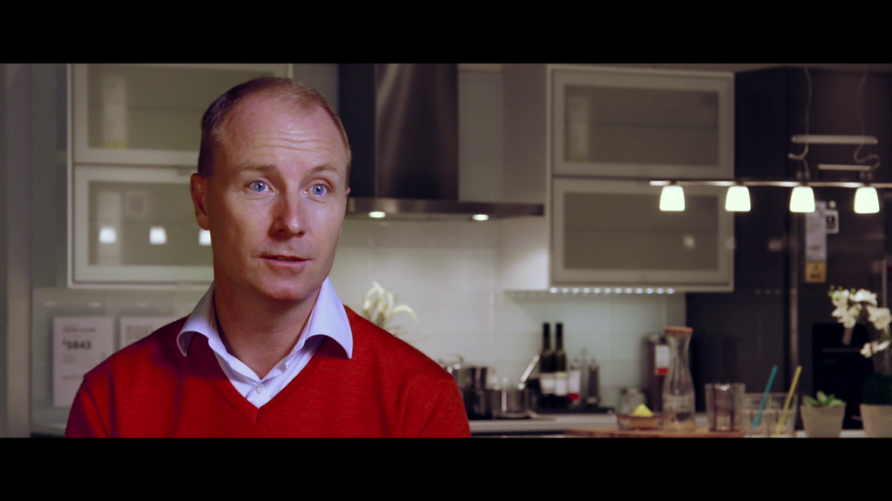
PETER AGNEFJALL
CEO, IKEA
Peter Agnefjall was named CEO of IKEA, a global leader in sustainability, in 2013 and has been with the company since 1995. Mr. Agnefjall presides over IKEA’s comprehensive sustainability efforts, from only selling LED lights in stores to investing millions of euros in renewable energy to producing more renewable electricity than it consumes by 2020.

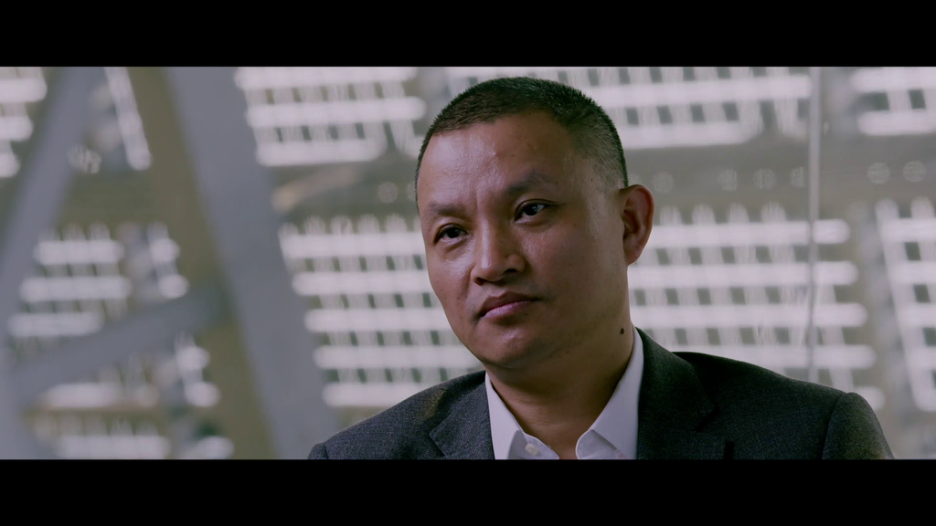
ERIC LUO
CEO, Shunfeng
Xin “Eric” Luo joined Shunfeng as CEO in January 2015. Previously, Mr. Luo was CEO of Suntech, which was bought out by Shunfeng in 2014. Mr. Luo has over twenty years of management experience in a variety of manufacturing industries.

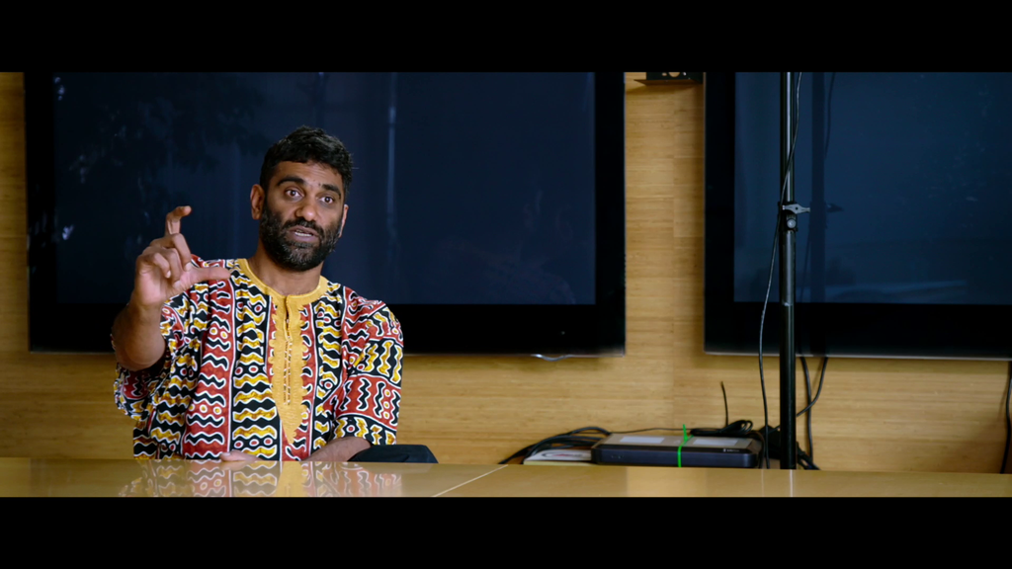
KUMI NAIDOO
Executive Director, Greenpeace International
Kumi Naidoo is a South African human rights activist and has served as Executive Director of Greenpeace International since 2009, leading efforts to expand into the Global South and East. Mr. Naidoo’s career began organizing against apartheid in the 1970’s and 1980’s. He was the first Black South African to earn a Doctorate at Oxford University and returned to South Africa work on a variety of adult literacy, voting, and citizen participation campaigns.

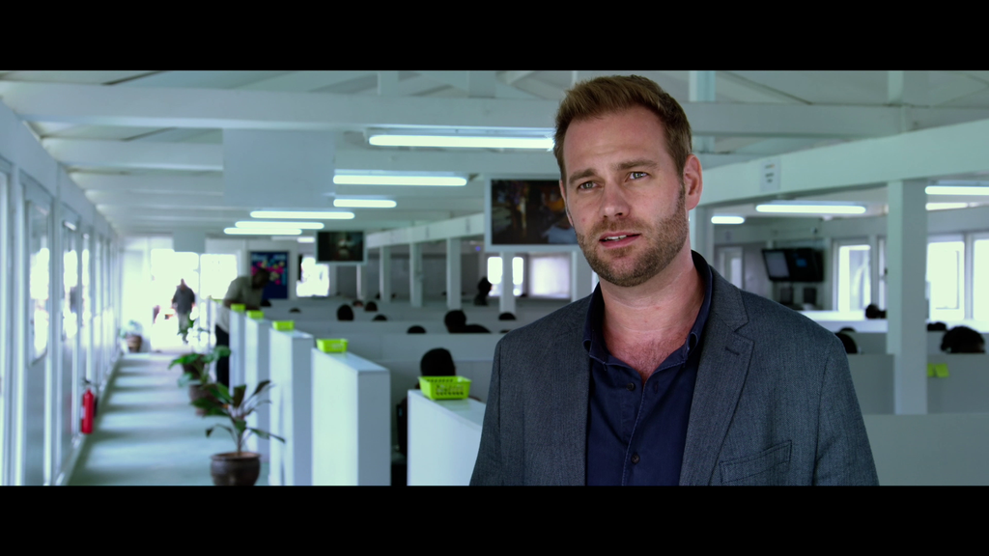
JESSE MOORE
Founder, M-Kopa
Jesse Moore co-founded M-Kopa in Kenya in 2012 and is the leader of “pay as you go” off grid energy. The company has electrified more than 200,000 homes since its launch and is currently adding 500 new homes each day. Before founding M-Kopa, Mr. Moore was the Director of the GSM Development Fund in London, which aimed to use mobile for development for low-income customers.

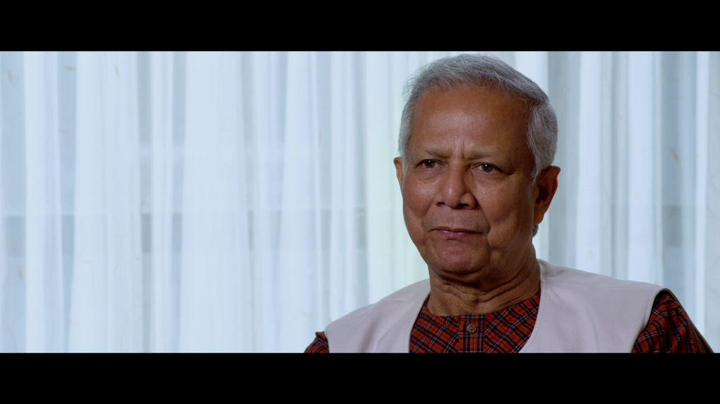
MUHAMMAD YUNUS
Nobel Peace Prize Winner; Founder, Grameen Bank
Muhammad Yunus is the founder of microcredit, social business, and Grameen Bank. He won the Nobel Peace Prize jointly with Grameen Bank in 2006 for his pioneering model of microcredit, microfinance, and community development. Mr. Yunus is a global authority on entrepreneurship and community development and has won 112 awards for his work globally.

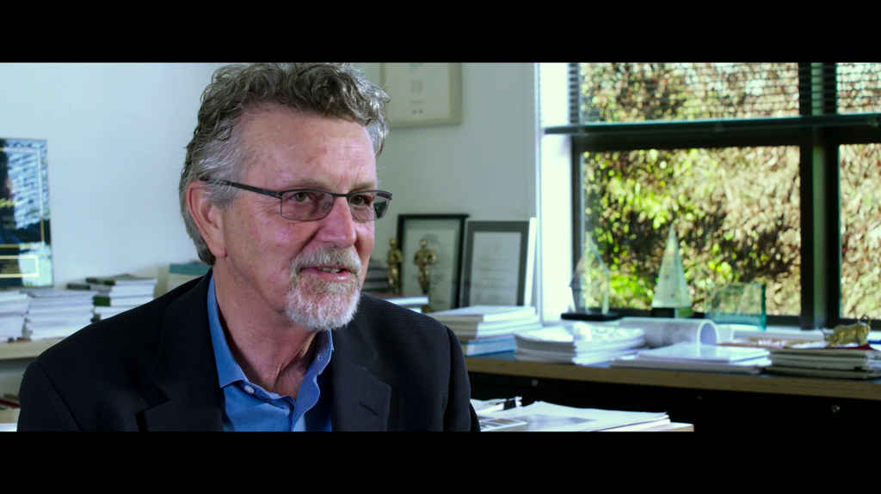
PETER CALTHORPE
Architect and Urban Designer; Author, “Urbanism in the Age of Climate Change”
Peter Calthorpe has been working in urban design since 1976 and is a pioneer of sustainable urban development. Mr. Calthorpe has published books and articles that have become guidelines for urban planning, such as his concept of “Transit Oriented Development”. Mr. Calthorpe works around the world to design human scale, sustainable cities and is currently developing examples and standards of Low Carbon cities in China.

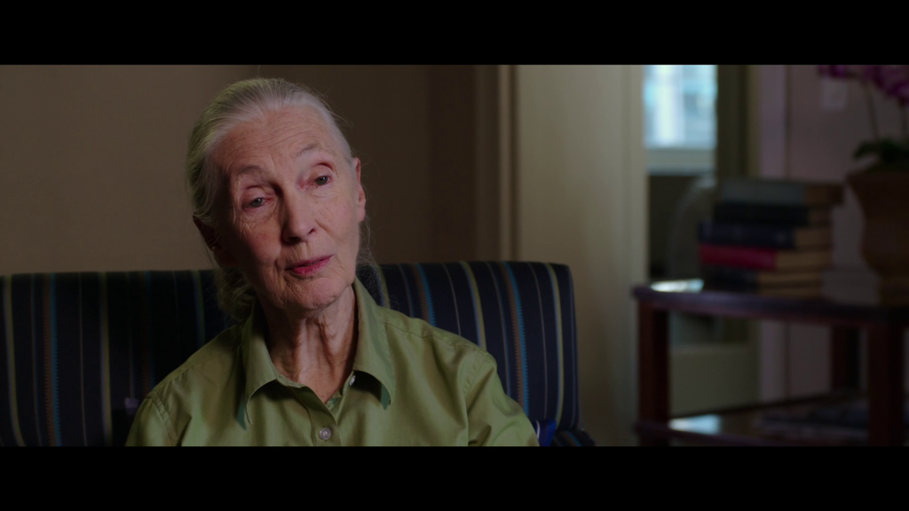
DR. JANE GOODALL, DBE
Founder, Jane Goodall Institute &
UN Messanger of Peace
Jane Goodall is known worldwide for her groundbreaking research on chimpanzees in the 1960s. Dr. Goodall has spent the last fifty-five years on research, advocacy, and education on chimpanzees and environmental protection and has received numerous awards and honorary degrees for her work. She founded the Jane Goodall Institute to protect the chimpanzees of Tanzania’s Gombe National Park and Roots and Shoots as a global environmental and humanitarian youth program.

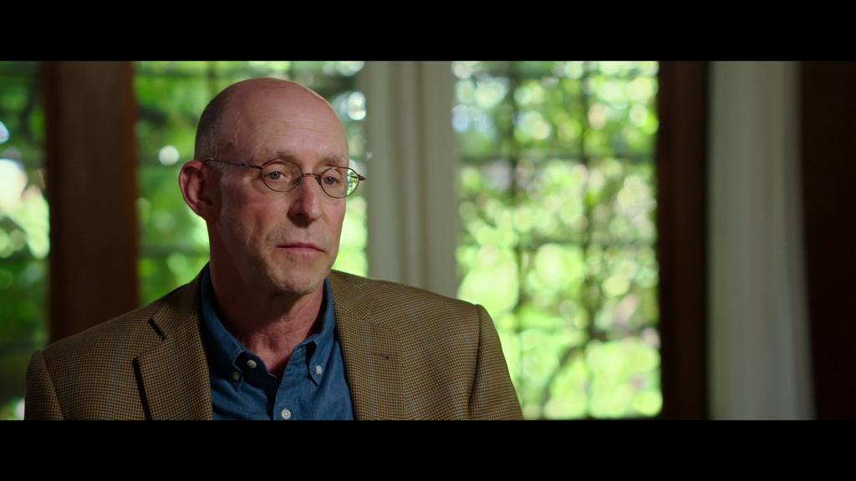
MICHAEL POLLAN
Journalist; Author, “In Defense of Food”
Michael Pollan is a New York Times best-selling author and food guru. Mr. Pollan writes about the complex relationships between our food, culture, history, environment, and economy. He has won numerous awards for his books and articles and appeared in the documentary Food, Inc. Mr. Pollan is currently the John S. and James L. Knight Professor of Journalism at UC Berkeley’s Graduate School of Journalism and the director of the Knight Program in Science and Environmental Journalism.

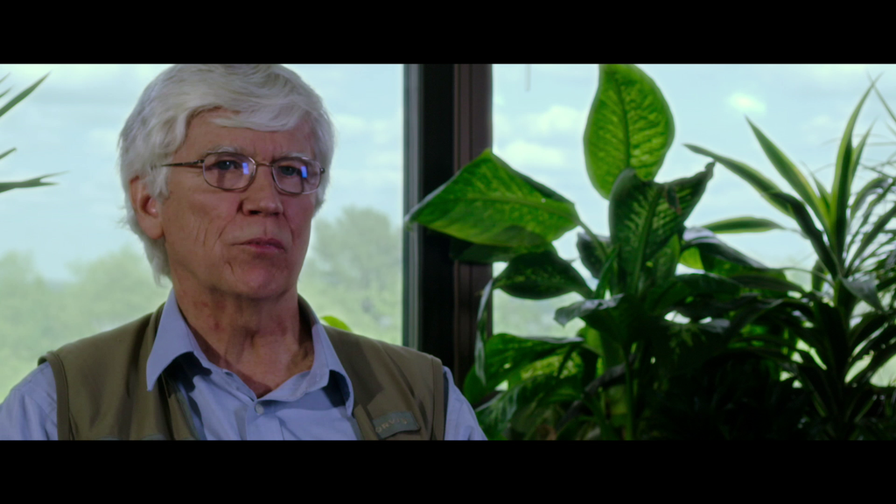
DR. RUSSELL MITTERMEIER President, Conservation International
Dr. Russell Mittermeier is the President of Conservation International and the only active field biologist to head an international conservation organization. Dr. Mittermeier has discovered twelve species and worked tirelessly to protect the globe’s most threatened places and species.

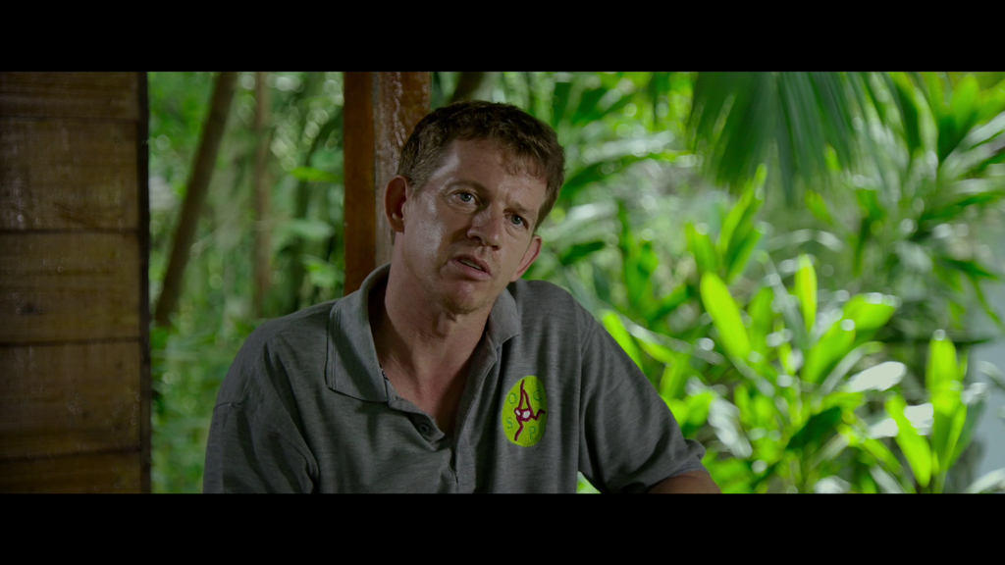
IAN SINGLETON
Founder and Director, Sumatran Orangutan Conservation Program
Dr. Ian Singleton has been working with the Sumatran Orangutan Conservation Program since its inception. Dr. Singleton began his career as a zookeeper and vacationed in Indonesia to learn more about orangutans. The experience led him to pursue a PhD and relocate to Indonesia to found the Conservation Program.

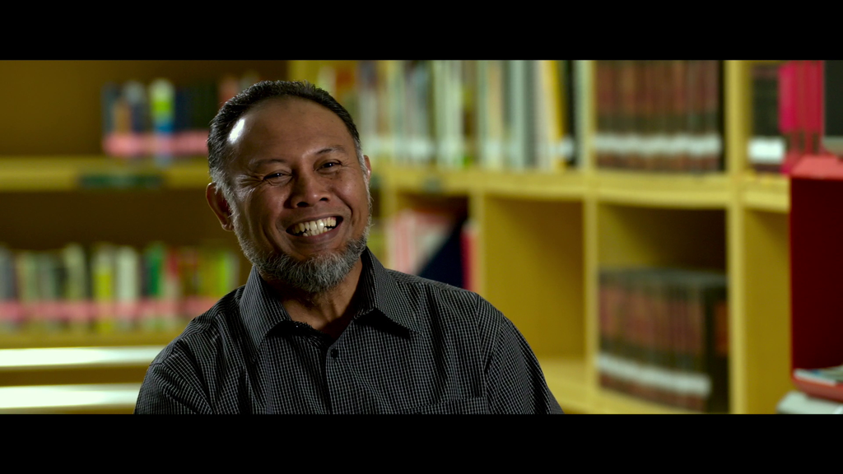
BAMBANG WIDJOJONTO
Deputy Chairman, Corruption Eradication Commission
Bambang Widjojonto is a human rights activist and Deputy Chairman of the Corruption Eradication Commission in Indonesia. Previously, Mr. Widjojonto founded the Indonesian Legal Aid Foundation to advocate for the people of West Papua. For this work he won the Robert F. Kennedy Human Rights Award.

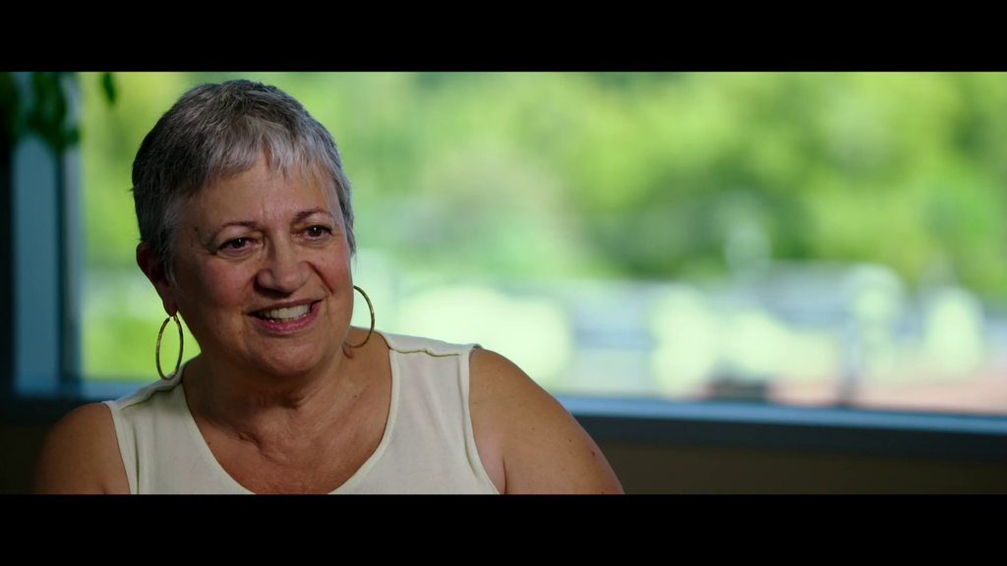
MARY NICHOLS
Chair, California Air Resources Board
Mary Nichols has been the Chair of the California Air Resources Board (CARB) since 2007. She also served as Chair from 1979-1983. In addition to serving on the CARB, she has been the Assistant Administrator for the U.S. Environmental Protection Agency's Air and Radiation program, Secretary for California's Resources Agency, and the Director of the Institute of the Environment at the University of California, Los Angeles.

ABOUT THE DISTRIBUTION PARTNERS

ABRAMORAMA
An independent distribution and marketing company, Abramorama is an industry leader in the focused, personalized form of film distribution that provides invaluable alternatives to filmmakers and content owners. Coming off the successful releases of Laurie Anderson's astonishing New York Times critics’ pick, HEART OF A DOG, and Dawn Porter’s Sundance Award-winner TRAPPED, Abramorama’s recent multiple-nominated and award-winning titles also include Showtime's LISTEN TO ME MARLON (National Board of Review Winner) and Drafthouse's THE LOOK OF SILENCE (2016 Documentary Academy Award® Nominee and 2015 IDA Best Documentary Winner).

Over the course of more than 20 years, Abramorama has successfully distributed and marketed hundreds of films, including Asif Kapadia’s SENNA, Robert Stone’s PANDORA’S PROMISE, Cameron Crowe’s PEARL JAM TWENTY, Sacha Gervasi’s ANVIL! THE STORY OF ANVIL, Banksy’s Academy Award®-nominated, EXIT THROUGH THE GIFT SHOP, the surprise indie hit AWAKE: THE LIFE OF YOGANANDA, and the critically acclaimed documentaries PARTICLE FEVER and AN HONEST LIAR.

Abramorama continues to lead in event cinema distribution, with current titles including HAMLET starring Maxine Peake from Manchester’s Royal Exchange Theatre, Operas from La Scala, Roma, Fenice & Torino, and recent titles including the Royal Opera House Ballet and Opera Cinema Season, Shakespeare’s Globe on Screen, Matisse at the Tate, Hermitage Revealed, PLANETARY (launched theatrically on Earth Day, 2015), the visceral action sport feature THE SEARCH FOR FREEDOM, Green Day’s HEART LIKE A HAND GRENADE, and Avi Lewis and Naomi Klein’s THIS CHANGES EVERYTHING. For more information visit www.abramorama.com

GATHR FILMS
Gathr Films is a technology-based specialty theatrical distributor focusing on documentaries and issues-oriented films. Gathr pioneered Theatrical On Demand® in 2011. TOD screenings harness organic demand—screenings occur when a minimum number of people reserve tickets in advance. The company works with more than 3,000 theaters across all the major theater chains including Regal, AMC, Carmike, Cinemark, Marcus, and Wehrenberg. Gathr uses political-style grassroots coalition-building to target decentralized communities to galvanize their supporters and communities around social impact and political action. Gathr also works with some of the largest and most prestigious brands and organizations to build national coalitions with our films, including UNICEF, UN Foundation, Just Label It, Faces and Voices of Recovery, and National Association of Social Workers. Films distributed through TOD include Girl Rising (4th highest grossing documentary of 2013), Awake: The Life of Yogananda ($1.4 million in revenue), Beyond the Mask (700+ screenings), The Square (2014 Oscar® nominee), The Tale of the Princess Kaguya (2015 Oscar® nominee), The Anonymous People (200+ screenings) and When Marnie Was There (2016 Oscar® nominee). Current films include Minimalism, Can You Dig This, Consumed, Frame by Frame, Finding Jenn’s Voice, Life in A Walk, Milk, Imba Means Sing, and The Prophet. Gathr Films is located in Los Angeles, New York City, and Washington, D.C. http://www.gathr.us/

CREDITS

Directed and Produced by
Charles Ferguson

Written by
Charles Ferguson and Chad Beck

Produced by
Audrey Marrs

Executive Producers
Tom Dinwoodie
Jeff Horowitz

Co-Executive Producers
David Desjardin
David Hochschild
John Madden
Diana Meservey

Editor
Chad Beck, ACE

Cinematography
Lula Cerri
Yuanchen Liu
Kalyanee Mam
Heloísa Passos, ABC
Lucian Read
Jerry Risius

Additional Editors
Bret Granato
Roland Schlimme
Vanessa Trengrove

Research
Emily Searles

Associate Producers
Caitlin Cutter
Solly Granatstein
Sophie Harris
Crystal Huang
Dan Kammen
Yuanchen Liu
Kalyanee Mam
Aoife Nugent
Justine Otondo
Krista Parris
Ali Roth
Stacy Roy
Emily Searles
Vanessa Trengrove

Music Supervisors
Geordon Nicol
Leigh Lezark

Narration by
Oscar Isaac

Graphics by
BigStar

Assistant Editors
James Casteel
Amina Ouchater

Additional Cinematography
Charlie Beyer
Mariusz Cichon
Antonio Rossi
Morgan Schmidt-Feng

Aerial Cinematography
Travis McMunn
SouthWings
Beijing Sky-Eye
Yellow Wings Air
Nettman Systems International
NYonAir
Big Bird Films
Marica Taxi Aereo

