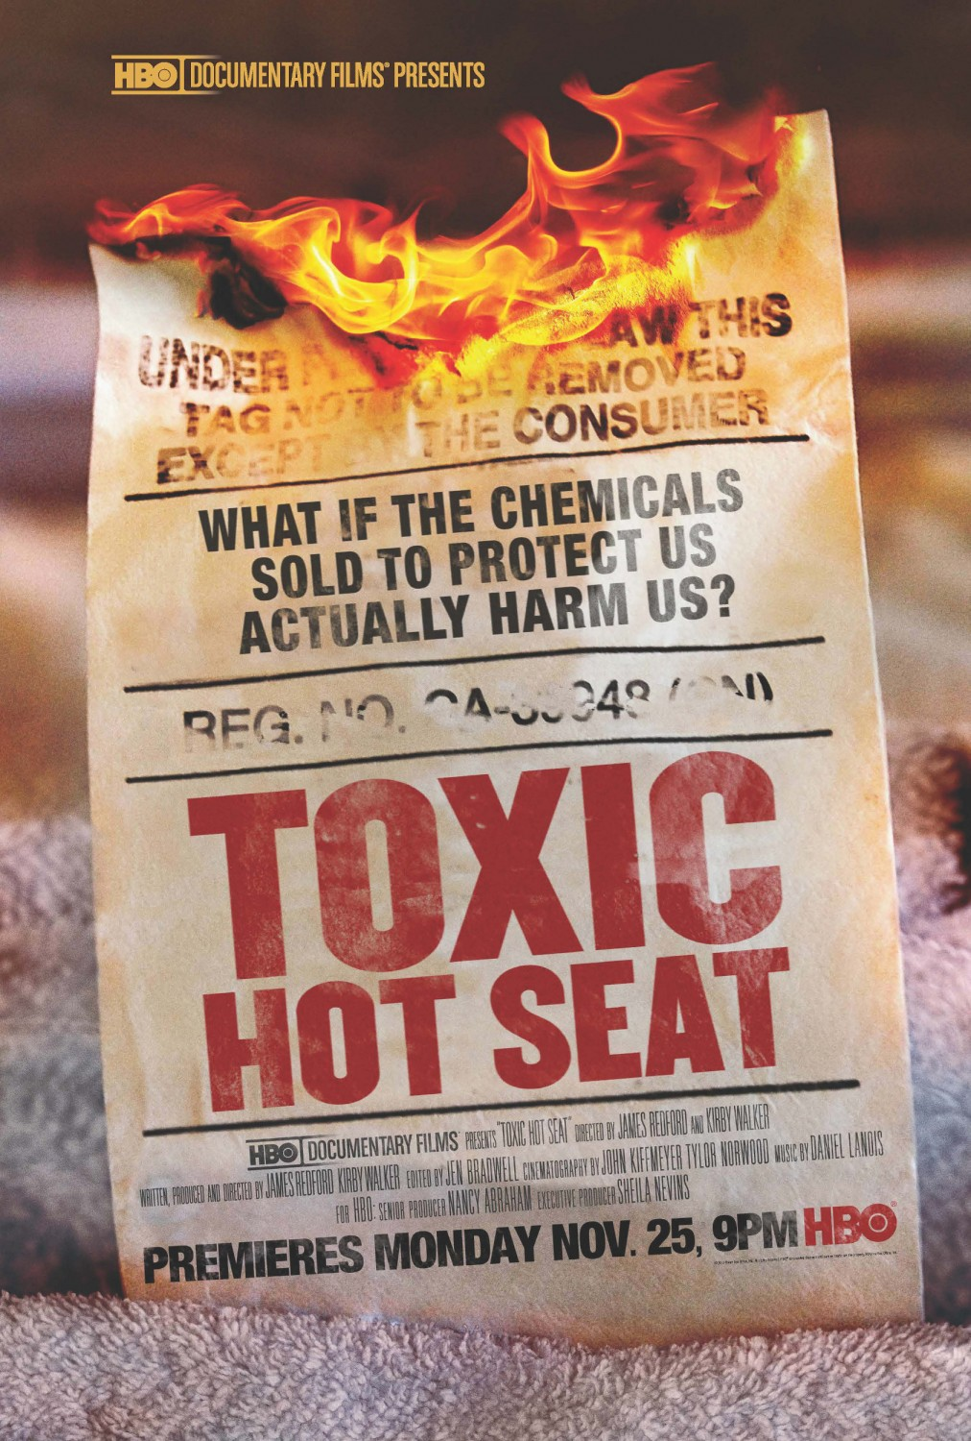
EDUCATIONAL GUIDE

TABLE OF CONTENTS

Overview
About the Issue: Why We Made “Toxic Hot Seat”
Where the Issue Stands Now

About The Film

About The Characters

About The Filmmakers

Post-Viewing Discussion Guide

Q&A
For Consumers
With Arlene Blum, Director of the Green Science Policy Institute

How To Take Action

OVERVIEW

About the Issue
Why We Made “Toxic Hot Seat”

Flame retardants have become a defining public health emergency, forced under the rug by a billion-dollar industry and for too long, a compliant government. These dangerous chemicals are in our furniture, and therefore our air, our breast milk, our blood and our urine.

Just like novelists, playwrights, and screenwriters, documentary filmmakers strive to tell stories. Non-fictions stories – those that expose what we have a right to know and have a duty to be told. Kirby Walker and James Redford felt compelled to give voice to a host of inspiring individuals crusading for justice against the Chemical Industry’s use of flame retardants. The voices of these heroes from around the country, have gone largely unheard. And the story of flame retardants and their impact on our health is still unknown to most Americans.

The urgency is as undeniable as it is universal - firefighters are dying, infants are being poisoned, wildlife is at risk, and so are you. Described as "an untold public health threat that's in everyone's home" by Pulitzer Prize winning investigative reporter Sam Roe. This is the type of story that absolutely must be told.

Why do we use dangerous flame-retardants in our couches? Science shows that they don’t even work. So why do we allow America’s children to jump, crawl and nap on objects that are endangering them? And what will put a stop to the crisis? The answers to these questions take us deep into the deadly nexus of money, politics and power. Progress is being made, and “Toxic Hot Seat” calls on you to join the growing movement of inspiring citizens leading the way towards positive change.

Where the Issue Stands Now

Since the film began production, several state legislatures have banned flame retardants in furniture. California’s Governor Jerry Brown directed a state agency to replace TB 117, the outdated and ineffective flammability standard that furniture manufactures nationwide tend to obey, with an updated standard that will eliminate the use of unnecessary and toxic chemicals while providing better fire safety. California's updated flammability standard TB117-2013 should be enacted on January 1, 2014 when it would become possible to buy fire safe furniture without harmful flame retardants.

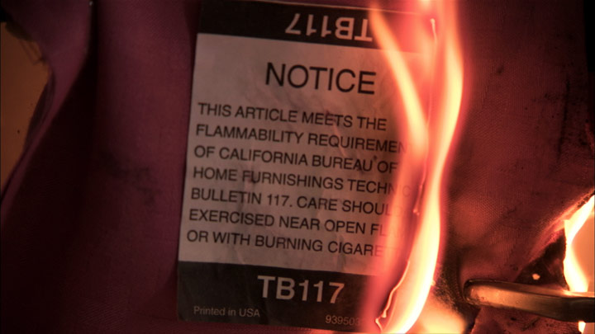

Currently, under the 37-year old Toxic Substances Control Act, chemical manufacturers have close to no responsibility to prove chemicals are safe before being used in commerce, and the government has almost no authority to ban hazardous chemicals. As Janet Nudelman wrote in The Hill, “Under TSCA it’s perfectly legal to use formaldehyde, benzene, vinyl chloride, asbestos and other known or suspected carcinogens to make items we use every day, including household cleaners, furniture and plastics.”

In February of 2013, New Jersey Sen. Frank Lautenberg and 22 other senators, all Democrats, called for the EPA to take a closer look at flame retardants and evaluate whether flame retardant chemicals are harmful. In June, the 23 senators introduced the Chemical Safety Improvement Act. Safer Chemicals does not support the bill in it's current form. Their proposed improvements fit within the framework of the Chemical Safety Improvement Act and, in their words “offer them in the spirit of promoting bi-partisan cooperation to enact a program that protects public health and the environment, and drives innovation.”

According to Marcia G. Yerman of The Huffington Post, “Toxic Hot Seat has ignited awareness,” and the results of that awareness are widespread: major actions at the state and federal levels are underway.

In the final days of Vermont's busy legislative session this May, the Green Mountain state unanimously passed the nation’s strongest ban on cancer-causing flame retardants. The public health victory included a ban on particularly chlorinated Tris, widely used in children’s products like high chairs, car seats, nursing pillows and changing pads. Recent studies have found Tris in the majority of couches on the market today. These chemicals migrate out of these products into air and dust, and from there enter our bodies, where they are linked to cancer, asthma, lowered IQ, decreased fertility, and other harmful effects.

Washington State failed to pass a similar bill in April, bowing to pressure from chemical makers, Walmart, and the Association of Washington Business.

Several efforts over the past few years in California have also come up empty, as the chemical lobby has spent millions in preventing any changes to the state’s flammability standard. Despite this, grassroots efforts in California have successfully pushed for an updated version of TB 117, the outdated and ineffective flammability standard that furniture manufactures nationwide tend to obey. In June of 2012, Governor Jerry Brown directed a state agency to replace TB 117, with an updated standard that will eliminate the use of unnecessary and toxic chemicals while providing better fire safety.

California's updated flammability standard TB117-2013 was enacted in January of 2014, and it is now would become possible to buy fire safe furniture without harmful flame retardants.

Similarly to Vermont, the state of Maryland passed a landmark bill in the month of May. The bill, although weak compared to Vermont’s, forces stricter regulation flame retardants in furniture.

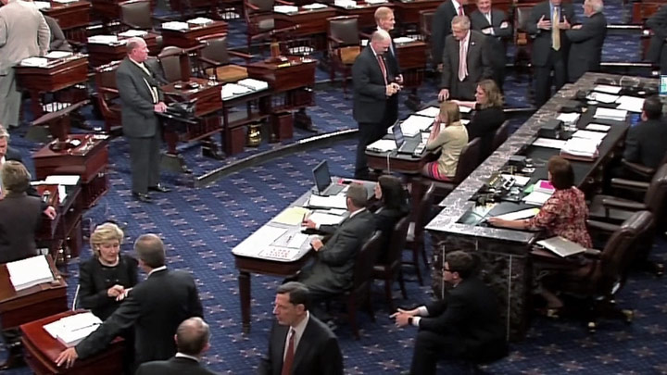

Flame retardant furniture bans have been proposed in several states where they have yet to be voted on. The state of Alaska introduced Senate Bill 27, which would ban flame retardants from furniture. The New Jersey legislature induced identical bills in the Senate (S 2722) and Assembly (A3915) to ban the manufacture and sale of products containing decabromodiphenyl ether (decaBDE). Introduced earlier this month by New York State Assemblyman Robert Sweeney, A 6557 would also require residential upholstered furniture sold in New York to comply with an open flame standard. If passed, beginning July 1, 2014, no residential upholstered furniture "that contains chemical flame retardants intentionally added" could be sold in New York.

Harvard, under pressure from students and faculty, is considering eliminating flame retardant dorm furniture from campus. “Harvard is actively seeking to purchase furniture to help meet that goal, while continuing to meet safety requirements included in state law,” Harvard College spokesperson Colin Manning said in a statement that was soon challenged by the chemical industry.

ABOUT THE FILM

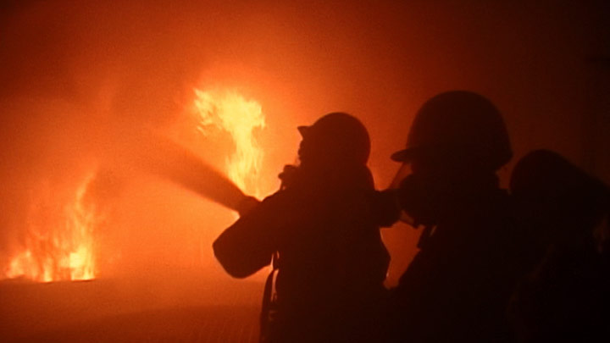

TOXIC HOT SEAT tells the story of a growing tide of activists, journalists and citizen groups who are bringing an end to the era of manipulation and misinformation about hidden toxic chemicals.

The film shows the struggle to remove toxic flame retardant chemicals from our couches, environment and bodies.

These chemicals are linked to lower IQ in children, thyroid disease, infertility, cancer and other rising rates of health problems. They are found in every living being on earth.

While we are entering the era of less toxic fire safety, our homes and children continue to be exposed to tens of thousands of unregulated chemicals.

Under the 37-year old Toxic Substances Control Act (TSCA), chemical manufacturers have little responsibility to prove chemicals are safe before using them in commercial household products.

As Janet Nudelman from Breast Cancer Fund wrote in a Washington, DC venue aimed at legislative staffers called The Hill: "Under TSCA, it's perfectly legal to use formaldehyde, benzene, vinyl chloride, asbestos and other known or suspected carcinogens to make items we use every day, including household cleaners, furniture and plastics."

The good news is that effort to reform the Toxic Substances Control Act is alive and well. With the tragic loss of the original sponsor, Senator Frank Lautenberg, authorship of the new bill has broadened to more Senators engaged in protecting environmental health and will be hitting the floor for a vote late 2013 or early 2014.

This is our chance. It will be up to all of us to make sure that special interests do not defeat this new bill with the addition of environmental health protections firmly in place.

Those who put corporate profit before public health cannot succeed unless we are disinterested and disengaged. So let’s spread the word online and on the ground that this bill with the additions to it of strong environmental health protections needs to pass.

TOXIC HOT SEAT captured a rare and special moment in time when Californians, with health advocates nationwide, came together to face unethical corporate interests to protect our health and the health off future generations.

The time is now for the entire country to insist on a toxic free future. Let’s get it done!

ABOUT THE CHARACTERS

Tony Stefani - Retired San Francisco Fire Department Capitan 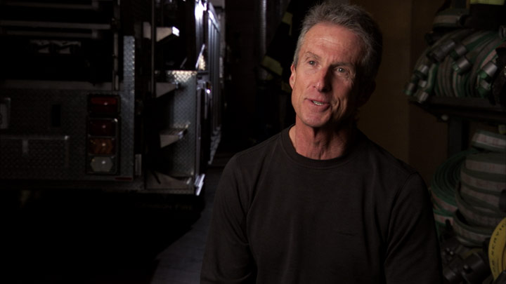
Tony Stefani is retired San Francisco Fire Department captain, who, after beating cancer, founded of the San Francisco Firefighters Cancer Prevention Foundation. He has been published in the San Francisco Examiner and his activism against flame retardants in furniture has led him to testify on the topic in Washington D.C.

Andrew McGuire - Fire Trauma Prevention Specialist & Grassroots Lobbyist

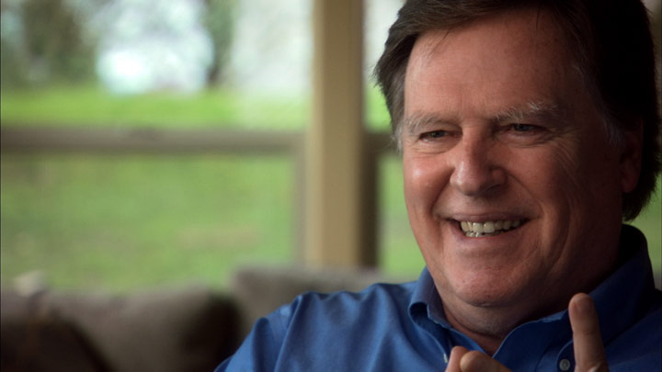
Andrew McGuire is a burn victim and has a lifelong commitment to preventing injuries from fires. He founded and was the former Executive Director of the Trauma Foundation, formerly known as the San Francisco Burn Council, where he advocates against unnecessary and deadly flame retardants in furniture. He was awarded a MacArthur Genius award for his decades long battle against the tobacco industry and his successful campaign for fire-safe cigarettes.

Hannah Pingree - Retired Maine Legislator & Former Speaker of the Maine House

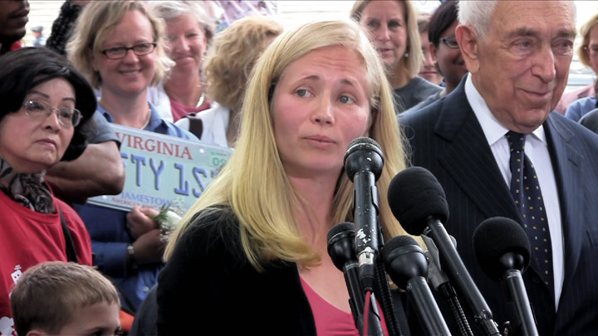
Hannah Pingree a mother of two young children and is a politician from Maine, where she served four terms in the State Legislature representing 10 islands and coastal towns, before being forced to leave office by state term limits. She served one term as Speaker of the Maine House, and her activism against fire retardants in furniture led to a statewide ban, allowing Pingree to testify in Washington. Pingree is actively involved in the battle to reform the outdated Toxic Substances Control Act.

Arlene Blum - Visiting Scholar at the Chemistry University of California, Berkeley



Arlene Blum Ph.D. is an award-winning writer and environmental health chemist who has pushed tirelessly for safer chemical standards, conducting breakthrough research around the world. Her work has led to major reductions in toxic chemicals in several industries and she has led the fight to eliminate fire retardants in household furniture. As a prominent American mountaineer, Blum is best known for leading the first successful American and only all-women ascent of Annapurna.

Michael Green, MS, MPH
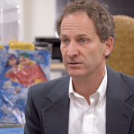

Michael is the Executive Director for the Center for Environmental Health (CEH) charged with raising public awareness of the corporate use of toxic chemicals and of the many viable, pragmatic solutions to this pervasive threat to public health. He founded CEH in 1996 and since then has helped lead national efforts to stop toxic exposures and protect public health.

Patricia Callahan - Investigative Reporter with The Chicago Tribune


Patricia Callahan is an investigative reporter on the Chicago Tribune's Watchdog Team. She launched the Chicago Tribune investigation that proved the nation's top consumer product safety agency failed to protect children from deadly chemicals. The series, which prompted the recall of more than 1 million baby products, won the 2008 Pulitzer Prize for Investigative Reporting and spurred Congress to pass the largest overhaul of consumer product safety laws in a generation.

Sam Roe - Investigative Reporter with the Chicago Tribune

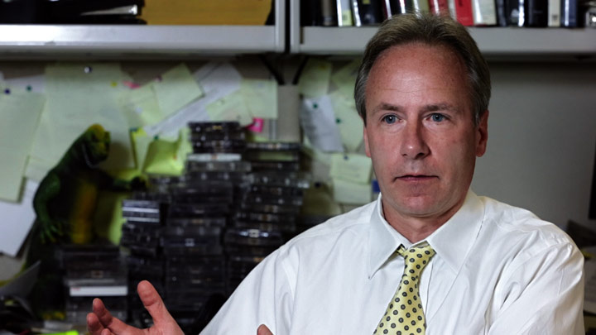

Sam Roe is a journalist at the Chicago Tribune, where he reports on public health, corporate wrongdoing and criminal justice. He was a key author of Goldsmith Prize-Winning work on industry deception regarding the safety and effectiveness of flame retardants.

Michael Hawthorne - Investigative Reporter with the Chicago Tribune
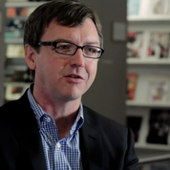

Michael Hawthorne is the award-winning environment reporter for the Chicago Tribune. He was also a key author of Goldsmith Prize-Winning work on industry deception regarding the safety and effectiveness of flame retardants.

Sarah Janssen MD -Former Senior Scientist at the NRDC (Natural Resources Defense Council)


Dr. Sarah Janssen is an expert environmental health scientist who works at the NRDC to protect vulnerable populations from chemical threats to development, reproduction and fertility. She received an MD and PhD in Reproductive Biology from the University of Illinois, and did her residency training in Occupational and Environmental Medicine in San Francisco, where she got a Masters in Public Health.

Gordon Damant - Author of TB117

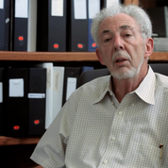
Gordon Damant is a fire flammability expert and fire safety advocate. He is the original author of California Technical Bulletin 117, which mandates high levels of fire-resilient filling materials in upholstered furniture. He has since advocated for a reform of the law.

Marcelo Hirschler - Ph.D. Chemist with GBH International, Specializing in Fire Science
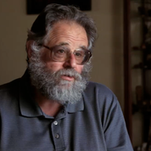

Marcelo Hirschler is an esteemed, author of over 350 technical and scientific publications and is a fire expert who works with the chemical industry defending the use of flame retardants. He is the founder of GBH International, which provides fire litigation support, codes & standards assistance, and contract fire testing & research. Hirschler has advocated fiercely for flame retardants in household furniture.

Vytenis Babrauskas - Founder of Fire Sciences and Technology Inc.
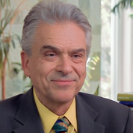

Dr. Vyto Babrauskas is highly experienced as a civil engineer, laboratory instructor, fire modeler, professor, and editorialist, with two graduate engineering degrees from the University of California, Berkeley. He is the first person ever to be awarded a Ph.D. degree in Fire Protection Engineering. He disputes the industry and has fought against the effectiveness of flame retardants. Babrauskas was featured in the front-page flame-retardant series in the Chicago Tribune.

Karen Kerr Stone - Lieutenant Firefighter in San Francisco
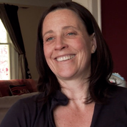

Karen Kerr Stone grew up in New York City dreaming of being a firefighter, and her dream came true- she spent 12 years as a firefighter in San Francisco, before being promoted to Lieutenant. She now works on Engine 25 in the San Francisco's Bayview neighborhood and is a Director, Crew Leader, and Board Member at Camp Blaze, a fire camp for young women. Stone has fought the chemical industry as an advocate against fire retardants. Karen has two young children and her concern for children’s health has motivated her passion.

Ana Mascareñas - Policy & Communications Director for Physicians for Social Responsibility-Los Angeles
As Policy and Communications Director at Physicians for Social Responsibility-Los Angeles, Ana Mascareñas works to inform doctors and politicians about toxic threats, promote safer practices, and strengthen local community organizations to engage in meaningful public health and environmental advocacy. Ana is Mexican American and she work tirelessly to protect communities of color from exposures to toxic chemicals. She is a steering committee member of Californians for a Healthy and Green Economy (CHANGE), a broad based coalition pushing for greater regulation of toxic chemicals. She has taken on the flame retardant industry and testified against them in Washington D.C.
Read more about Mascareñas : http://www.psr-la.org/about/staff/

Jerry Brown - Governor of California

The current governor of California, Jerry Brown has put forth new flammability standards for furniture and baby products to reduce use of chemicals that have been found in toddlers' bodies. Brown previously served as California's 34th Governor from 1975 to 1983. Both before and after his original two terms as Governor, Brown served in numerous state, local, and party positions.

Barbara Boxer - United States Senator from California
Senator Barbara Boxer is a California Democrat who chairs the Senate Environment and Public Works Committee. Boxer has spent 30 years in congress and has been active in fiercely challenging chemical corporations about flame retardants.

Don Lucas Ph.D. - Chemist at UC Berkley & Lawrence Livermore National Laboratory
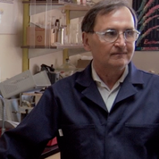
Don Lucas is a staff scientist in the Environmental Energy Technologies Division of the Lawrence Berkeley Laboratory, where he is a Principal Investigator in the Combustion Group. He has received funding from several major agencies and organizations including the Department of Energy, the state of California, and the EPA. Lucas has led the fight against flame retardant chemicals in furniture.

ABOUT THE FILMMAKERS



Kirby Walker
Kirby is an award winning independent film and video producer. She worked for CBS News in New York, and left to do graduate work in communications at Stanford University, where she received her MA in Communication. She founded Omega Productions, an educational and corporate film and video and production firm where she produced and directed projects for numerous clients including: Apple, The Gap, Levi Strauss, Pacific Telesis. She is currently an Honorary Board member of the Natural Resources Defense Council in New York, and Summer Search San Francisco and has served on the boards of Marin Country Day School, and The Center for Investigative Reporting. She serves on the Advisory Committee for Golden Gate National Parks Conservancy.

James Redford
James writes, produces and directs for film and television. His latest directorial project, Aces, is a documentary film that explores the emerging link between childhood trauma and life-long health problems - and what can be done about it. He directed The Big Picture: Rethinking Dyslexia currently airing on HBO. He also produced the film Watershed about the Colorado River and the acclaimed HBO documentary Mann V. Ford.
Additionally, James wrote and directed Quality Time, an award-winning short comedy starring Jason Patric. He recently combined his passion for music and directing in Andain’s new music video, Much Too Much.
Other credits include producing The Kindness of Strangers which premiered at Sundance in 1999 and was picked up by HBO as well as adapting and directing Showtime’s Spin starring Stanley Tucci, Dana Delany, and Ruben Blades. Redford also wrote the original screenplays for Cowboy Up starring Kiefer Sutherland and Darryl Hannah as well as adapting Tony Hillerman’s Skinwalkers, a PBS/Mystery! series that was the highest-rated PBS-scripted program of 2002. The Acting Thing, a comedic short written by James, was named best comedic short at the 1996 Houston Film Festival and aired on the Sundance Channel that same year.
After surviving two liver transplants, James founded JRI, a non-profit dedicated to promoting a deeper understanding of the miraculous gift of organ donation. His live musical event, "Share the Beat", has been performed across the country with the help of notable talents such as:? Tim McGraw, Phil Vassar, Deana Carter, Ruben Blades, Dana Delaney, James Denton, Ryan Merriman, and Eric Stromer among others.
James also plays guitar for Olive and the Dirty Martinis, a popular Bay Area rock and roll cover band. He is an avid surfer, cyclist, and skier and currently lives in Marin County, CA.

POST-VIEWING DISCUSSION GUIDE

The following questions serve as suggested discussion topics for viewers of “Toxic Hot Seat.” We recommend asking these questions of others you know who watched the film. We hope this can act as a helpful tool for groups of people immediately after they finish a screening party or family viewing.

Question 1
Did you know about the threat of toxic chemicals in your home? Had you ever considered the threat of flame retardants in your furniture? Does “Toxic Hot Seat” make you rethink the furniture in your home? Where was your furniture manufactured and sold?

Question 2
Several states have regulated or banned couches with flame retardants? Are you curious or aware where your state legislature stands? Do you believe this should be a state or federal regulatory matter?

Question 3
Who do you blame for the lack of public knowledge about flame retardants? Had you read the Chicago Tribune article on the topic or any of the similar articles that followed? Do you think they were unsuccessful in getting flame retardants into everyday conversations?

Question 4
What impact do you anticipate “Toxic Hot Seat’s” HBO premiere having?

Question 5
Will you now be more actively supporting or campaigning for chemical reform? Do you plan on being politically active related to the issue of flame retardants?

Q&A

For Concerned Citizens

Why has upholstered furniture been treated with flame retardants?
A California furniture flammability standard called Technical Bulletin 117 (TB117) led to the use of harmful and ineffective flame retardant chemicals in upholstered furniture and baby product foam across the US and Canada from 1975 to the present.
This standard only tests product filling material and does not address the fabric covering where fires start, nor does it address the leading cause of furniture fires: cigarettes. TB117 has been updated and is being replaced by TB117-2013, which stops cigarette fires where they start, on the fabric. The new standard provides increased fire safety without the use of flame retardants.

How can I buy furniture without flame retardants?
Manufacturers can begin to make flame retardant-free furniture under the new regulation, TB117-2013, beginning January 2014.
Although the new standard can be met without flame retardants, it does NOT ban their use. Look for the TB117-2013 label on products, and then verify with your retailer or manufacturer that products do not contain flame retardants.

What are the health concerns associated with flame retardants in furniture?
Flame retardant chemicals have been associated with a host of human health concerns, including lower birth weight, reduced IQ (similar to lead poisoning), hyperactivity, poorer coordination, reduced fertility, birth defects, hormonal changes, and cancer.

Is there scientific research to back up the information about health problems?
To date, there have been over 4,000 studies on PBDEs alone and the literature continues to grow. The Green Science Policy Institute compiled a bibliography with hundreds of references regarding the negative health impacts of flame retardants used in furniture which is available here.

How do I know if my old couch or other furniture contains flame retardants?
If your furniture contains polyurethane foam and has a label stating that it meets California Technical Bulletin 117 (TB117), then it almost certainly does contain flame retardant chemicals. Unfortunately, even if furniture does not have a TB117 label, if it contains polyurethane foam, it could still contain flame retardants. Since there are no laws that require manufacturers to provide this information to consumers, the only way to know for sure is to test the foam by analytical chemistry methods.

Can I get my product with foam tested?
Testing for all types of flame retardants is not readily available to consumers as far as we know.
There is one service for consumers we are aware of that can test foam samples for brominated flame retardants (like PBDEs):
http://berkeleypurehome.myshopify.com/
Note that this service does not test for all kinds of flame retardants, only brominated. Chlorinated and phosphate flame retardants are also of concern.

What can I do to reduce my family’s exposure to flame retardants?
The best way to reduce exposure to flame retardants is to remove products containing them from your indoor environments.
The next best strategy is to keep household dust levels down. Most exposure to flame retardants occurs after the chemicals migrate out of a product’s foam and settle into household dust, which then enter our bodies by hand-to-mouth contact. Vacuuming frequently with a HEPA filter, wet mopping, and dusting with a damp cloth can reduce household dust. Finally, washing your and your children’s hands frequently, and always before eating, can help reduce ingestion of dust containing flame retardants. Visit our Consumer Resources page to learn more.

Do slipcovers help prevent flame retardants from leaving the foam?
Unfortunately, slipcovers offer no protection from potentially harmful flame retardants--the chemicals are not bound to the foam and can easily travel through a slipcover. The chemicals are constantly dispersing into the air, then settling in dust. Exposure comes primarily from ingesting contaminated dust.

Is my mattress treated with flame retardants?
If your mattress was made after 2007, it is unlikely that the foam inside contains flame retardants. Adult mattresses are now regulated by a severe flammability standard (16 CFR 1633) which cannot be met by including flame retardants in the foam. Barrier materials wrapped around the foam are used to stop fires before they reach the foam. Some barrier materials, like fiber batting, are naturally fire resistant, and others, like cotton, may be treated with boric acid which does not present the same concerns as flame retardants. However, there may be other chemicals of concern in some mattress barrier materials. There are companies that sell mattresses with a removable zippered barrier. Some companies can also sell you a mattress without the barrier with a prescription for a chemical free mattress from a doctor saying that you experience chemical sensitivity.
If your mattress was made before 2007, it may contain flame retardant chemicals in the foam. It is not a bad idea to consider replacing these older mattresses as your budget allows.

Is my child’s mattress treated with flame retardants?
Smaller mattresses that contain polyurethane foam, such as juvenile and crib mattresses, usually do contain flame retardants.

What other children’s products contain flame retardants?
We tested 101 foam samples from baby products including nursing pillows, nap mats, and sleep positioners, and found that over 80% contained flame retardants at levels up to 12 percent of the weight of the foam.

Is my carpet or carpet cushion treated with flame retardants?
Carpets are not usually treated with flame retardants as there is no standard that we are aware of that would require carpets to contain these chemicals. However, bonded polyurethane carpet cushion, which is over 85% of carpet cushion currently produced in the United States, usually contains flame retardants. This cushion is made from the same flame retardant foam that is used in furniture. One solution to avoid flame retardants is to use a natural wool, natural rubber, fiber or felt pad under carpeting rather than bonded foam carpet cushion.

Do children’s pajamas/ clothing contain flame retardants?
Toxic "Tris" flame retardants were removed from children’s pajamas in the 1970s, and it is unlikely that other halogenated flame retardants are used in pajamas.
Sleepwear for children under 9 months of age and pajamas that are tight fitting for any age should not contain added flame retardants. Look for a tag that says, "For child’s safety, garment should fit snugly. This garment is not flame resistant. Loose fitting garment is more likely to catch fire," or similar language. This means that the fabric used to make the garment was probably not treated with flame retardants.
Some cotton pajamas may be treated, often with the phosphate chemical tetrakis hydromethyl phosphonium chloride (THPC or Proban aka Securest).

With Arlene Blum, Director of The Green Science Policy Institute
From Healthy Building News
Bill Walsh: How did you get started working on flame retardants?
Arlene Blum: Thirty years ago, as a researcher at the University of California, Berkeley, I published a paper in Science magazine showing that "Tris" flame retardants in children's sleepwear caused mutations, were possible cancer hazards, and migrated from pajamas into children. The flame retardants were removed from children’s sleepwear in 1977, but chlorinated tris is now back in use in foam in furniture and other products.
BW: Why are you so concerned about flame retardants in building materials?
AB: If a building contains halogenated flame retardants in the insulation, they can filter into the building throughout its life and also form toxic dioxins if the building burns.
I know it's a real dilemma for people when they learn that plastic insulation materials, such as polystyrene, polyisocyanurate, and polyurethane, that can help reduce climate change, often contain flame retardants which can cause serious health and environmental harm. But the good news is that this is a problem that can be solved.
Once green building professionals understand the issue, they can move to safer substitutes and strategies that don't have potential adverse health impacts. In fact of the various groups with which I've worked on reducing toxics in products, the green building community has been the most responsive. So I am very happy to have the opportunity to share the message about moving away from the use of halogenated flame retardants at Greenbuild.
The new LEED Pilot Credit on Chemical Avoidance for not using phthalates and halogenated flame retardants inside buildings should accelerate our progress towards healthier buildings.
BW: You mentioned that this is also a chemical contamination problem that could have negative impacts on our health and well-being at a global level? How?
AB: Many halogenated flame retardant chemicals are persistent and bioaccumulate especially in humans and animals high on the food chain. It is almost impossible to clean them up once they are out in the world. For example, PCBs, chlorinated chemicals that were also used as flame retardants, were banned in 1977, but very high concentrations can still be found in wildlife and some human populations today. Studies show that human breast milk contains flame retardants, and toddlers have three to four times higher body levels than their mothers.
When tested in animals, many halogenated flame retardants have been found to cause health problems like cancer, reduced fertility and IQ, thyroid disorders, and developmental impairment. Many halogenated flame retardants are also endocrine disrupting chemicals that can harm us at very low concentrations.
BW: How do you weigh the known benefits today against long term unproven risks?
AB: In furniture there is no proven benefit. It makes more sense to reduce the sources of ignition with fire-safe cigarettes and candles than to put potentially toxic chemicals in all the possibly flammable materials in our homes. Today the risk of home fires is diminishing due to a 50% decrease in cigarette consumption since 1980, enforcement of improved building, fire, and electrical codes, increased use of sprinklers and smoke detectors. These strategies provide measurable improvements in fire safety without toxicity.
Smoke and toxic gases kill people in fires, more than flames. Research on furniture fires show that while halogenated flame retardants can reduce the time for ignition by seconds, they greatly increase the carbon monoxide, smoke, and soot. The chemicals also release dioxin and related compounds when burned at relatively low temperatures. So the benefits of retarding the fire with toxic chemicals is greatly reduced by the increased fire toxicity and dioxins at the fire scene.
Given the lack of proven benefit in some cases, the risk-benefit calculation on chemical flame retardants can be tenuous even before you start to consider the widespread exposure to these chemicals on a daily basis.
Better methods of reducing fire risks include careful material selection and alternative fire suppression strategies that can be designed into products and buildings.
BW: What will people take with them from your speech at Greenbuild?
AB: I hope they will leave with the confidence that the toxic flame retardant problem can be solved, and that they can contribute. When people know about the hazards of the flame retardants that are commonly used in many plastic foam insulations, furnishings and other building materials, they can choose alternative products or push for less toxic flame retardants. I will give them the information they need to get started avoiding halogenated flame retardants. When green building professionals make these choices, this will increase the availability and decrease the cost of the alternatives.
We will also have a discussion of the new Chemical Pilot Credit - how to get it and how to improve it. The credit currently targets interior finish materials and furniture but can be even more beneficial if it includes insulation - one of the largest sources of halogenated flame retardants in the building.
Moving the market demand for flame retardants in the huge building sector can also help with policy changes. We have been providing scientific support to change a California furniture flammability standard to provide similar or greater fire safety without flame retardant chemicals.
We also need national chemical policy reform. Because of weaknesses in the Toxic Substances Control Act, which has not been updated since 1976, chemicals are innocent until proven guilty and that proof is almost impossible to obtain. Even asbestos could not be banned. And manufacturers are not required to perform any toxicity tests before putting chemicals into products! Green buildings need to be both energy-efficient and healthy. Reducing the use of halogenated flame retardants will help achieve this and help create a healthier world for us all.

HOW TO TAKE ACTION



- Join Safer Chemicals
  - Visit http://www.toxichotseatmovie.com/take_action and sign up to join Safer Chemicals, Healthy Families

- Host a Screening of “Toxic Hot Seat”
  - Visit http://www.toxichotseatmovie.com/contact and sign up to host a screening of “Toxic Hot Seat”

- Learn More
  - Visit http://www.toxichotseatmovie.com/take_action to learn more about organizations committed to chemical safety reform.
  - Visit http://www.toxichotseatmovie.com/contact to learn more about the film

EDUCATIONAL GUIDE BY SAM SMITH

