THE TEAM

Director/Producer:
Margreth Olin
Margreth.olin@speranza.no

Margreth Olin is a Norwegian award winning director and producer, most known for her documentaries. In 1998 her first full-length documentary In the House of Angels was released theatrically in Norway. Her international breakthrough came with the film “My Body” in 2002. Olin’s documentary “Doing Good” is one of the highest grossing documentaries ever in Norway.

Filmography:
The Self Portrait (2020) Director/Producer
Isolation Row (2018) Producer
Childhood (2017) Director/Producer
Doing Good (2016) Director/Producer
Cathedrals of Culture (2013) Director
Nowhere Home (2012) Director/Producer
The Angel (2009) Director
Lullaby (2006) Director
Raw Youth (2004) Director
My body Min (2002) Director
Gluttony (2000) Director
In The House of Angels (1998) Director
My Uncle (1997) Director
In the House of Love (1994) Director

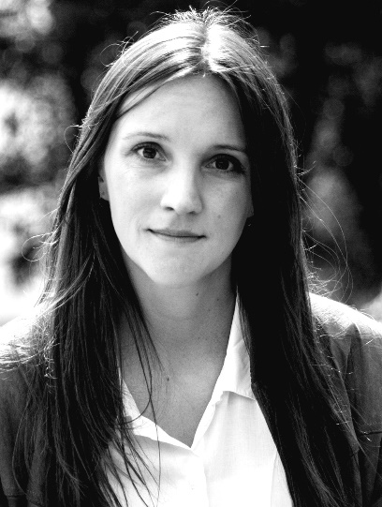
Director:
Katja Høgset
katjahogset@yahoo.no

Katja Høgset graduated in 2014 from Lillehammer University College as a documentary film director. Her graduation film “The best” was screened at several festivals in Norway. Since then she has been working in Speranza Film, making her debut documentary feature “Isolation Row” (2018). It was seen by 600 000 people on national television, and it created national debate and political change.

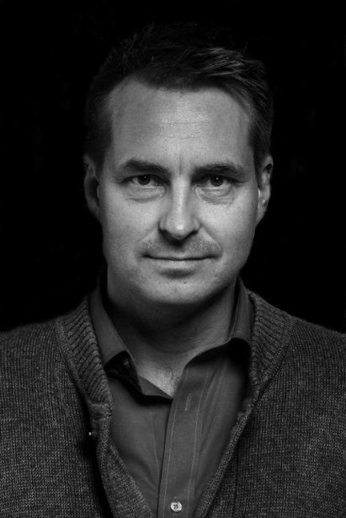
Director:
Espen Wallin
espenwallin@me.com
Espen Wallin is a Norwegian photographer, who has published his documentary images, portraits and own work in the major Norwegian magazines. Lately he has been focusing on filming and has done several music videos and commercials for social media. He has also been working with Lene Marie Fossen for 8 years, and has through that relationship earned an exclusive and unique position to capture the essence of her work.

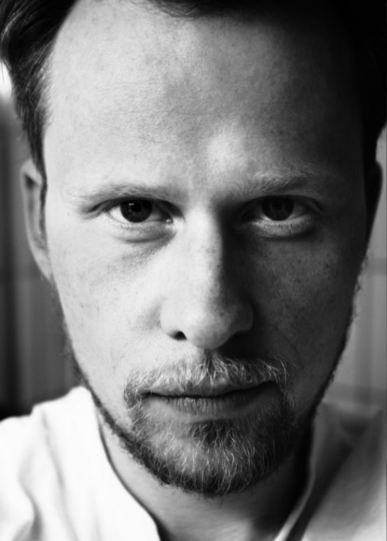
Cinematographer:
Øystein Mamen
oysteinmamen@gmail.com

Øystein Mamen graduated as cinematographer at The Norwegian National Filmschool in 2006. He has received several awards for his work, among them Kanonprisen and Amanda: «Best Cinematographer of 2017» for «The rules of everything», «Cinematographer of the year 2008» by Kodak Norway for his work on «The Summerhouse» and Kodak Grant for his diploma film «To the moon».

Production company:
Speranza Film AS
St.Halvardsgt. 12
0192 Oslo, Norway
Margreth.olin@speranza.no
Lena.sandvik@speranza.no

Speranza Film is a Norwegian film production company, founded in 1995 by Thomas Robsahm and Margreth Olin, producing feature films, documentaries and Tv-series. Speranza’s feature film “Doing Good” is one of the highest grossing documentaries ever in Norway.

