MAYA
www.mayafilm.co.uk
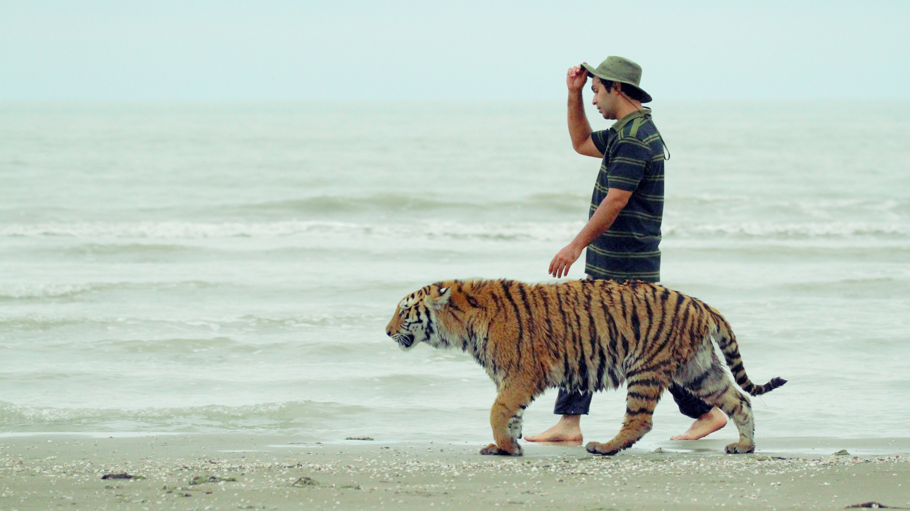
Logline: An Iranian zoo keeper takes a bengal tiger into the wilds of the Caspian sea - a trip that kick-starts the beginning of the end of their relationship.

Synopsis:
Every day, thousands of visitors flock to the zoo in the Iranian city of Mashhad to see the tigress Maya and her trainer Mohsen with their own eyes. Having raised the Bengal tiger, he is the only one that Maya listens to. From feeding and stroking to playful fighting, the predator tolerates her foster father’s presence in the enclosure. When Maya is allowed to leave the zoo for a short period to star in a film, she’s sent to an empty tiger farm on the Caspian Sea. Between shooting dates, Mohsen allows her to run around in the almost deserted landscape. With the freedom to roam around without bars for the first time in her life, the animal’s suppressed instincts rise to the surface. But their sobering return, and the revelation of frightening incidents at the zoo, casts a new light on their relationship. With an extraordinary approach to the protagonist and the predator, the filmmakers highlight the complex and questionable fascination with the domestication of wild animals.

The zoo, like the cinema, is a space designed with exhibition in mind and from its inception cinema and video has exploited this space from the Lumiere brothers film ‘Lion’ shot in 1895 to the first Youtube video ‘Me at the Zoo’ in 2005. Maya sits within a continuation of cinema’s fascination with zoos where the act of looking is turned on its head as the animals look back at us.

Production Details
Year: 2020
A film by: Jamshid Mojaddadi, Anson Hartford
Producer: Hugh Hartford

Credits

BFI DOC SOCIETY FUND presents a BANYAK FILMS production ‘MAYA’ in co-production with ZDF & MAKING MOVIES in collaboration with ARTE in association with Yle, SVT, SRF, ERT with support of CREATIVE EUROPE – MEDIA PROGRAMME OF THE EUROPEAN UNION original music by CHRISTOPHER WHITE editor OLLIE HUDDLESTON cinematographers NICOLAS BOOTH, REZA JAFARZADEH, MAJID TAHERMANESH sound designer JAMES BULLEY visual effects JACK KIBBEY NEWMAN co-producers JAMSHID MOJADDADI, KAARLE AHO co-producer LADAN ANOUSHFAR commissioning editor for ZDF/ARTE TÜRKAN SCHIRMER executive producer LISA MARIE RUSSO produced by HUGH HARTFORD directed by JAMSHID MOJADDADI & ANSON HARTFORD

Stills
Download Here: https://drive.google.com/drive/folders/1qFy-BGu8Dig1p2KaIPA2Ql6jW_TBSJIU

Context
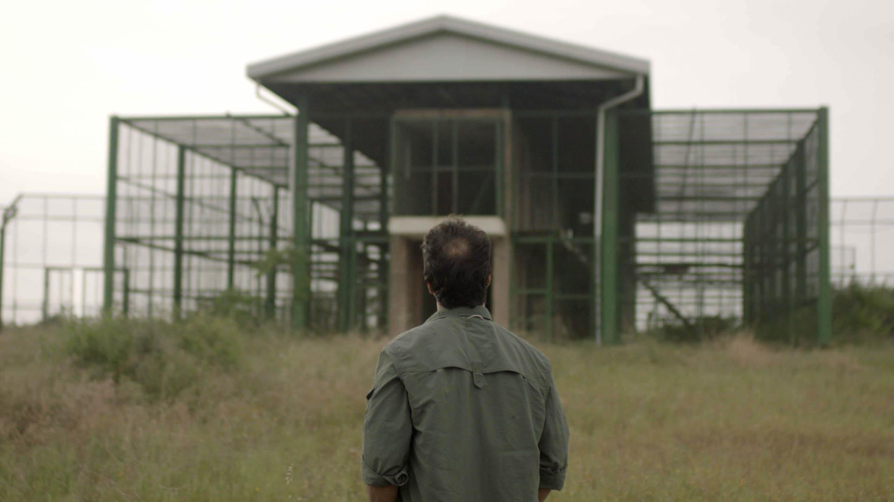

Mohsen and Maya travel 400km out of Mashhad to the Miankaleh Peninsula, a remote part of Northern Iran and home to the now extinct Caspian Tiger. The last one was reportedly shot in the peninsula in 1957. Today reintroducing tigers globally is a key part of a WWF goal of doubling the planet's wild tiger population. Meanwhile, there are more captive tigers in the U.S alone than wild tigers worldwide and petting zoos in Asia are being seen more as tiger farms breeding tigers for wildlife trade and traditional medicine.

In Iran, there was a re-wilding attempt in 2010 when 2 Siberian tigers were flown from Russia to Tehran - sadly one died of disease on the way and the rewilding project was abandoned. The only legacy from the attempt was the purpose built release compound positioned in the heart of the remote Miankaleh Peninsula and the reason that 8 years later Maya’s trip from the zoo was possible.

Story Overview
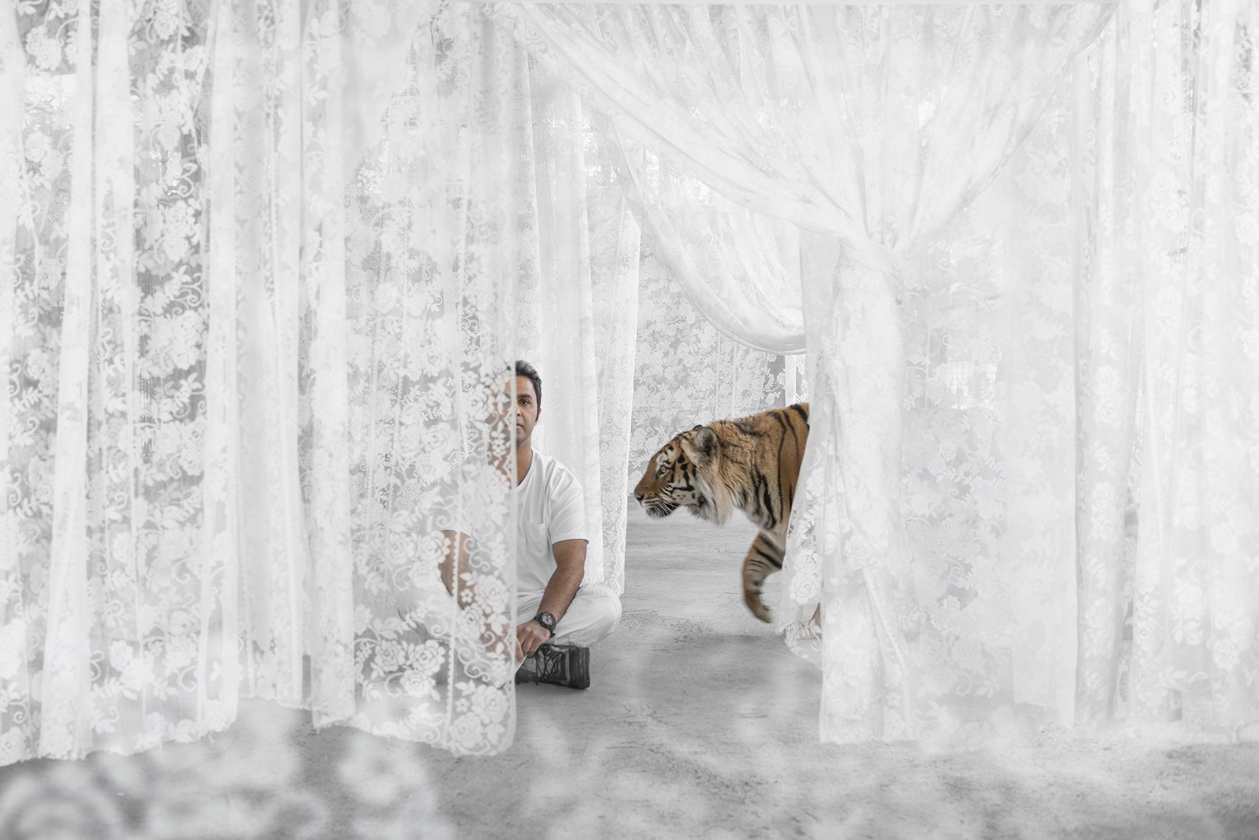
In 2009 there was a tragic accident in a circus in Mashhad. A trainer was attacked by a lion while performing a live show. In an attempt to save the man’s life the lion was killed. The man survived. After watching the horrific footage Mohsen reflects that the relationship between the lion and trainer was all based on fear and so the attack was unsurprising. The real tragedy was that the lion need not have been shot. “They should have just thrown water over it and he would have released the trainer. Lions hate water.”

The film plays out as an immersive piece of cinema that chronicles the curious, contradictory, compassionate and conflicted relationship between Mohsen and Maya.

The film starts with daily life at northern Iran’s Mashhad Zoo. Mohsen is the head keeper and is known for his ability to get close to big, wild and potentially deadly animals. While he clearly has a gift of working with crocodiles, snakes, leopards, chimpanzees and lions; Mohsen’s greatest achievement is his 4 year relationship with Maya.

Maya allows him to get closer than any other animal he has worked with. The bond is so strong that Mohsen feels comfortable allowing others into the cage to meet her and this has led to national fame for Mohsen and Maya. Everyday people arrive at the zoo hoping to catch a glimpse of Maya and Mohsen together, and maybe they will be lucky enough to be invited into the cage.

Today, Mohsen and Maya are preparing for a road trip to the north of Iran to shoot a fiction film. Here he meets an older farmer who remembers shooting a caspian tiger in the area and a discussion is had on the possibilities of rewilding tigers in Iran. Mohsen's enthusiasm is not shared by the locals.

In between filming Mohsen starts ‘releasing’ Maya into the wilderness and she experiences life as it was for the caspian tiger who used to live in the region. We see the natural beauty of the Caspian coast through her eyes; it has smells, textures, animals and rhythms all of which are new for her. We, as an audience, feel this as a long forgotten memory for Maya; we see her swim in the sea and we see her slow to a low hunched walk as she tracks a horse on the horizon. As the old memories become clearer, her instincts awaken and she starts to change. The film raises the thought that in remembering she is a wild tiger she discovers she has been captive her entire life and Mohsen takes her back to the zoo.

6 months later in Mashhad; Iran is under new US sanctions and the cost of living has doubled, the zoo comes under fire from local environmental activists after a tiger cub is found roaming the streets of Mashhad just outside the zoo director’s home. Both Mohsen and the zoo director are asked in for questions by a court judge, the rumour is that they give contradictory evidence and Mohsen is fired by the director of the Zoo. As Mohsen is forced to stop working at the zoo, he walks away from Maya and returns to his old job - as a taxidermist. But that's not the end of it - further scrutiny reveals a discrepancy in animal numbers at the zoo. Nine tigers appear to have died in just one year and the zoo is closed down until further notice.
With emotions running high and the zoo under inspection we find out that Maya is pregnant. Her new ‘caretaker’ Habib has promised to call Mohsen when she is in labour so he can come to help out with the birth.
At the zoo the authorities have decided that the closure of the zoo is damaging the wider economy in the city. Sanctions have really impacted on everyday life and the zoo is a key part of an economic ecosystem providing jobs and bringing in business for taxi drivers and the shops that surround the zoo. Under these circumstances, the authorities come up with a 10 point plan to improve the overall condition of the zoo, including the size of Maya’s cage and with the Director’s agreement the zoo is re-opened.
The day Maya goes into labour arrives and Mohsen heads to the zoo for the birth of Maya’s cubs. In an emotional scene he gets there to find she has killed 2 of her 3 cubs. With the help of the staff at the zoo he stitches the surviving cub's wounds and then tries to return her to suckle from Maya but stops short of entering the cage carrying the cub. In a very tense scene Mohsen realises that Maya is still very aggressive towards the newborn and for the first time feels that Maya might actually attack him. Finally Mohsen decides he has to try and get the cub to feed, it’s the only chance it has of survival and a chance for him to do the right thing after showing Maya her ‘freedom’ and then taking it away again. Bracing himself he takes the cub and enters the cage.

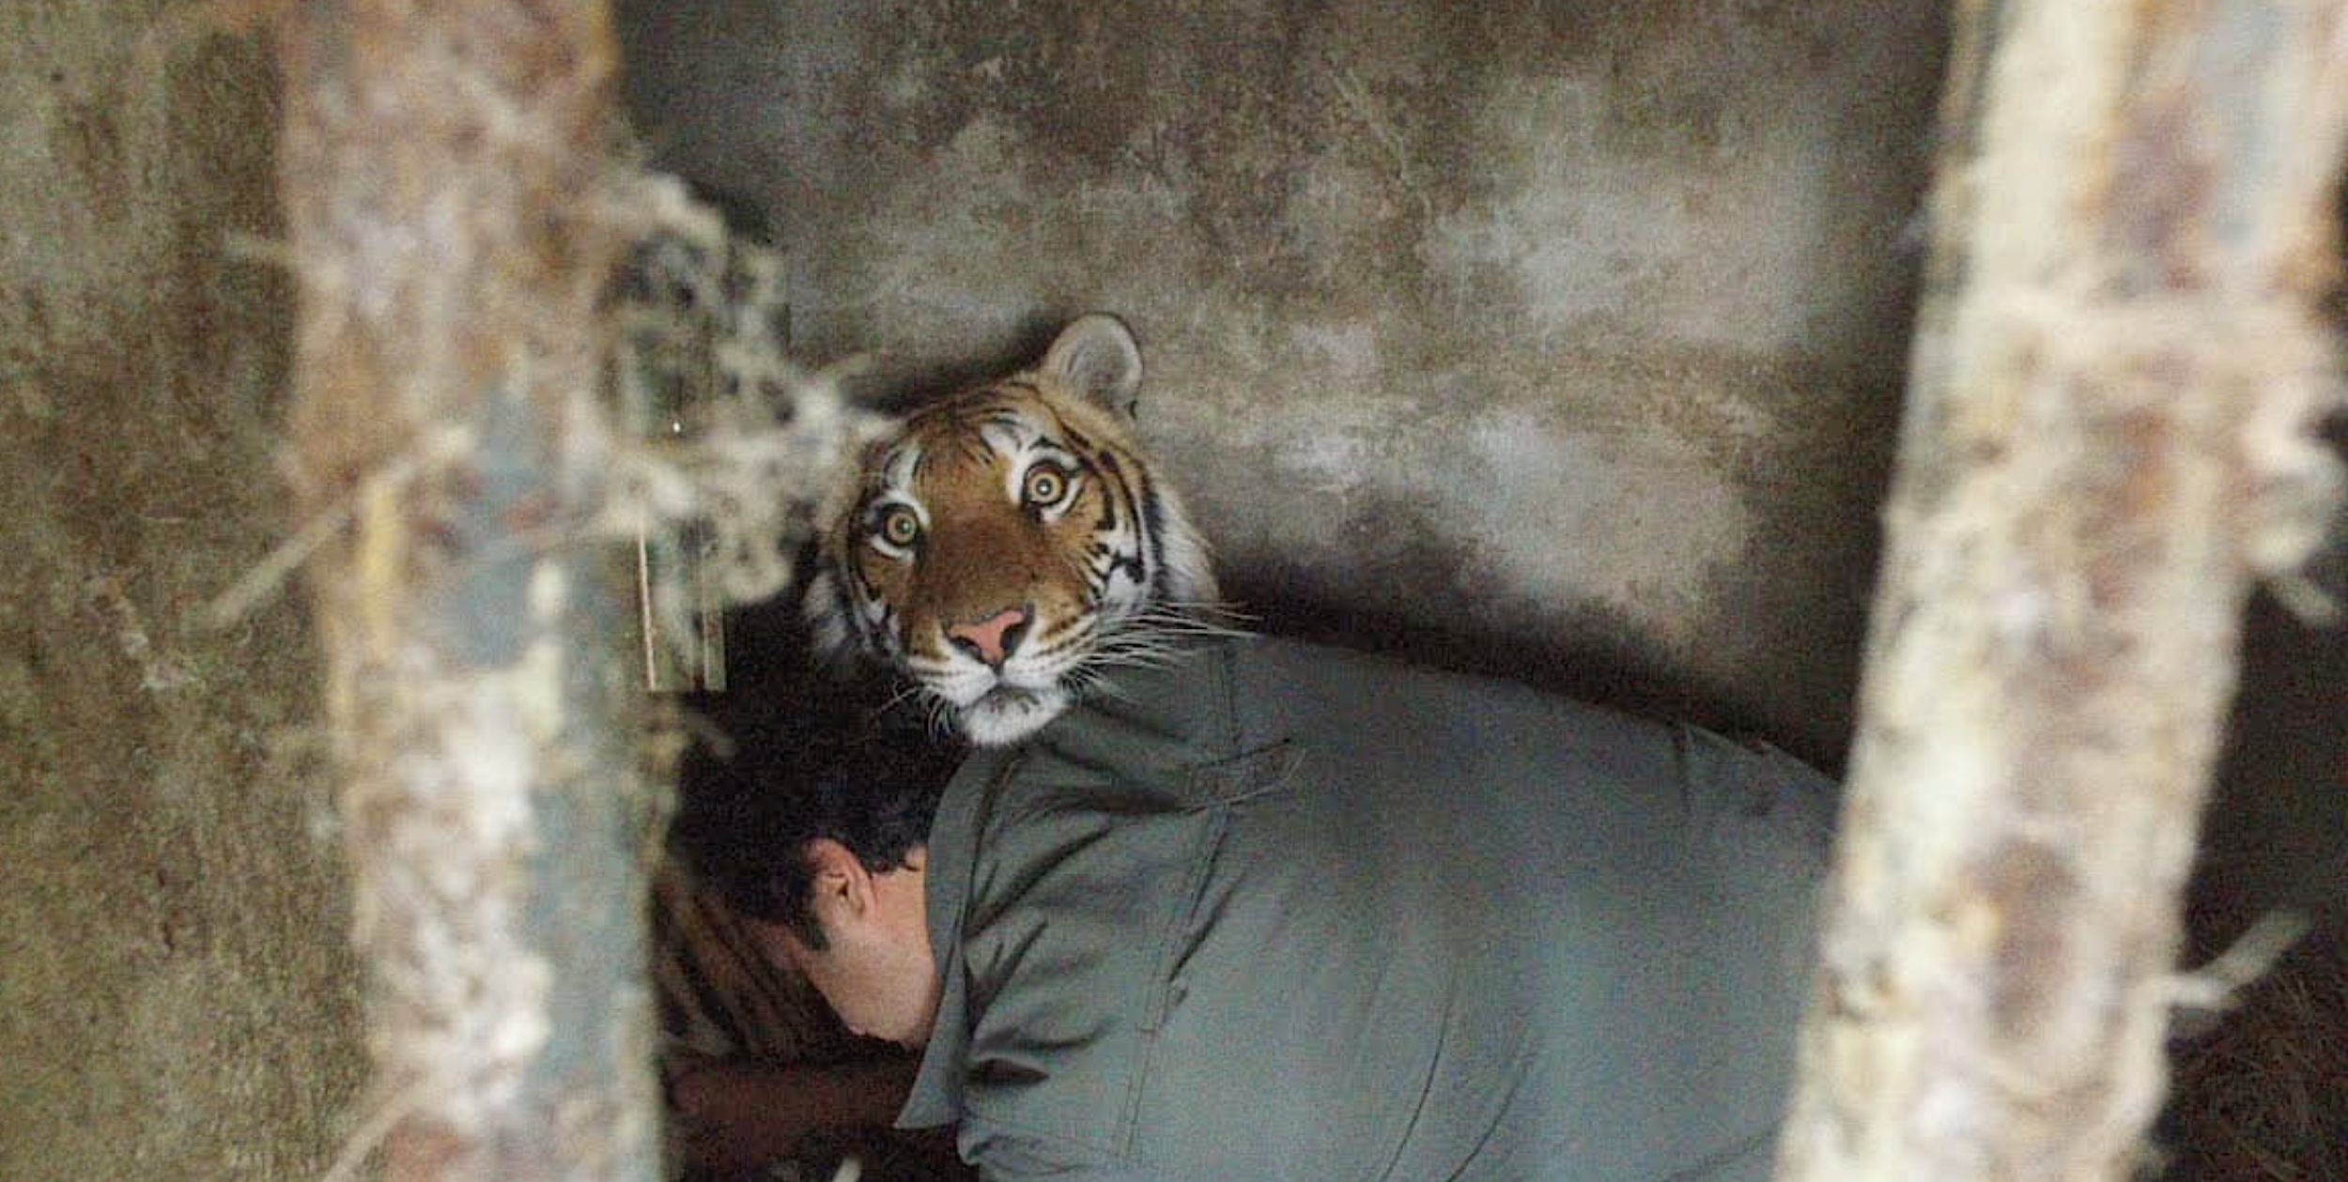

Filmmaker’s statement

JAMSHID MOJADDADI
“As an Iranian filmmaker I always look to tell stories that can resonate outside of my country. Maya is such a story; one that is important to tell right now as it talks about our own, often conflicted, relationship with the natural world.”

ANSON HARTFORD
“Is Maya better off with Mohsen in her life? This question is at the heart of this film and the answer is not black and white. On the one hand Mohsen seems to care very deeply for Maya and yet every time he is with her there is a sense that he is exploiting her in some way. Is he masking his self interests behind the illusion of a loving relationship? For me, this question and conflict resonates with the broader global questions surrounding how we see ourselves as separate to or part of the natural world.”

Key Creative Personnel

Director
Jamshid Mojaddadi is an Iranian documentary filmmaker with more than 20 awards to his name. He studied filmmaking at Tehran University for Television and Radio and over the last 15 years his films have screened at over 37 festivals worldwide and in 2004 his film ‘Life On The Other Hand’ was screened at the ‘Cinema House Festival’ as one of Iran’s top 16 films. His films have been broadcast in Iran across IRIB 1 and 2.

- It’s confirmed, Director - Jamshid Mojadaddi, Duration: 39 min, Date of production: 2009, In Competition IDFA, 2010
- A cold night in winter, Director - Jamshid Mojadaddi, Duration: 35min, Date of Production: 2007, First prize in Ashoura Film Festival, In competition - Royesh International Film Festival

Director
Anson Hartford studied film at the Surrey Institute of Art where he was taught the craft of filmmaking on celluloid film. His first documentary celebrated this medium in a story about an unknown genius of photography - James Ravilious which was narrated by Alan Bennett. His next film consolidated a working partnership with his brother Hugh on the film Short Man of The Forest, an ethnographically inspired adventure following a primatologist on the hunt for the ‘Orang Pendek’; an animal few had seen, none had photographed and many believed didn’t even exist. After multiple short form films for Aljazeera's award winning environmental show earthrise, Anson produced the Film 4 feature doc Ping Pong which was described as ‘remarkable’ by film critic Mark Lawson and was released in cinemas across Europe, North America and Asia. Maya is his second feature film.

- Ping Pong, Producer. Feature Documentary. Film 4, DocSociety, POV

Producer
Hugh Hartford is a creative producer/director with an MA in Visual Anthropology from Manchester, UK. He is a board member of the Royal Anthropological Institute film program. His credits include the feature films Ayouni (Doha Film Institute) Thank You For The Rain (ZDF/ARTE) and Ping Pong (BRITDOC/Film4). He’s had films released theatrically worldwide and screened documentaries at Hotdocs, Palm Springs, Zanzibar & Zurich IFF; the UN, The Hague, and the UK Parliament.

Hugh has worked with broadcasters around the world including BBC, ARTE, PBS, NRK, NBC, TVO, NHK, Channel 4, SVT, Yle.

- Ayouni, Feature film co-produced with Doha Film Institute, SANAD - Abu Dhabi film fund.
- Thank You For The Rain, Feature film co-produced with ZDF in association with ARTE. In competition at CPH Dox, Hotdocs & Sheffield. Theatrical Release: Denmark, UK, Germany, East Africa. TV Broadcasts in over 15 countries.
- Ping Pong, Feature Documentary. Cinema release in UK, USA, Taiwan, Australia & New Zealand. TV broadcasts in over 20 countries include Film 4, NRK Norway, PBS’ strand for the year’s best feature docs, POV.

Co-Producer
Ladan Anoushfar is a multifaceted award-winning documentary filmmaker who has produced, directed and edited films for BBC World, The Guardian, Al Jazeera, and the Aga Khan Architecture Awards. After studying at Central Saint Martins and the Royal College of Art in London, She trained with cinema legend Abbas Kiarostami and double Oscar winner Asghar Farhadi in Iran where some of her projects are set. Her film The Sanctions Hotel won a silver medal at the New York Festivals Best Film and TV Awards in 2018 and was a runner up for a Foreign Press Association award. In 2019 she edited Stealing From the Sick for the BBC, winner of the AIB award for Investigative Documentary.

Editor
Ollie Huddleston is a film editor with over 30 years of experience in television and cinema documentaries. He has worked with some of the great documentary directors including Kim Longinotto, Adam Curtis, Sean McAllister, Marc Isaacs, Angus Macqueen and Leo Regan. His films have won prizes at festivals all over the world including one at Cannes, three at Sundance and three at IDFA. Ollie has been BAFTA nominated twice and won two Royal Television Society editing awards.

Banyak Films
Founded in 2007 Banyak make story driven films with social issues at their heart. To date they have made feature films with BFI, Film4, ARTE, Norwegian Film Institute, Doc Society; and broadcast for BBC, Channel 4, Al Jazeera, NBC. They have won numerous industry awards and film festival prizes.

Every film we've ever made has been a collaboration. A collaboration between people in front of and behind the camera. This collaboration is often the creative journey of the film itself. www.banyak.co.uk

Awards
Doc Hi5 Impact Award - 2019
Royal Anthropological Institute Basil Wright - Feature Film Award 2019
Kalasha - Best Documentary Film 2018
One World Media - Nominated Best Feature Film 2018
Thessaloniki Documentary Film Festival - WWF Best Film 2018
SIMA Documentary Feature - Winner Jury & Cinematography 2018
AlimenTerre Film Festival - Jury Award 2017
Singapore Eco Film Festival - Pangolin Power Film Award 2017
AGROFILM Festival - Best Film - 2017
FICMEC Spain - Best Feature 2017
Vimeo Staff Picks 2013 & 2015
Foreign Press Association - Best Environmental Story 2012 & 2013
Film of the Year - Short of the Week 2013
Wellcome Trust - Audience Award 2011
Winner ‘Best Arts Documentary’ New York Film Festival 2007
Royal Anthropological Institute - Short Film Award 2006
Winner ‘Audience Award’ Hamburg Film Festival 2006

