Fortunate Sons (Feature Documentary) - Electronic Press Kit
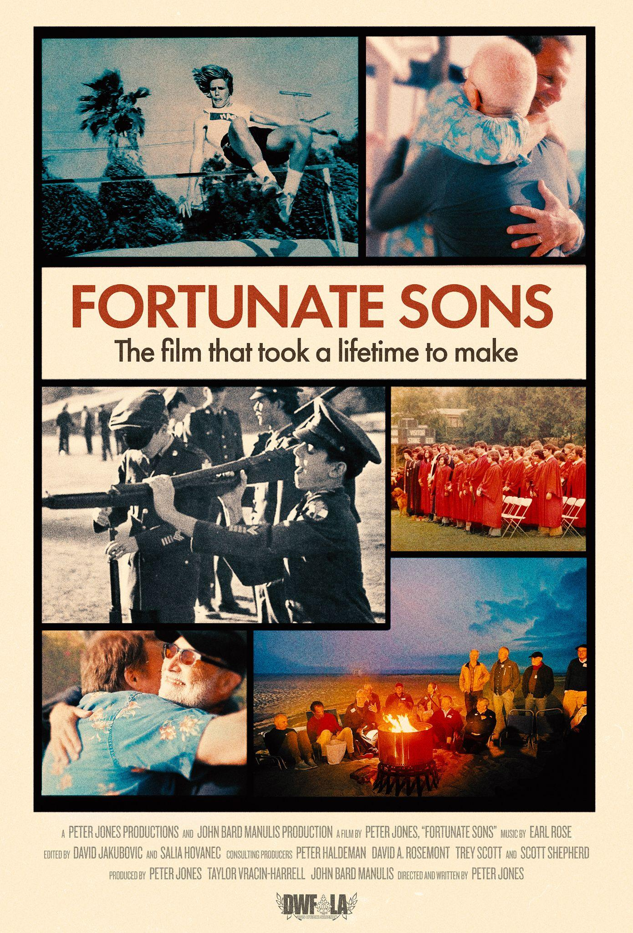

"A truly magnificent film...it took my breath away"
Jackie Tepper, Documentary Chair, Dances With Films festival

Festivals:  Dances With Film: LA, 2025  Festival World Premiere  https://danceswithfilms.com/fortunate-sons/ | Official Film Website: https://www.fortunate-sons.com/  Production Company Website: www.peterjonesproductions.com  Promotional Images (Including Key Art):  https://drive.google.com/drive/folders/1hFIOVYnESWW7iirjkym4VT7hQuNGcSNC?usp=sharing  Short Trailer (2:11):  https://vimeo.com/1082986174?share=copy  Long Trailer (3:48):  https://vimeo.com/840120262/597414304f?ts=0&share=copy
Run Time: 85 minutes  Rating: Not Rated  Language: English | A Peter Jones Productions and John Bard Manulis production  Directed, Written and Produced by  Peter Jones  Produced by  Taylor Vracin-Harrell  Produced by  John Bard Manulis  Edited by  David Jakubovic  Salia Hovanec  Music by  Earl Rose
Publicity Contacts:  Taylor Vracin-Harrell  taylor@peterjonesproductios.com  John Manulis  john@manulisventures.com | Sales Contact:  Savant Artists  Sebastian Twardosz  Phone: 818-613-5466  Email: savantartists@gmail.com
Social Media buttons (clickable!):

@fortunatesonsmovie

TAG LINE

The film that took a lifetime to make.

LOG LINE

An American journey through friendship, life, loss, and redemption with the Harvard School for Boys class of '74.

SHORT SYNOPSIS

The story of the 1974 graduating class of the Harvard School, a private military academy for the sons of the Los Angeles elite. During Covid they reconnected, rekindling friendships with rare emotional honesty about life, love, loss, and redemption.

MEDIUM SYNOPSIS

Fortunate Sons is a feature-length documentary about the 1974 graduating class of the Harvard School, then a private, military school for the sons of the Los Angeles elite. Born into privilege and groomed to lead, they entered 7th grade of this all-male, military school in the cultural watershed year of 1968. An American journey about friendship, life, loss, and redemption - culminating with the class’s 50th reunion in 2024 - it resonates powerfully with the developing national conversation about the mental health of boys and men, the cultural evolution of masculinity, and the power of connection and vulnerability.

LONG SYNOPSIS

In 1968 – while The Beatles rocked a generation, and the assassinations of Martin Luther King and Robert Kennedy shocked the nation – seventy-two 12 year-old boys entered the 7th grade at the elite, military Harvard School for Boys in Los Angeles…the young men of the baby boom generation being raised to lead American society.

But all that was about to change. There was a cultural revolution coming…and additional seismic shocks ahead, over the next 50+ years.

Born from a series of Zoom conversations launched during the early, isolating months of the Covid pandemic, Fortunate Sons is at once a story about the real lives of a small group of privileged men - dreams and fears, love and loss, family dysfunction, ambition, failure, and achievement - and a larger narrative about the challenges all Americans confronted as the world around them changed more rapidly and in more ways than anyone expected.

Its thematic power lies in subverting expectations - on the surface, a story about privilege, friendship, and universal life challenges, it’s fueled by a display of male vulnerability that resonates with the developing national conversation about the mental health of boys and men, the cultural evolution of masculinity, and the power of connection.

TESTIMONIALS:

“This made me think about life in a different way. Profound, utterly mesmerizing, and transformative."
- Jennifer Aaker, Professor, Stanford Graduate School of Business

"Unexpectedly cracks your heart wide open. I did not expect a film about privileged white men to touch on such universal themes of hope, love, loss, the fear of being seen, and the importance of friendship, and what matters. It’s touching, funny, real, so well made, and so needed in these toxic times....it had me in tears. Seeing these men be vulnerable brings so much hope. Bravo!"
- Cecilia Peck, Award-winning documentary filmmaker

"Fantastic, what a journey - so full of real emotion, coming from so many different directions. A broad, humanistic approach to storytelling that’s a much forgotten art."
- Peter Guralnick, Author, "The Last Train to Memphis: The Rise of Elvis Presley

"A profoundly moving documentary, Fortunate Sons explores the complex relationships between fathers and sons, masculinity, race, privilege, and the legacy of generational trauma in America. With honesty, vulnerability, and emotional intelligence, the film examines how men inherit not only societal expectations but also unspoken wounds—and how they can begin to heal. It’s a deeply human story that invites introspection and opens the door for meaningful dialogue around what it means to be a man today."
- Jack Myers, Author, "The Future of Men"; Founder, MediaVillage Education Foundation

"An ever surprising story of adolescence and aging, told by men with breathtaking honesty about the boys they were and the men they'd become."
- Griffin Dunne, Actor, Director, Producer, and Author

"It's a great film!"
- Blake Mycoskie, Founder, TOMS Shoes
​
"A marvelous, moving film that starts strong and gathers great emotional force. Fortunate Sons ought to be appreciated by anyone who cares about life and growing up."
- Todd Purdum, Author, "Desi Arnaz: The Man Who Invented Television"

“An extraordinary, fascinating, and moving film.”
- Susan Reed, Magazine editor and journalist

DIRECTOR’S STATEMENT:

When quarantine began in 2020, a number of my high school classmates began gathering on Zoom to talk about their lives and about how they were coping with this historic health crisis. Sometime that summer, the guys started to talk about planning our 50th reunion, happening four years later in 2024. I won’t name names, but one of my classmates said, “Why don’t we get Peter to make a documentary about our class?” Informed about this, I joined the next scheduled Zoom session. It was great to see much older but still familiar faces. But I didn’t mince words: “Guys, who would care about a bunch of privileged white men? Is there a more loathed demographic right now?”

Two years into the project, I apologized. Zoom technology allowed me to interview nearly thirty classmates scattered around the country. One of the guys lived above a wine bar he operated in the South of France. The cost to me was nothing but time, of which we all had plenty - homebound during the pre-vaccine pandemic.

Something magical happened. There was a level of candor and vulnerability I had never experienced in decades of doing interviews. Maybe it was because we were all the same age and had spent the formative years of our youth in the same class, at the same school. But no subject was off limits: the untimely death of classmates, the ravages of addiction and mental illness, giving back after having been given so much, losing parents, the death of a child - living life and loss in full.
We spent four years making Fortunate Sons. But this was a film about increments of time: our six years together in school, our lives after that, and our digital reconnection over the past four years before we came together in person - proof positive that all of it had been real.
For me, I had the time of my life.
- Peter Jones

SELECTED FILM QUOTES:
“Some guys talk about what a dramatic year ‘68 was, but as 12 year olds, we're not really thinking ‘look at our place in this dramatic year’ and all, we're just going to this new school where we have to wear all this military stuff.” - Peter Jones
“I mean just the perception of our, or the lack of perception, I should say, that we had. We had no idea that we were standing on like, multi-zillion dollar property. Within the Westside of LA, there were these micro climates of class. I personally was always really aware of the difference between people who lived in lower Bel Air and upper Bel Air.” - John Manulis
“Back then the thing was, you start a family and if you're rich enough, you hire a nanny, the nanny takes care of the kids. You see the kids when you want to. I was much closer with my nannies than I was with my parents, that's for sure.” - Bill Taradash
“There’s a revolution going on, so why not free things up? We’re in freaking LA, California! You know, we’re on the west coast.” - Trey Scott
“Life was happening faster than we could grow out our hair.” - Peter Jones
“To be a man then is, you have to go to the best school, to get to the best college to get the best job, so we can perpetuate this elite class of upper middle class white people.” - Pat McCabe
“The last few years have opened my eyes so much further to how much more deeply the exploration needs to go into the impact of centuries of racism, and misogyny, and homophobia.” - Christopher Hormel
“Privileged white men who were taught to never ever show weakness, never to let them see you cry. I think we’re all dying to share some of the hurt and pain and experience we’ve had.” - Brad Leonard
“When we are willing to be vulnerable and authentic and real with other men, there could be some magic that happens.” - Kevin Cooper

FILMMAKER BIOS:
Peter Jones, Writer/Director/Producer (Harvard School '74)
Peter Jones has been nominated for a Primetime Emmy Award five times, winning twice: for his A&E Biography special Judy Garland: Beyond the Rainbow, and for Stardust: The Bette Davis Story. His Peabody Award-winning Inventing LA: The Chandlers and Their Times premiered as a national primetime special on PBS, and Johnny Carson: King of Late Night remains the highest-rated film in the nearly 40-year history of the PBS series “American Masters”. Angeleno earned a nomination for Independent Programming by the Los Angeles area Emmy Awards. Blue Sky Metropolis was recognized as Best TV Documentary by the Radio and Television News Association and won a Los Angeles area Emmy Award.
Jones has twice been the recipient of the Producer of the Year Award from The Producers Guild of America.
John Bard Manulis, Producer (Harvard School '74)
John Bard Manulis' diverse career as a creative producer, executive, and entrepreneur spans the worlds of entertainment, live events, technology, and social/political activism - focused on encouraging a healthier, more just and productive world.
He has produced or executive produced over twenty film, television, and theater productions, including The Basketball Diaries, Swing Kids, and Tortilla Soup. As co-founder and CEO of Visionbox Media Group, he pioneered the use of digital technology for the production and distribution of motion pictures. And as Head of Filmed Entertainment for Samuel Goldwyn Films, he supervised the production or acquisition of films including The Madness Of King George, The Preacher’s Wife, Angels And Insects, I Shot Andy Warhol, Bent, The King Of Masks, and Big Night.
Taylor Vracin-Harrell, Producer
Taylor Vracin-Harrell is a producer and archivist who has worked with Peter Jones since 2018, on the docuseries Blue Sky Metropolis and the feature film ALL MAN: The International Male Story, which premiered at Tribeca. For ALL MAN, she served as Supervising Producer and assembled an archive which included over one hundred “International Male” catalogs.
Taylor’s personal work centers social justice and civil rights issues, and their short film Faith Alone was shown in festivals around the country and aired on KCET's Fine Cut program. Taylor was homeschooled, but as a native of Los Angeles with a love for the music and culture of the 1970s, she feels right at home with the class of '74.
David Jakubovic, Editor
Throughout his editing career, David Jakubovic has cut feature films, TV shows, live concerts, commercials, and every possible other form of motion picture content - but documentaries have always been the most gratifying.

His documentary work includes hard-core journalism-based films, music documentaries, heartfelt human interest stories, science films and now, the fascinating, groundbreaking Fortunate Sons.

Recent credits include Amazon Freevee's Monumental: Ellie Goulding at Kew Gardens, Hulu's Where is Private Dulaney, Masterclass's series GOAT, and other work for Disney, HBO, Paramount+, History, A&E, and more.

Salia Hovanec, Editor
Salia Hovanec is a film editor who began her career at 14, cutting music videos, corporate, and fashion content for clients including PepsiCo and Carnegie Hall. At 18, she produced and edited a documentary for Paul Rodgers which was released alongside the artist’s album The Royal Sessions, which reached number one on the Billboard Blues Charts.
After several years working on set as an assistant camera person, she returned to her first love: editing. While music content has long been her passion, she’s found documentary storytelling to be a deeply rewarding, creative challenge. Drawn to stories with emotional depth and real-world relevance, she has focused on projects that explore political conflict, mental health, and social justice across diverse global contexts.
Recent credits include Amazon Freevee’s Monumental: Ellie Goulding at Kew Gardens, a growing slate of feature and short documentaries, trailers, and sizzles.
Earl Rose, Composer
Earl Rose is an Emmy winning American composer, pianist, arranger, and conductor. In addition to composing film, television, jazz and classical music, he has also composed several well-known pop and R&B songs. He has received an Emmy Award, 13 Emmy Award nominations and three ASCAP awards for being among the top five most performed composers in television. He continually performs in concert in the US and internationally. This includes a musical residency at the Carlyle Hotel in New York for twenty-nine years.
His film scores include the PBS American Masters presentation, Johnny Carson: King of Late Night, PBS’ Inventing L.A.:The Chandlers and Their Times, Alan Pakula: Going For Truth, and Always At The Carlyle. Beginning in 2002, Rose composed the scores for over a dozen History Channel documentaries and mini-series.
His original music has been featured in such series as this season’s True Detective and Reacher and past years’ Shameless, American Woman, The Goldbergs, The Brave, The Magicians, Pan Am, The West Wing, and countless others. He was the pianist for the TV special, A Colbert Christmas:The Greatest Gift of All accompanying Elvis Costello, John Stewart and Stephen Colbert.

TOP CREDITS:

Directed, Written, and Produced by
PETER JONES

Produced by
TAYLOR VRACIN-HARRELL

Produced by
JOHN BARD MANULIS

Edited by
DAVID JAKUBOVIC
SALIA HOVANEC

Music by
EARL ROSE

Consulting Producers
PETER HALDEMAN
DAVID A. ROSEMONT
TREY SCOTT
SCOTT SHEPHERD

Full credits available here.

PRESS:

Deadline:
https://deadline.com/2025/05/dances-with-films-2025-lineup-announcement-1236408540/

Harvard-Westlake Chronicle:
https://hwchronicle.com/109587/uncategorized/back-to-the-future/

# # #

